Electronic Firework Machine
LD-077B

Operating Instructions

★ Please carefully read this manual before use.
★ This manual contains the warranty card. Please keep it properly.

Safety Instructions
Warnings & Cautions
This symbol reminds the operator of danger and provides important information on safe and effective operation.
Example of safety statement:
Warning: Remind the operator of hazards or potential danger. This manual contains the hazard description and consequences.

Eye Protection

This warning symbol reminds the operator to protect the eyes when close to the firework machine.

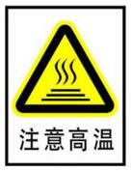
Caution! High Temperature!

The nozzle may be heated as it is close to the nozzle. Please pay attention to high temperature and avoid touching the nozzle.

Caution! Electric Shock!
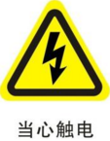
Warning: The dangerous voltage in the equipment and controller may cause electric shock.
Do not open the firework machine and controller or remove (adjust) any part inside them without authorization. The machine and controller must be opened by the engineer that has received professional training.

Warning of Moisture Prevention
Warning: Remind the operator to keep the machine and controller dry. Do not use them on rainy and snowy days.

Safety Distance
Keep a 3m safety distance away from flammables.

Emergency
In the case of emergency, stop the firework machine quickly, press “Pause” on the controller, and turn the power switch on the machine panel into the “OFF” position. If necessary, contact the fire department and seek medical help.

Noise Emission
The noise of the firework machine is less than 80dB, which is not harmful to the ears. It is not necessary to use eye protection equipment during work beside the firework machine.

Cleaning
After the performance, observe the nozzle for dross. Clean dross, as it affects the firework effect and may even damage the machine.
After the performance, pour out excess materials in the bin and keep them in a dry and sealed place. Clear the pipe by the cleaning function (or directly run the firework machine until there is no firework in 30s).

Consumable Precautions
- If consumables are accidentally ignited, cover them with sand until fire is extinguished.
- Keep consumables in a dry and sealed place to prevent moisture.

Contents
I. Safety Precautions 6
II. Parameters of Electronic Firework Machine 6
III. Features of Electronic Firework Machine 7
IV. Operating Instructions of Electronic Firework Machine 7
V. System Configuration and Connection 13
VI. Preparation before Operation 14

I. Safety Precautions
  - Do not open the shell for repair; otherwise, serious accidents may be caused.
  - Keep the machine dry. Do not use it on rainy or snowy days.
  - Properly close the top consumable cover, and prevent it from accidental opening. If consumables are accidentally ignited, cover them with sand until fire is extinguished. Keep consumables in a dry and sealed place to prevent moisture.
  - Keep people and flammables at least 3m away from the machine. Make sure that the light spot sprayed is in the air and not exposed to any object.
  - Clean excess materials in the pipe by the cleaning function before and after the performance. Observe the nozzle for dross after the performance. Clean dross, as it affects the firework effects and may even damage the machine. Pour out excess materials in the bin, and keep them in a dry and sealed place. Then clean excess materials in the pipe (or directly run the firework machine until there is no firework in 30s).
  - One standard power supply (including connecting power cables) can be connected with at most six firework machines in series. Otherwise, damage or fire may be caused.
  - Do not block the air inlet and outlet to avoid the influence on heat dissipation.
  - Do not cover the nozzle.

II. Parameters of Electronic Firework Machine
Model: LD-077B
Size: 230*220*320mm
Weight: 8.8kg
Input power: AC220V±10% 50Hz
Working power: 600W; 2.8A
Working temperature: -10℃ to 50℃
Chassis material: flame-retardant ABS
Firework height: 2m-5.0m, depending on consumables
Communication interface type: double DMX interfaces
Power interface type: double AC power interfaces

III. Features of Electronic Firework Machine
  - Raw materials are sealed to prevent collision, and can be thoroughly used.
  - The machine is easy to operate, and can be started with one button.
  - The machine supports the standard DMX512 communication protocol. The linkage operation of multiple firework machines and between the firework machine and other stage equipment is allowed.
  - With the cooling device, internal components can be protected effectively.
  - The machine has the function of automatic shutdown in the case of over-temperature alarm.
  - The machine is made of flame-retardant and high-temperature-resistant material.
  - Due to the delicate and compact structure, the machine is lighter and smaller.

IV. Operating Instructions of Electronic Firework Machine
  - Operation Interface
The operation panel includes the LCD information display area, control button operation area, LED indicator status display area and card swiping area.
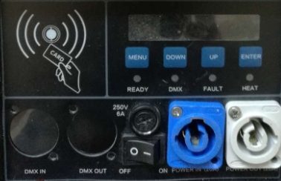
    - LCD information display area: displaying the operation menus and equipment running status.
During spraying, the screen will be black and the indicator will flash normally. After spraying, the screen will be in the normal status.
    - LED indicator status display area
READY: if the system is running normally, this indicator will flash once a second;
DMX: if a DMX controller is connected, this indicator will flash frequently;
FAULT: if a fault is detected, this indicator will be normally ON;
HEAT: if the real-time temperature of the heating rod is less than the set value in the operation process of the system, this indicator will flash.
    - Control button operation area
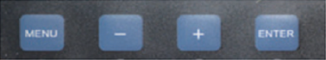
MENU: short-press it to switch the setting interfaces.
-: decrease the value.
+: increase the value.
ENTER: confirm and save the setting.
    - Card swiping area (not enabled)
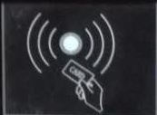
  - Operating Instructions
    - Contents displayed after startup:
RUN Time
00032.33 Minute
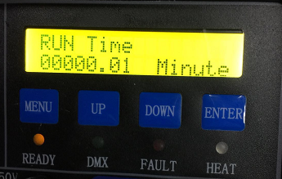
Note: Once the machine is started, the cumulative running time will be displayed automatically, including the actual spraying time but excluding the standby and warm-up time. The cumulative time is maximum 60000.00 minutes and accurate to a second. If the cumulative time exceeds 60,000 minutes, the system will automatically clear it and re-calculate the time, as shown below:
Warning:
Equipment Repair

This functional interface will last for about 2s. Then the initialization interface will appear.
    - Initialization interface
The initialization interface is shown below:
DMX Address 001
Ready For Work…
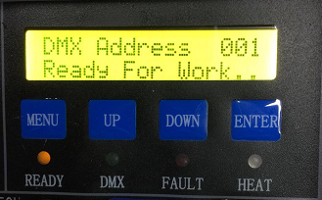
Note: The DMX address saved last time and “Ready For Work…” will be shown on the standby interface. The user can enable warm-up via the DMX stage controller or press MENU to enter the working status interface.

The working status interface is shown below:
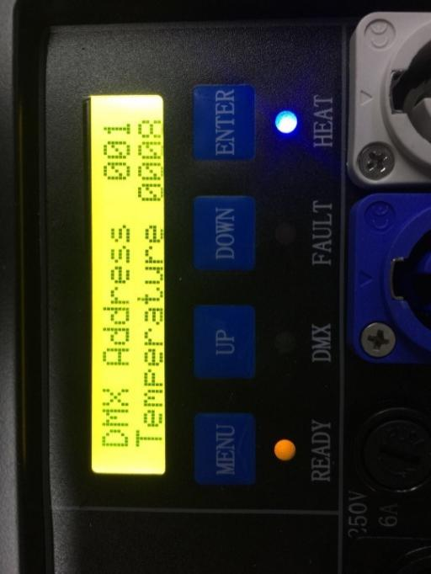
When the machine is working, the warm-up function will be enabled automatically, and the DMX address and real-time core temperature will be shown. If the temperature sensor is abnormal, the FAULT indicator will flash, and the following interface will pop up.
Error 1
Temp Sensor
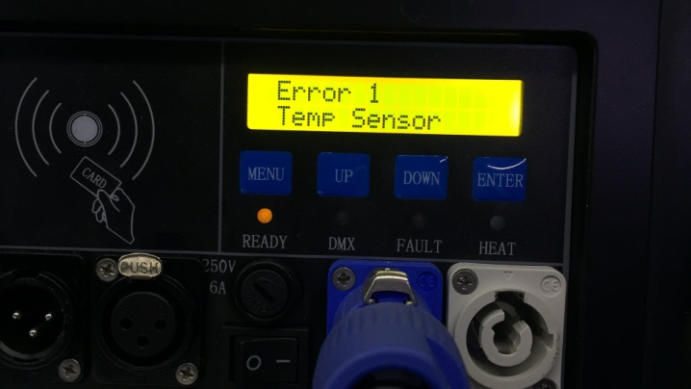
If the temperature sensor is in the normal status, warm-up will be started. The HEAT indicator will flash in the warm-up process. After warm-up, the HEAT indicator will be OFF.
If the heating module is abnormal in the warm-up process, the following interface will pop up.
Error 0
Heat Fail
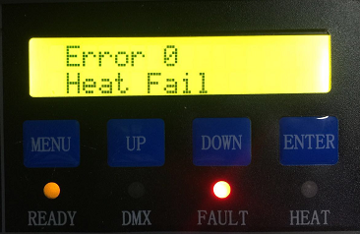
If the fan is abnormal during operation, the following interface will pop up.
Error 3
AIRMOTOR ERROR
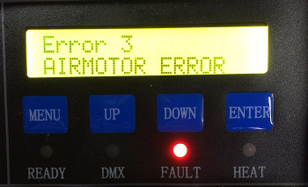
If the above interface pops up, immediately shut down the machine and return it to the factory for repair.
    - Button operation process
There are four buttons, namely MENU, UP, DOWN and ENTER. The operator can press MENU to set the parameters when the system is working. The specific operation process is shown below.

    - Parameter setting
When the machine is in the working status, press MENU to enter the setting interface to set different parameters. Then go back to the main interface.
The interface of DMX address is shown below:
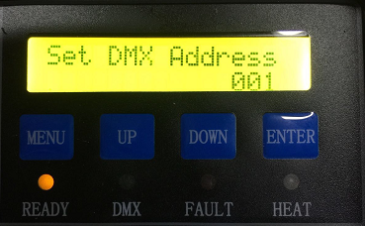
Press UP or DOWN to select the value within 1-512. Then press ENTER to go back to the working status interface or MENU to enter the core temperature setting interface.

The temperature setting interface is shown below:
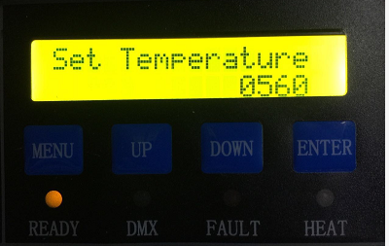
Press UP or DOWN to set the temperature between 560℃ and 620℃. Then press ENTER or MENU to go back to the working status interface.

  - DMX Control
1st channel | Function
0-9 | Spray OFF
10-255 | Spray ON
2nd channel | Function
60-80 | Consumable cleaning
20-40 | Emergency stop
0-10 | Warm-up OFF
240-255 | Warm-up ON

V. System Configuration and Connection
  - System Configuration
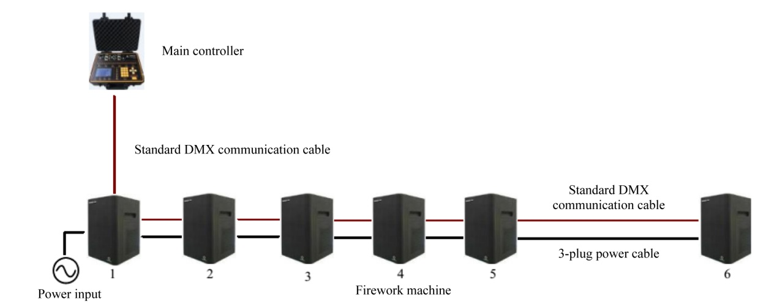
List of Standard 6-unit Assembly
S/N | Name | Specification | Unit | Quantity | Remarks
1 | Electronic firework machine | LD-077 | Set | 6
2 | Main controller |  | Set | 1
3 | Communication cable of firework machine |  | Nos. | 5
4 | Communication cable of main controller |  | Nos. | 1
5 | Power cable |  | Nos. | 1
6 | Intermediate power cable |  | Nos. | 5
  - System Connection

    - Main controller and firework machine
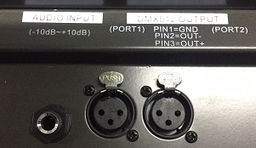
    - Power cable of firework machine
In order to facilitate operation, the power cable with plug and the connecting power cable are used. The connecting power cable is used for “hand-in-hand” connection of multiple machines, at most 6 machines in a cascading way. All power plugs are industrial plugs with lock. The buckles should be moved and rotated during operation.
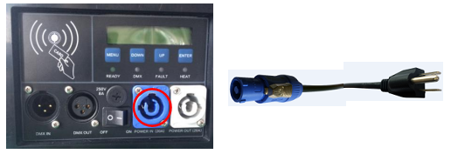
    - Power cable between firework machines
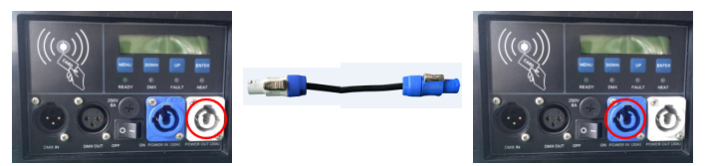
    - Communication cable between firework machines
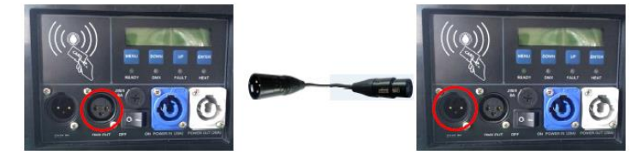

VI. Preparation before Operation
  - Adding of consumables into firework machine
Add consumables through the top consumable inlet. Note that the firework supports the consumables of at most 200g.
    - Open the consumable package.
Picture
    - Add consumables into the firework machine.
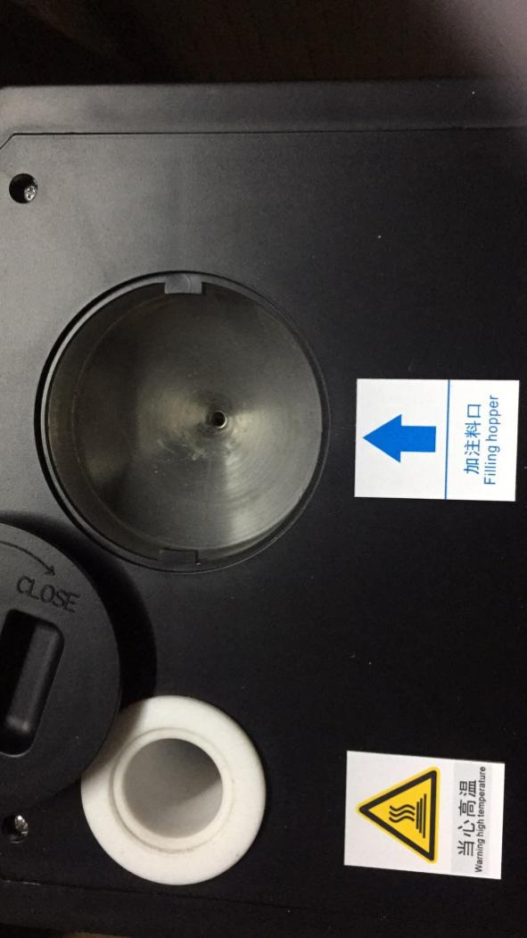
  - Connection of signal cable between the console and firework machine
  - Power-on of controller
Turn on the controller switch.
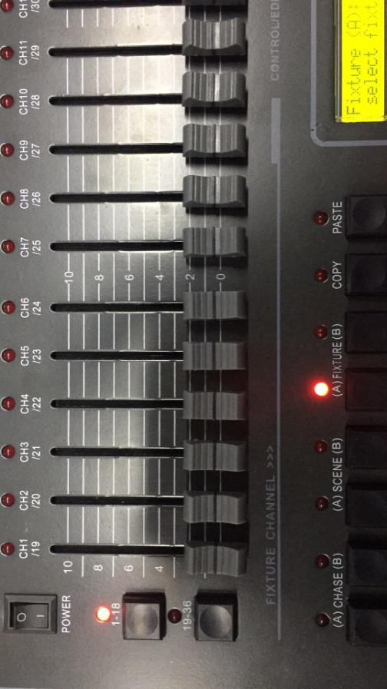
  - Power-on of firework machine
Turn on its switch.
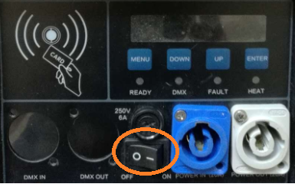

  - Parameter setting
Set the DMX address and firework effects according to Part IV of this manual and the instructions of the main controller.
  - Startup
After parameter setting, make the manual button of the controller and the corresponding button of the firework machine ON.
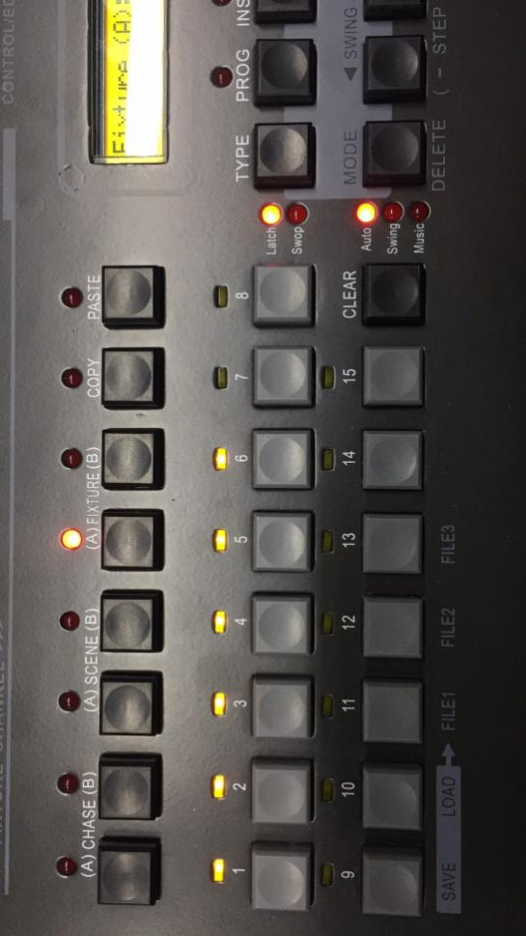
  - Push the second push rod of the controller to the top to warm up the machine.
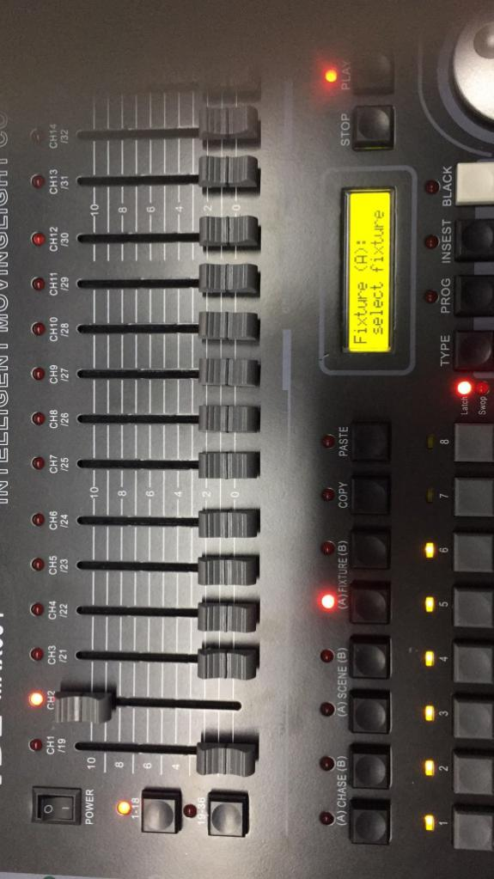

  - When the core temperature reaches the set value, push the first push rod of the controller to start spraying according to the firework height. The firework height depends on the push rod data: 10-19 as the first gear, 20-29 as the second gear, 30-39 as the third gear, 40-49 as the fourth gear, 50-59 as the fifth gear, 60-69 as the sixth gear, 70-79 as the seventh gear, 80-89 as the eighth gear, 90-99 as the ninth gear, and 100 and more as the tenth gear.
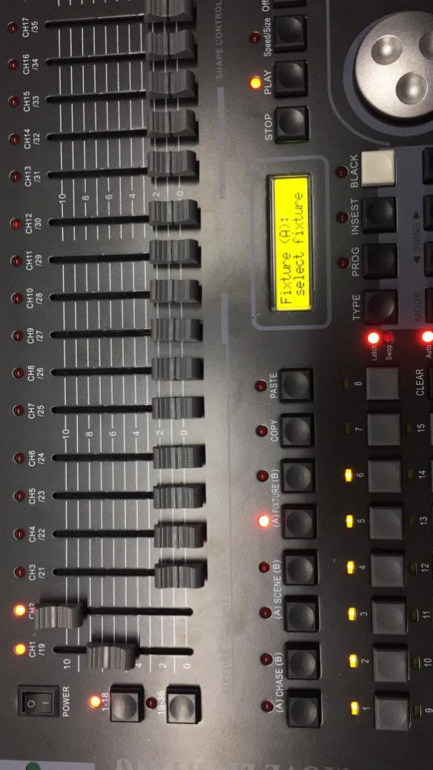
Note: If the core temperature reaches the alarm value during long-time operation, spraying will be conducted intermittently and the FAULT indicator will flash. In this case, stop spraying, and wait until the core temperature is equal to the set value.
  - Shutdown
After operation, shut down the firework machine and main controller.
  - Cleaning
After operation, turn off the power switch of the firework machine, make the machine inverted, and pour out excess consumables. Then turn on the power switch, and clean excess consumables in the pipe by the cleaning function (or directly run the firework machine until there is not firework in 30s). Finally, shut down the firework machine and main controller.

Note: Store excess consumables in the bottle or bag instead of discarding.

