80W LED Beam Moving Head Light

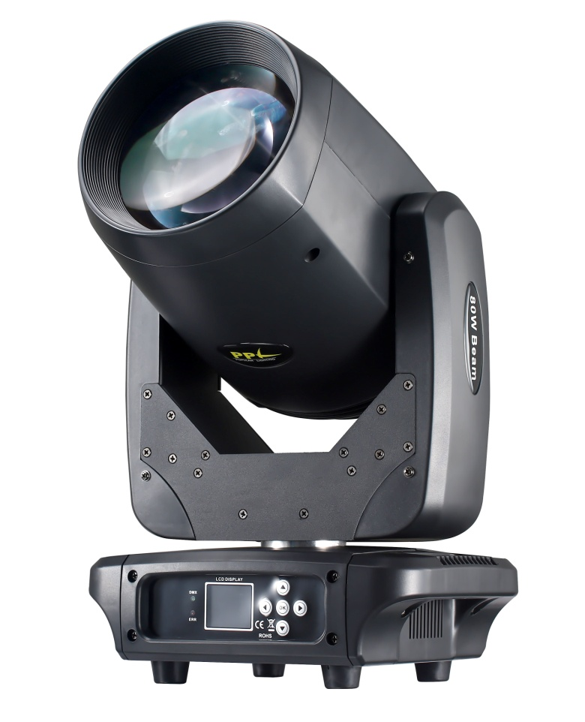

USER MANUAL

KEEP THIS MANUAL FOR FUTURE NEEDS

1. General Information:
Thank you very much for choosing our product. For safety purpose, please read this manual carefully before your operation. This manual included installation and using information. Please install and operate it according to this manual.
Unpacking:Once receive it,please handle it carefully and check if there is some shatter because of transportation and the following fittings are OK.
In the carton,there are four things available:

Moving head light: 1PC
Power cable: 1PC
Fast Lock: 2PC
User manual: 1 PC

Warning! To prevent or reduce the risk of electrical shock or fire, do not expose this unit to rain or moisture.

Caution! There are no user serviceable parts inside this unit. Do not attempt any repairs yourself. Doing so will void your manufactures warranty. In the unlikely event your unit may require service please contact us.

2. Safety Instructions
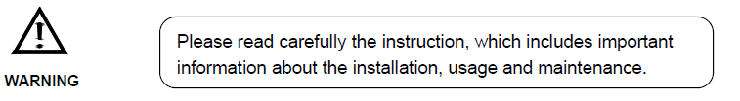

- Please keep this User Guide for future consultation. If you sell the unit to another user, be sure that they also receive this instruction booklet.
- Unpack and check carefully there is no transportation damage before using the unit.
- Before operating, ensure that the voltage and frequency of power supply match the power requirements of the unit.
- It’s important to ground the yellow/green conductor to earth in order to avoid electric shock.
- The unit is for indoor use only. Use only in a dry location.
- The unit must be installed in a location with adequate ventilation, at least 50cm from adjacent surfaces. Be sure that no ventilation slots are blocked.
- Disconnect main power before replacement or servicing.
- Make sure there are no flammable materials close to the unit while operating as it is fire hazard.
- Use safety cable when fixes this unit. DO NOT handle the unit by taking its head only, but always by taking its base.
- Maximum ambient temperature is Ta: 40℃. DO NOT operate it where the temperature is higher than this.
- Unit surface temperature may reach up to 85℃. DO NOT touch the housing bare-hand during its operation. Turn off the power and allow about 15 minutes for the unit to cool down before replacing or serving.
- In the event of serious operating problem, stop using the unit immediately. Never try to repair the unit by yourself. Repairs carried out by unskilled people can lead to damage or malfunction. Please contact the nearest authorized technical assistance center. Always use the same type spare parts.
- DO NOT touch any wire during operation as high voltage might be causing electric shock.

Warning:
- To prevent or reduce the risk of electrical shock or fire, do not expose the unit to rain or moisture.
- DO NOT open the unit within five minutes after switching off.
- The housing, the lenses, or the ultraviolet filter must be replaced if they are visibly damaged.

Caution:
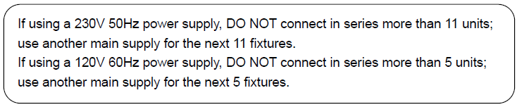
There are no user serviceable parts inside the unit. DO NOT open the housing or attempt any repairs yourself. In the unlikely event your unit may require service, please contact your nearest dealer.

Installation:
The unit should be mounted via its screw holes on the bracket. Always ensure that the unit is firmly fixed to avoid vibration and slipping while operating. And make sure that the structure to which you are attaching the unit is secure and is able to support a weight of 10 times of the unit’s weight. Also always use a safety cable that can hold 12 times of the weight of the unit when installing the fixture.
The equipment must be fixed by professionals. And it must be fixed at a place where is out of the touch of people and has no one pass by or under it.

3. Technical Specifications
Voltage: AC100-240V, 50/60Hz
Power: 120W
LED Source: 1pc High power 80W White LED@4500lm
Over 50000hrs working life
Color Temperature: 7000k-7500k
Beam Angle: 2degree
Lumin: 123000lux @ 4m
DMX Channel: 16CH/20CH
Control Mode: DMX 512, Master/Slave, Auto, Sound active
Support RDM
Movement: Pan: 540° / Tilt: 270 °, 16bit Fine Pan/Tilt control
Color Wheel: 9colors + white, half-color, rainbow effect
Gobo: 15 fixed gobo+blank, Gobo shake
7Colors Effect: An independent wheel with 6colors , can make the gobos in rainbow effect
Frost: A frost soft light mirror
Dimmer: 0-100% linear adjustment
Strobe: Synchronized Pulse strobe, Random pulse strobe
Prism: Double Prisms, 8 facet rotate prism + 24 facet rotate prism, double prism can Overlapped
Focus: 0-100% Linear adjustment focus
IP Rate: IP20
Display: LCD display, Chinese & English surface, reverse 180º displayed
High efficiency cooling system, Temperature monitoring, Over temperature automatic protection
N.W: 11.88kgs
Size: 280*215*510mm

- Photometric Diagram:

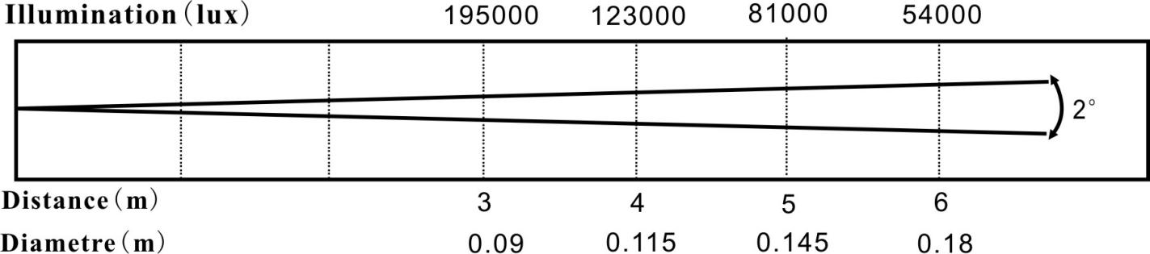

5. Interface Description
Main Interface
Chinese/English surface
Reverse 180 displayed
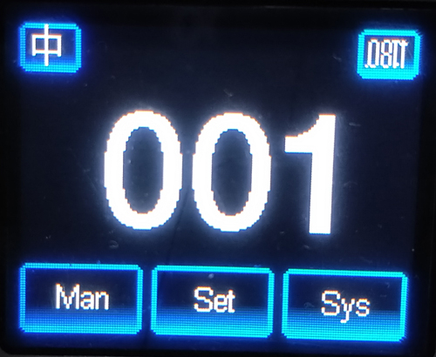

DMX Address

System Information
Setting
Manual

6. Subinterface
Manual Control
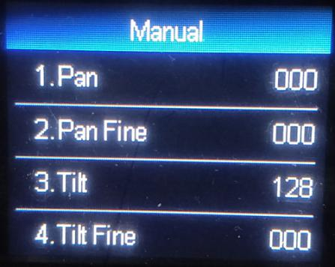
(2) Press “OK” key enter into Edit status, the word is red, then press “UP” “DOWN” to select, press “OK” save and Exit edit status.
(1)Yellow arrow indicates selected

This interface is used to control the current luminaire and automatically enters the host state (does not receive the DMX signal and sends a DMX signal to the slave to the host).
The manual menu will display 16 channels or 20 channels according to the standard 16-channel or extended 20-channel mode set in the setup menu.

Option | Description
1CH. Pan | 0-255 | Yellow arrow indicates selected, Press “OK” key enter into Edit status, the word is red, then press “UP” “DOWN” to select, press “OK” save and Exit edit status.
…… | 0-255
15CH. Frost | 0-255
16CH. Reset |  | Press “OK” to see the confirmation dialog box, press “OK” again to enter the reset interface, all motor reset
17CH. Pan/Tilt Speed | 0-255 | Channel Mode is”Extended 20-channel” can display
18CH. Color Wheel Speed | 0-255
19CH.Dimmer-Prism-Frost Speed | 0-255
20CH. Gobo Wheel Speed | 0-255

Setting
(2) Press “OK” key enter into Edit status, the word is red, then press “UP” “DOWN” to select, press “OK” save and Exit edit status.
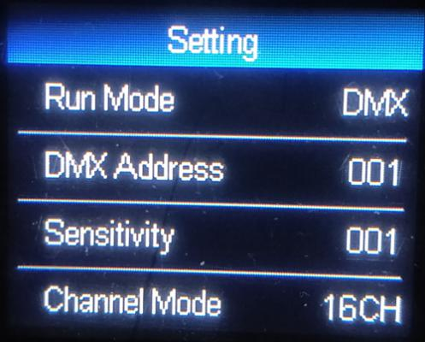
(1)Yellow arrow indicates selected

Option | Description
Run Mode | DMX | Slave status: Receive DMX signals from the console or Master
 | AUTO 1 | Auto run ;  Master status: Auto run and send DMX signal to slave
 | AUTO 2
 | Random
 | Sound
DMX Address | 001-512 | Press “OK” key enter into edit status, then press “UP” “DOWN” to change DMX address. press “OK” key save and exit edit status.
Channel Mode | 16 CH | Standard 16 Channel Mode, 17-20CH No Function
 | 20 CH | Extend 20 Channel Mode, 17-20CH for speed control.  (please check the detail on Channel table.)
Invert Pan | OFF | ON for starting and ending , the default is OFF.
 | ON
Invert Tilt | OFF | ON for starting and ending , the default is OFF.
 | ON
Pan-Tilt Swap | OFF
 | ON | Exchange Pan/Tilt channel (include Pan/Tilt Fine)
Pan-Tilt Encoder | ON | Use encoder (optocoupler) to determine out of step and automatically correct position
 | OFF | Correct position without encoder (optocoupler)
DMX Signal | KEEP | Continue running as it is
 | CLEAR | All motors return to the position and stop running.
Linear Color | ON | Color liner change
 | OFF | Color nonlinear change, half color change
Load Default |  | Press the "OK" button to see the confirmation dialog, press "OK" again  The key restores the default settings

System
Version No.
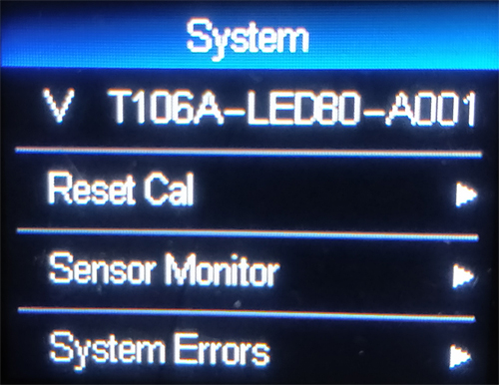

Option | Description
Version No.(V) |  | Version No.
Reset Calibration | Pan Calibration | After entering the sub-interface, you can adjust the motor such as X-axis and Y-axis.  Reset position to compensate for errors in hardware installation,  Adjustment range -128~+127, +0 means no adjustment.
 | Tilt Calibration
 | Color Calibration
 | Gobo Calibration
 | Focus Calibration
 | Prism1 Calibration
 | Prism2 Calibration
 | Rainbow Calibration
 | Frost Calibration
Sensor Monitor | Pan Hall | 0 when magnetic is detected, otherwise 1
 | Tilt Hall
 | Color Hall
 | Gobo Hall
 | Focus Hall
 | Prism1 Hall
 | Prism2 Hall
 | Panwheel State | 2 digits, each corresponding to a photoelectric switch in the encoder disc
 | Tiltwheel State
 | Panwheel Step | When walking in the positive direction, the step value should increase, when going back,  The step value should be reduced. The value is the same every time you go to a certain point
 | Tiltwheel Step
System Error | (See common mistakes  Rear) | If the red ERR indicator is lit, the luminaire is running.  An error can be made by going to the sub-interface for details.  After viewing, you can press the "Clear" button to clear the error record.
DMX Monitor |  | This enters the sub-interface and displays the channel values as values for viewing.

Error | Description
MT board connection failed | The driver board did not respond. Serial communication line connecting display panel and driver board  There is a problem, or there is a problem with the driver board.
Pan Reset failed | X-axis photoelectric switch, or problem with X-axis motor
Tilt Reset failed | Y-axis photoelectric switch, or problem with Y-axis motor
Pan Hall failed | Pan Hall have problem
Tilt Hall failed | Tilt Hall have problem
Color Wheel Reset failed | Color Wheel Hall , or Color Wheel motor have problem
Gobo Wheel Reset failed | Gobo Wheel Hall , or Gobo Wheel motor have problem
Focus Reset failed | Focus Hall , or Focus motor have problem

7. DMX Channel Table
CH | Channel Mode
 | 16CH | 20CH
1 | Pan | Pan
2 | Pan Fine | Pan Fine
3 | Tilt | Tilt
4 | Tilt Fine | Tilt Fine
5 | Dimmer | Dimmer
6 | Strobe/Shutter | Strobe/Shutter
7 | Color Wheel | Color Wheel
8 | Gobo Wheel | Gobo Wheel
9 | Prism 1 | Prism 1
10 | Prism 1 Rotation | Prism 1 Rotation
11 | Prism 2 | Prism 2
12 | Prism 2 Rotation | Prism 2 Rotation
13 | Focus | Focus
14 | 7-Color Effect | 7-Color Effect
15 | Frost | Frost
16 | Reset | Reset
17 |  | Pan/Tilt Speed
18 |  | Color Wheel Speed
19 |  | Dimmer-Prism-Frost Speed
20 |  | Gobo Wheel Speed

8. 16/20 DMX Channel Description
CH | Function | Value | Effect
1 | Pan | 000-255 | Pan 540 degree scan
2 | Pan Fine | 000-255 | Pan 1.2 degree scan
3 | Tilt | 000-255 | Tilt 270 degree scan
4 | Tilt Fine | 000-255 | Tilt 1.2 degree scan
5 | Dimmer | 000-255 | From dark to bright
6 | Strobe | 000-003  004-251  252-255 | OFF  Strobe from slow to fast  ON→(control by dimmer channel)
7 | Color Wheel  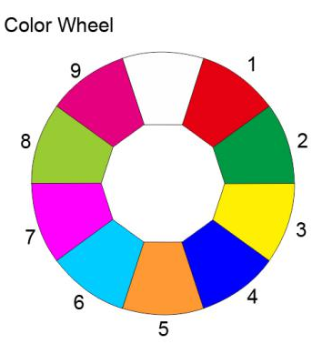 | 000-004  005 -009  010 – 014  015 – 019  020 – 024  025 – 029  030 – 034  035 – 039  040 – 044  045 – 049  050 – 054  055 – 059  060 – 064  065 – 069  070 – 074  075 – 079  080 – 084  085 – 089  090 – 094  095 – 099  100 -177  178 - 255 | White  White + Color1  Color 1  Color 1 + Color 2  Color 2  Color 2 + Color 3  Color 3  Color 3 + Color 4  Color 4  Color 4 + Color 5  Color 5  Color 5 + Color 6  Color 6  Color 6 + Color 7  Color 7  Color 7 + Color 8  Color 8  Color 8 + Color 9  Color 9  Color 9 + White  Positive flow (from fast to slow)  Reverse flow (from slow to fast)
8 | Gobo Wheel  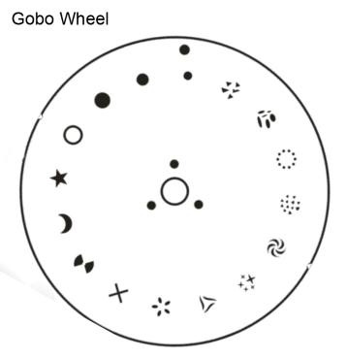 | 000 – 004  005 – 009  010 – 014  015 – 019  020 – 024  025 – 029  030 – 034  035 – 039  040 – 044  045 – 049  050 – 054  055 – 059  060 – 064  065 – 069  070 – 074  075 – 079  080 – 084  085 – 089  090 – 094  095 – 099  100 – 104  105 – 109  110 – 114  115 – 119  120 – 124  125 – 129  130 – 134  135 – 139  140 – 144  145 – 149  150 – 154  155 – 159  160 – 207  208 – 255 | White  Gobo 1  Gobo 2  Gobo 3  Gobo 4  Gobo 5  Gobo 6  Gobo 7  Gobo 8  Gobo 9  Gobo 10  Gobo 11  Gobo 12  Gobo 13  Gobo 14  Gobo 15  White shake (from slow to fast)  Gobo 1 shake (from slow to fast)  Gobo 2 shake (from slow to fast)  Gobo 3 shake (from slow to fast)  Gobo 4 shake (from slow to fast)  Gobo 5 shake (from slow to fast)  Gobo 6 shake (from slow to fast)  Gobo 7 shake (from slow to fast)  Gobo 8 shake (from slow to fast)  Gobo 9 shake (from slow to fast)  Gobo 10 shake (from slow to fast)  Gobo 11 shake (from slow to fast)  Gobo 12 shake (from slow to fast)  Gobo 13 shake (from slow to fast)  Gobo 14 shake (from slow to fast)  Gobo 15 shake (from slow to fast)  Positive flow (from fast to slow)  Reverse flow (from slow to fast)
9 | Prism 1 | 000-127  128-255 | Prism 1 out  Prism 1 in
10 | Prism 1 Rotation | 000-127  128-190  191-192  193-255 | Prism angle adjustment  Reverse rotation (from fast to slow)  Stop  Forward rotation (from slow to fast)
11 | Prism 2 | 000-127  128-255 | Prism 2 out  Prism 2 in
12 | Prism 2 Rotation | 000-127  128-190  191-192  193-255 | Prism angle adjustment  Reverse rotation (from fast to slow)  Stop  Forward rotation (from slow to fast)
13 | Focus | 000-255 | Pattern definition from far to near
14 | 7-Color Effect | 000-127  128-255 | 7-Color Effect out  7-Color Effect in
15 | Frost | 000-127  128-255 | Frost out  Frost in
16 | Reset | 000-049  050-099  100-199  200-255 | No Function  Small Motor Reset  Big Motor (Pan/Tilt) Reset  All Motor Reset
Extend Channel:
17 | Pan/Tilt Speed | 000-255 | Speed from fast to slow
18 | Color Wheel Speed
19 | Dimmer-Prism-Frost Speed
20 | Gobo Wheel Speed

9. Special Instructions
- During the reset process, press and hold the 5 seconds “OK” button to interrupt the reset.
- Press and hold the “OK” key during power-on to interrupt the reset process and enter test mode.
- Set the DMX address to 512, return to the main interface, press and hold the 10 seconds “OK” button to set the “display”.Or "hidden" the LOGO.
- Signal indicator:
- The ERR red indicator flashes to indicate that there is an error message and enters the "System Information" -> System Error" view information.
- DMX green indicator light, steady light indicates that the DMX signal is received, and frequent off indicates no DMX signal.
- The green indicator on the motor drive board flashes quickly at 1 second intervals, indicating that it is received.The serial port signal sent by the display board; if it flashes slowly at 2 second intervals, it means no string Port signal, the flashing of the light is used to indicate that the system is running; if the indicator light is always on or off, it means There is a problem with the motor drive board.

