LED 250W Super Beam Moving Head

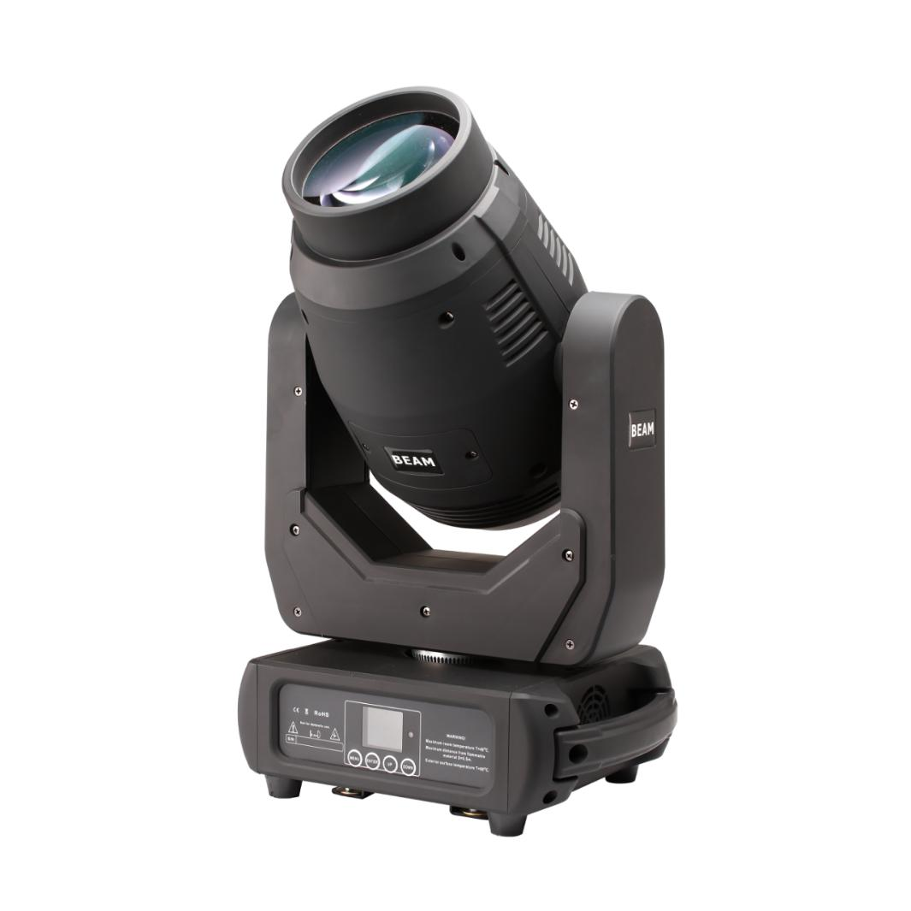

User Manual

1 SAFETY INSTRUCTIONS


This device has left the factory in perfect condition. In order to maintain this condition and to ensure a safe operation, it is absolutely necessary for the user to follow the safety instructions and warning notes written in this user manual.

If the device has been exposed to temperature changes due to environmental changes, do not switch it on immediately. The arising condensation could damage the device.
Leave the device switched off until it has reached room temperature.
This device falls under protection-class I. Therefore it is essential that the device be earthed.
The electric connection must carry out by qualified person.
The device shall only be used with rate voltage and frequency.
Make sure that the available voltage is not higher than stated at the end of this manual.
Make sure the power cord is never crimped or damaged by sharp edges. If this would be the case, replacement of the cable must be done by an authorized dealer.
Always disconnect from the mains, when the device is not in use or before cleaning it. Only handle the power cord by the plug. Never pull out the plug by tugging the power cord.
During initial start-up some smoke or smell or smell may arise. This is a normal process and does not necessary mean that the device is defective, it should decrease gradually.
Please don’t project the beam onto combustible substances.
Fixtures cannot be installed on combustible substances, keep more than 50cm distance with wall for smooth air flow, so there should be no shelter for fans and ventilation for heat radiation.
If the external flexible cable or cord of this luminaire is damaged, it shall be exclusively replaced by the manufacturer of his service agent or a similar qualified person in order to avoid a hazard.
2 UNPACKING
Thank you for choosing our LED 250W moving head light. For your own safety, please read this manual before installing the device. This manual covers the important information on installation and applications. Please install and operate the fixture with following instructions. Meanwhile, please keep this manual well for future needs.

The LED 250W is made of a new type of high temperature strength of engineering plastic and cast aluminum casing with nice outlook. The fixture is designed and manufactured strictly following CE standards, complying with international standard DMX512 protocol. It’s available independently controlled and linkable with each other for operation. And it is applicable for large-scale live performances, theater, studio, nightclubs and discos.
The 250W Moving head light which features high brightness and stability. Please carefully unpack it when you receive the fixture and check whether it is damaged during the transportation. And please check whether the following items are included inside the box:
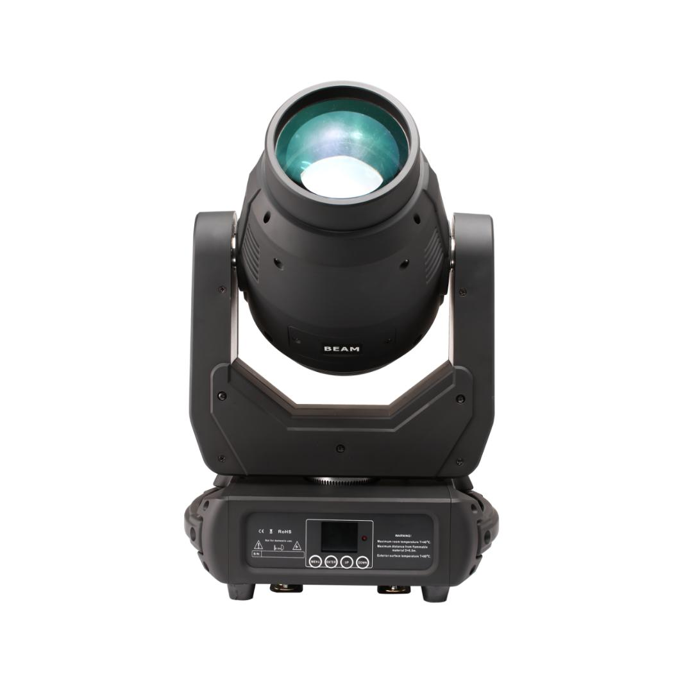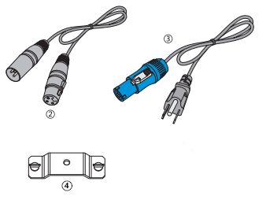

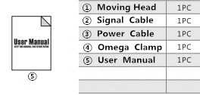
3 FEATURES & SPECIFICATIONS

Features
- 250W High Output White LED
- 50,000 hours lifespan and low power consumption
- beam angle 3°, focus function
- High light output,28600LUX@5M at White light
- Temperature protect function, when the internal Temperature is up to 40° then the fans begin to work, when the internal temperature is up to 70°and the brightness reduce half.
- Color Wheel: 7 colors +white, color fine tuning, rotation with variable direction and speed
- 1 Rotation Gobo Wheel: 7 gobos + white, wheel rotation and shake
- 1 Static Gobo Wheel: 8 gobos + white, wheel rotation and shake
- Prism: 16-facet Prism & Honeycomb Prism, bi-directional rotatable at variable speeds
- Frost effect
- High speed strobe effect with 1-25 flashers per second
- Internal program available
- 16/18 DMX Channels USITT DMX-512
- DMX 512, master-slave and sound activated controllable or auto operation
- Colorful LCD display
- Efficient low noise fan cooling system
- PowerCon IN/OUT
- 3-pin & 5-pin XLR connectors IN/OUT
- Two 1/4 turn fastening Omega Clamps
- IP 20 protection rating

Specifications
Input Voltage: AC90-260V 50/60Hz
Light Source: 250W High Output White LED
Control Signal: DMX 512, master-slave and sound activated or auto operation
Control Channel: 16/18 DMX Channels USITT DMX-512
Power Consumption: 350W
Dimensions: 320(L)*220(W)*480(H)mm
Packing size: 365(L)*290(W)*615(H)mm
Net Weight: 13.50kg,Gross Weight: 16.50kg

4 PHOTOMETRIC DATA

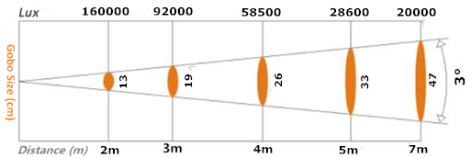

5 OPERATION INSTRUCTIONS
- The moving head is for spot effect for on-site decoration purpose.
- Don’t turn on the fixture if it’s been through severe temperature difference like after transportation because it might damage the light due to the environment changes. So make sure to operate the fixture until it is in normal temperature.
- This light should be keep away from strong shaking during any transportation or movement.
- Don’t pull up the light by only the head, or it might cause damages to the mechanical parts.
- Don’t expose the fixture in overheat, moisture or environment with too much dust when installing it. And don’t lay any power cables on the floor. Or it might cause electronics shock to the people.
- Make sure the installation place is in good safety condition before installing the fixture.
- Make sure to put the safety chain and check whether the screws are screwed properly when installing the fixture.
- Make sure the lens are in good condition. It’s recommended to replace the units if there are any damages or severe scratch.
- Make sure the fixture is operated by qualified personnel who know the fixture before using.
- Keep the original packages if any second shipments is needed.
- Don’t try to change the fixtures without any instruction by the manufacturer or the appointed repairing agencies.
- It is not in warranty range if there are any malfunctions from not following the user manual to operate or any illegal operation, like shock short circuit, electronic shock, lamp broke, etc.

6 INSTALLATIONS
Cautions: For added protection mount the fixtures in areas outside walking paths, seating areas, or in areas were the fixture might be reached by unauthorized personnel.

Before mounting the fixture to any surface, make sure that the installation area can hold a minimum point load of 10 items the device’s weight.

Fixture installation must always be secured with a secondary safety attachment, such as an appropriate safety cable.

Never stand directly below the device when mounting, removing, or servicing the fixture.

From a ceiling, or set on a flat level surface (see illustration below). Be sure this fixture is kept at least 0.5m (1.5ft) away from any flammable materials (decoration etc.).

Always use and install the supplied safety cable as a safety measure to prevent accidental damage and/or injury in the event the clamp fails.

Mounting points: Overhead mounting requires extensive experience, including amongst others calculating working load limits, a fine knowledge of the installation material being used, and periodic safety inspection of all installation material and the fixture. If you lack these qualifications, do not attempt the installation yourself. Improper installation can result in bodily injury.
Be sure to complete all rigging and installation procedures before connecting the main power cord to the appropriate wall outlet.

Clamp Mounting: The LED moving head provides a unique mounting bracket assembly that integrates the bottom of the base, and the safety cable rigging point in one unit (see the illustration below). When mounting this fixture to truss be sure to secure an appropriately rated clamp to the included omega bracket using a M10 screw fitted through the center hole of the “omega bracket”. As an added safety measure be sure to attached at least one properly rated safety cable to the fixture using on of the safety cable rigging point integrated in the base assembly.
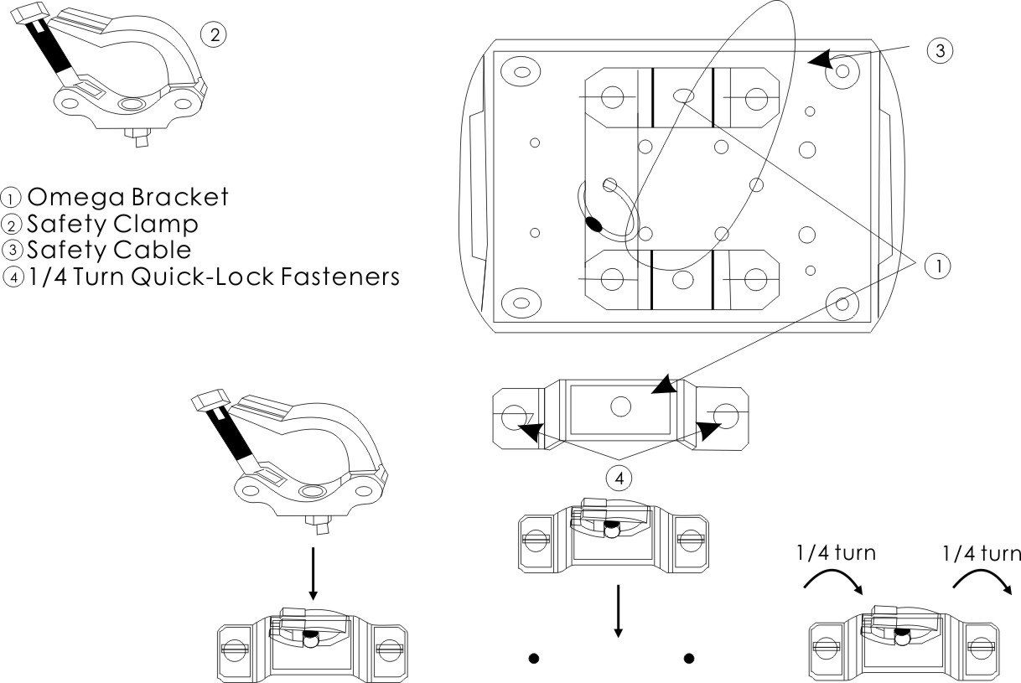

Regardless of the rigging option you choose for your LED moving head, always be sure to secure your fixture with a safety cable. The fixture providers a built-in rigging point for a safety cable on the hanging bracket as illustrated above. Be sure to only use the designated rigging point for the safety cable and never secure a safety cable to a carrying handle.

7 DMX-512 CONTROL CONNECTIONS
Connect the provided XLR cable to the female 3-pin XLR & 5-pin XLR output of your controller and the other side to the male 3-pin XLR & 5-pin XLR input of the moving head. You can chain multiple moving head together through serial linking. The cable needed should be two core, screened cable with XLR input and output connectors. Please refer to the diagram below.

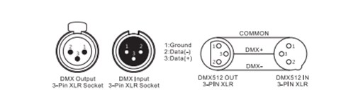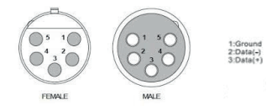

For installations where the DMX cable has to run a long distance or is in an electrically noisy enviroment, such as in a discotheque, it is recommended to use a DMX terminator. This helps in preventing corruption of the digital control signal by electrical noise. The DMX terminator is simply an XLR plug with a 120 Ω resistor connected between pins 2 and 3, which is then plugged into the output XLR socket of the last fixture in the chain. Please see illustrations below.
.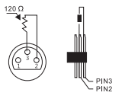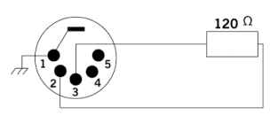

8 MENU OPERATIONS

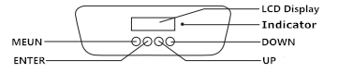

MENU

Address Set [Set Address Numbers]

[DMX]
Run Mode [AUTO] Auto 1- Auto 2
[SOUND]
[MANUAL] Manual Test Function and Operation

Pan reverse
Tilt reverse
Display
Screen Reverse
Setup [Advanced Setting] Channel (16/18CH Select)
Sensitivity (01-100)
Motor zero
Reset
Factory Set

Ver V1
System Information DMX Address
Temperature

9 DMX CHANNELS

18/16 channel mode sheet
18CH | 16CH | Function | Channel Value | Description
CH1 | CH1 | Pan | 0-255 | 0-540°
CH2 |  | Pan fine | 0-255 | Pan Fine
CH3 | CH2 | Tilt | 0-255 | 0-270°
CH4 |  | Tilt Fine | 0-255 | Tilt Fine
CH5 | CH3 | X, Y speed | 0-255 | From fast to slow
CH6 | CH4 | LED Dimmer | 0-255 | From dark to bright
CH7 | CH5 | LED Strobe | 0-7 | Turn on
CH7 | CH5 | LED Strobe | 8-250 | Strobe from slow to fast
CH7 | CH5 | LED Strobe | 251-255 | Turn on
CH8 | CH6 | 7 color + White | 0-15 | White Lighting
CH8 | CH6 | 7 color + White | 16-31 | Color 1
CH8 | CH6 | 7 color + White | 32-47 | Color 2
CH8 | CH6 | 7 color + White | 48-63 | Color 3
CH8 | CH6 | 7 color + White | 64-79 | Color 4
CH8 | CH6 | 7 color + White | 80-95 | Color 5
CH8 | CH6 | 7 color + White | 96-111 | Color 6
CH8 | CH6 | 7 color + White | 112-127 | Color 7
CH8 | CH6 | 7 color + White | 128-191 | CW from slow to fast
CH8 | CH6 | 7 color + White | 192-255 | CCW from slow to fast
CH9 | CH7 | Color effect | 0-10 | No function
CH9 | CH7 | Color effect | 11-209 | Color fine tuning
CH9 | CH7 | Color effect | 210-255 | Color shake from fast to slow
CH10 | CH8 | Static gobo wheel | 0-6 | open
CH10 | CH8 | Static gobo wheel | 7-13 | Gobo1
CH10 | CH8 | Static gobo wheel | 14-20 | Gobo2
CH10 | CH8 | Static gobo wheel | 21-27 | Gobo3
CH10 | CH8 | Static gobo wheel | 28-34 | Gobo4
CH10 | CH8 | Static gobo wheel | 35-41 | Gobo5
CH10 | CH8 | Static gobo wheel | 42-48 | Gobo6
CH10 | CH8 | Static gobo wheel | 49-55 | Gobo7
CH10 | CH8 | Static gobo wheel | 56-63 | Gobo 8
CH10 | CH8 | Static gobo wheel | 64-70 | Gobo 8 shake
CH10 | CH8 | Static gobo wheel | 71-77 | Gobo 7 shake
CH10 | CH8 | Static gobo wheel | 78-84 | Gobo 6 shake
CH10 | CH8 | Static gobo wheel | 85-91 | Gobo 5 shake
CH10 | CH8 | Static gobo wheel | 92-98 | Gobo 4 shake
CH10 | CH8 | Static gobo wheel | 99-105 | Gobo 3 shake
CH10 | CH8 | Static gobo wheel | 106-112 | Gobo 2 shake
CH10 | CH8 | Static gobo wheel | 113-119 | Gobo 1 shake
CH10 | CH8 | Static gobo wheel | 120-127 | open
CH10 | CH8 | Static gobo wheel | 128-191 | Gobo rotate CW from slow to fast
CH10 | CH8 | Static gobo wheel | 192-255 | Gobo rotate CCW from slow to fast
CH11 | CH9 | 7 rotation gobos +White | 0-15 | open
CH11 | CH9 | 7 rotation gobos +White | 16-31 | Gobo1
CH11 | CH9 | 7 rotation gobos +White | 32-47 | Gobo2
CH11 | CH9 | 7 rotation gobos +White | 48-63 | Gobo3
CH11 | CH9 | 7 rotation gobos +White | 64-79 | Gobo4
CH11 | CH9 | 7 rotation gobos +White | 80-95 | Gobo5
CH11 | CH9 | 7 rotation gobos +White | 96-111 | Gobo6
CH11 |  | 7 rotation gobos +White | 112-127 | Gobo7
CH11 |  | 7 rotation gobos +White | 128-191 | Gobo Rotate CW from slow to fast
CH11 |  | 7 rotation gobos +White | 192-255 | Gobo Rotate CCW from slow to fast
CH12 | CH10 | Gobo Rotation | 0-15 | open
CH12 | CH10 | Gobo Rotation | 16-95 | Gobo Fine 0-250
CH12 | CH10 | Gobo Rotation | 96-135 | Gobo Rotating 0-90
CH12 | CH10 | Gobo Rotation | 136-155 | Gobo Rotating 0-250
CH12 | CH10 | Gobo Rotation | 156-175 | Gobo Rotating 0-360
CH12 | CH10 | Gobo Rotation | 176-215 | Gobo self-rotating CW from slow to fast
CH12 | CH10 | Gobo Rotation | 216-255 | Gobo self-rotating CCW rotating from slow to fast
CH13 | CH11 | Focus | 0-255 | Gobo hazy to clear
CH14 | CH12 | Prism 1 | 0-63 | Open
CH14 | CH12 | Prism 1 | 64-255 | Prism In
CH15 | CH13 | Prism 2 | 0-63 | Open
CH15 | CH13 | Prism 2 | 64-255 | Prism In
CH16 | CH14 | Prism Rotation | 0-15 | open
CH16 | CH14 | Prism Rotation | 16-95 | Prism Fine 0-250
CH16 | CH14 | Prism Rotation | 96-135 | Prism Rotating 0-90
CH16 | CH14 | Prism Rotation | 136-155 | Prism Rotating 0-250
CH16 | CH14 | Prism Rotation | 156-175 | Prism Rotating 0-360
CH16 | CH14 | Prism Rotation | 176-215 | Prism self-rotating CW from slow to fast
CH16 | CH14 | Prism Rotation | 216-255 | Prism self-rotating CCW rotating from slow to fast
CH17 | CH15 | Frost | 0-4 | No function
CH17 | CH15 | Frost | 5-127 | Frost from shallow to deep
CH17 | CH15 | Frost | 128-191 | Frost shake
CH17 | CH15 | Frost | 192-255 | Frost effect
CH18 | CH16 | self-setting  Program | 0-7 | No action
CH18 | CH16 | self-setting  Program | 8-131 | Auto mode
CH18 | CH16 | self-setting  Program | 132-249 | Soud mode
CH18 | CH16 | self-setting  Program | 250-253 | Reset
CH18 | CH16 | self-setting  Program | 254-255 | No action

10 MAINTENANCE AND CLEANING
The following points have to be considered during the inspection:
- All screws for installing the devices or parts of the device have to be tightly connected and
must not be corroded.
- There must not be any deformations on the housing, color lenses, fixations and installation
spots (ceiling, suspension, trussing).
- Mechanically moved parts must not show any traces of wearing and must not rotate with
unbalances.
- The electric power supply cables must not show any damage, material fatigue or sediments.
Further instructions depending on the installation spot and usage have to be adhered by a skilled installer and any safety problems have to be removed.

In order to make the lights in good condition and extend the life time, we suggest a regular cleaning to the lights.
- Clean the inside and outside lens each week to avoid the weakness of the lights due to accumulation of dust.
- Clean the fan each week.
- A detailed electric check by approved electrical engineer each three month, make sure that the circuit contacts are in good condition, prevent the poor contact of circuit from overheating.
We recommend a frequent cleaning of the device. Please use a moist, lint-free cloth. Never use alcohol solvents.
There are no serviceable parts inside the device. Please refer to the instructions under “Installation instructions”.
Should you need any spare parts, please order genuine parts from your local dealer.

