USER MANUAL
LED ZOOM MOVING HEAD LIGHT
(19PCS RGBW 4IN1 DMX 512 15/23CH)

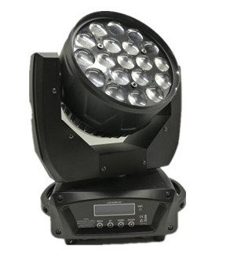



Please read over this manual before operation the light

CONTENTS

Contents…………………………………………………………….0
Important notice……………………………………………………..1
Attention …………………………………………………………..1
I. Product Illustration………………………………………………2
II .The installment of led moving head …………………………...2
III. The connection of control correspond wire……………………3
IV. Clean maintenance ……………………………………………4
V. Warning…………………………………………………………5
VI. Difficult processing……………………………………………5
VII. Equipment and appendix……………………………………...5
VIII. Technical paramet………………………………..6
IX. Functional description…………………………….6
X. Functional description…………………………...6
XI. Panel operation…………………………………...7
ＸII．DMX512channels……………………………….9

Important notice:
· In this instruction for use contains about the installment and the use aspect important information of the LED moving head. When installing and using, you need to look this usage instruction strictly.
· Before open the LED moving head and if you want to do the repair work, please make sure the power source is at the separation condition.
Attention:
Unceasingly carries on the product improvement about our company the policy, in this instruction booklet carries the data will have the possibility to be able to change in the future, when no longer separate notice change matters concerned. Our company retains when the product improvement changes the related specification the authority. This instruction booklet publisher cannot be responsible regarding this instruction booklet in information accuracy, also cannot the related consequence which causes regarding these information be responsible.
I. Product Illustration
Our product adopt semiconductor to produce radiation, LED as light origin. With advantage of operation quietly, less power waste, high brightness, gaily-colored, astigmatic, high longevity (60-100 thousands hours), non-calorific etc. Our product apply to use 3 kinds light as red, green, blue LED, synthesize turn colors under election, can create effect of auto gradual change/skip change color, frequent blinking. Can accept control by DMX512, real save power, no pollution green lighting tool.

II .The installment of led moving head
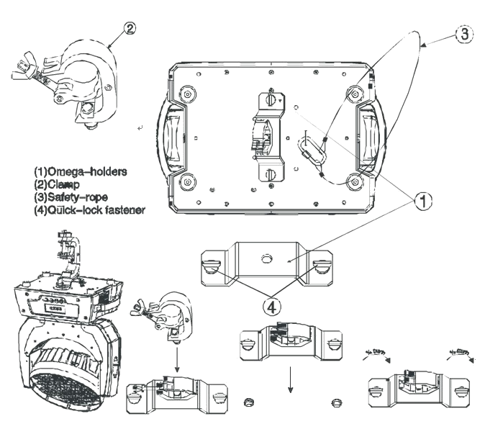
Use the four bolts with M8 size by the clip of the LED moving head to install it. Should guarantee the reliability of the install, this way is to prevent the LED moving head occur swings and skids when it’s working. The weight is about 8Kg of each LED moving head, before install, you should confirm the structure whether can support this weight of the LED moving head light. In order to guarantee the security, you also need to install a safety chain in the lamp body side handle.

Warning: Do not use the hand of the LED moving head to up and down or fix.
III. The connection of control correspond wire
The connection of controller between the led moving head lamp and respectively led moving head lamp should use the twin core shielded cable, and the diameter of each core at least be 0.3mm. After receives the DMX512 signal, the lamp of nearby the address switch condition will glisten. When it’s do not receive the DMX signal, the lamp will in extinguish condition, but if the signal lamp glisten continuously, the mean is the DMX signal is not be correct.
When installing, uses the DMX signal terminal is much better. It can avoid the digital control signal breached by the electrical noise. Generally speaking, the DMX terminal is Cannon plug coupling, it has a 120 ohm resistances between the 2 feet and 3 feet, it will connected on the last led moving head lamp’s digital plug of the led moving head lamp chain.
DMX+
3

1 2
3

2 1

33
DMX-

GND
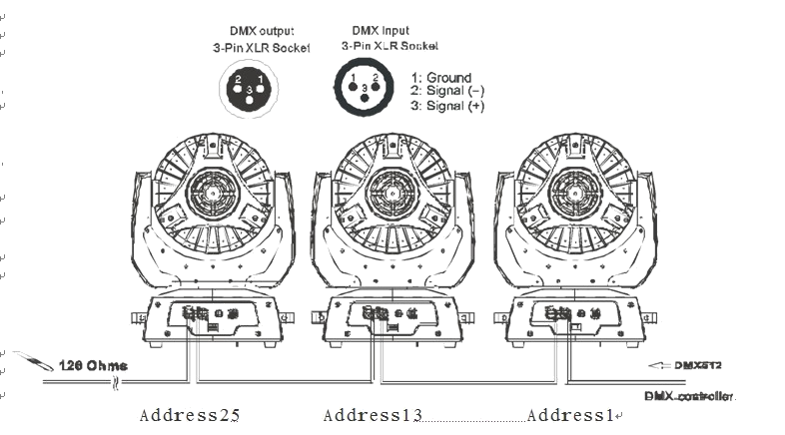

Connecting DMX512 digital signal,
Please using high quality screen line to connect it, for fear interfering.
GND
3

1 2
3

2 1

33
DIGITAL SIGNAL

IV. the connection of Power Cable
Use the provided plug to connect the main power to the projector paying attention to the voltage and frequency marked on the panel of the projector. It is recommended that each projector be supplied separately so that they may be individually switched on and off.

IMPORTANT
It is essential that each projector is correctly earthed and that electrical installation conforms to all relevant standards. Power consumption of this projector is 200VA.
The connection of Power cable between the led moving head lamp and respectively led moving head lamp should use the three core shielded cable,
Power cable joint (at most 4pcs) in each other, this is the Connector picture as below:
Important Notice:
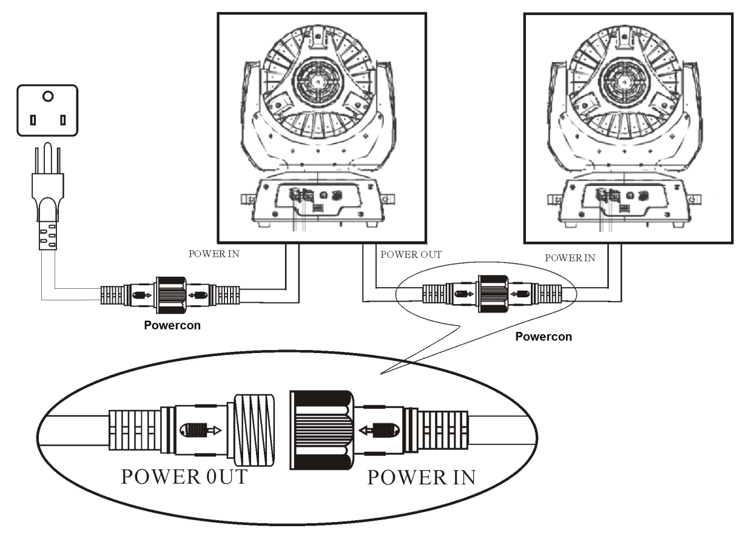
In order to avoid overloading the power supply, the power cable can only supply power for at most 4 light

V. Clean maintenance
In order to guarantee the LED moving head lamp can work better, you should keep the lamp in clean state. Suggests clean the lamp body and fan in each 15 days. For the PVS board, you need clean it on time. When you cleaning the PVC piece, please do not use any soluble cleanser,

VI. Warning
·Don’t disassemble and assemble the LED moving head.
·Please do not put the led moving head lamp in water or other any type’s liquids and the metal (IP20).
·Do not install the led moving head lamp in the humidity environment.
·Should maintain the minimum 0.5 meter distance between the led moving head lamp and other neighboring object surface.

VII. Difficult processing
Question | Answer
The LED moving head lamp can not start. | Inspects the fuse on the rear panel.
Although shines, but the LED moving head lamp can not accept the instruction of the controller. | Check the digital start address (sees  09th) and also check the connection situation of the communication control line the (to see 03rd).
LED moving head lamp only can work intermittently. | Inspect the power supply and voltage is whether normal.
Do not receive the DMX512 signal | Whether the signal lines do contact  good or broken
The light beam appears gloomily. | Inspect the optics part is whether clean.

Other maintains work should by the specialist which has the experience to carry on.

VII. Equipment and appendix
1 led moving head lamp 1PCE
2 the product of USER MANUAL 1PCE
3 Power source connected lines 1PCE
4 signal lines 1PCE

VIII. Technical parameters
Voltage / frequency: □90-130V/180V-240V/50-60Hz
Bulbs: 19*10W RGBW
Power:250 W
Control signal: DMX 512, in sets at the automatic procedure
Channel: 15/23CH, DMX512 channel control
Motion: level 540°, vertical 280°, horizontal and vertical uses the electronic replacement function
Color: 16.7 million kinds of colors changes
Adjusts the light: 0-100 electron adjusts the light, various colors may alone move also may mix the color tone
Strobe: 1-25/second high speed strobe, but single color mixes the color strobe
ZOOM angel: 105-30degree adjust

IX. Functional description
Ccontroller can control Moving head light’s three axes (PAN axis, TITL axis and Zoom axis), The light have RGBW 4IN1 Multi-Chip LED Lamp, and 3IN1 Tricolor RGB LED Moving Head, and 3color and 4 color, it have DMX mode (can be set DMX address), self-propelled mode (can be set up master-slave), Sound mode (can be set master / slave), The mode selection can be set by the panel or DMX 512 controller (this must be set to DMX mode); The light also have strobe / random frequency flash / strobe out fast and slow / slow forward faster strobe mode, the color jump / gradients

X. Functional Setting
- Fast operation settings
Controller can quickly set the light’s mode, the main interface, followed by "ESC" key to select DMX mode, Auto mode or sound-activated mode,
- In DMX mode: Press "UP" "DOWN" to optional DMX address;
- In the self-propelled mode: Press "UP" "DOWN" to choose master or slave;
- In the sound mode: Press "UP" "DOWN" to choose master or slave
I

XＩ. Panel operation

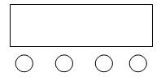
A． Manual
B． up
C． down
D． Enter
E. LCD Display

A B C D
Operating instructions: Pree A will show different function,Press B or C for changing function,Press D for enter.

Detailed function instruction:
- ◆ [DMX Address Set] for setting DMX address for light
- ◆ [Work Mode Set] For setting diffrent work mode, 3 mdoes workable ,they are DMX512,AUTO,SOUND Activated..When entering AUTO or SOUND,Light will send DMX signals automatically.
- ◆ [Invert PAN Set]
- ◆ [Invert TILT Set]
- ◆ [Channel Set] For chosing different Channel Mode, two kinds available,23 channels or 15 Channels.
- ◆ [Restore Factory Settings]
- ◆ [Reset] For resetting light

3．DMX channel function
23 Channels：
CH 1： | pan Adjustment | pan Adjustment | 0----255
CH 2： | Pan fine | Pan fine | 0----255
CH 3： | Tilt Adjustmen | Tilt Adjustment | 0----255
CH 4： | Tilt fine | Tilt fine | 0----255
CH 5： | pan/tilt moving speed | from fast to slow | 0----255
CH 6： | zoom | from near to far | 0----255
CH 7： | dimming | from duck to bright | 0----255
CH 8： | strobe | no function | 0----15
CH 8： | strobe | strobe from slow to fast | 16----255
CH 9： | LEDS color changing | no function | 0----15
CH 9： | LEDS color changing | LEDS color changing | 16----255
CH 10： | LEDS color changing speed | from fast to slow | 0----255
CH 11： | R1 | from dark to bright | 0----255
CH 12： | G1 | from dark to bright | 0----255
CH 13： | B1 | from dark to bright | 0----255
CH 14： | W1 | from dark to bright | 0----255
CH 15： | R2 | from dark to bright | 0----255
CH 16： | G2 | from dark to bright | 0----255
CH 17： | B2 | from dark to bright | 0----255
CH 18： | W2 | from dark to bright | 0----255
CH 19： | R3 | from dark to bright | 0----255
CH 20： | G3 | from dark to bright | 0----255
CH 21： | B3 | from dark to bright | 0----255
CH 22： | W3 | from dark to bright | 0----255
CH 23： | Reset | no function | 0----127
CH 23： | Reset | reset | 128----255
15 Channels：
CH 1： | pan Adjustment | pan Adjustment | 0----255
CH 2： | Pan fine | Pan fine | 0----255
CH 3： | Tilt Adjustment | Tilt Adjustment | 0----255
CH 4： | Tilt fine | Tilt fine | 0----255
CH 5： | pan/tilt movign speed | from fast to slow | 0----255
CH 6： | zoom | from near to far | 0----255
CH 7： | Dimming | from dark to brightness | 0----255
CH 8： | strobe | no function | 0----15
CH 8： | strobe | strobe from slow to fast | 16----255
CH 9： | LEDS color changing | no function | 0----15
CH 9： | LEDS color changing | LEDs’ Color changing | 16----255
CH 10： | LEDs color changing speed | from fast to slow | 0----255
CH 11： | R | from dark to bright | 0----255
CH 12： | G | from dark to bright | 0----255
CH 13： | B | from dark to bright | 0----255
CH 14： | W | from dark to bright | 0----255
CH 15： |  | nofunction | 0----127
CH 15： |  | reset | 128----255

Powered on LED Moving light,conect it to the DMX controller,after receving the DMX signal, the singal mark X disappeared,then light is under DMX controller’s control.
Under DMX Mode,connecting multiple lights together,but disconnect with DMX controller, all lights can work in the same step. When connected the first one to controller, the whole group can move in the same step under DMX controller’s control.

