LED Wall Washer

24X15W 6in1 LED

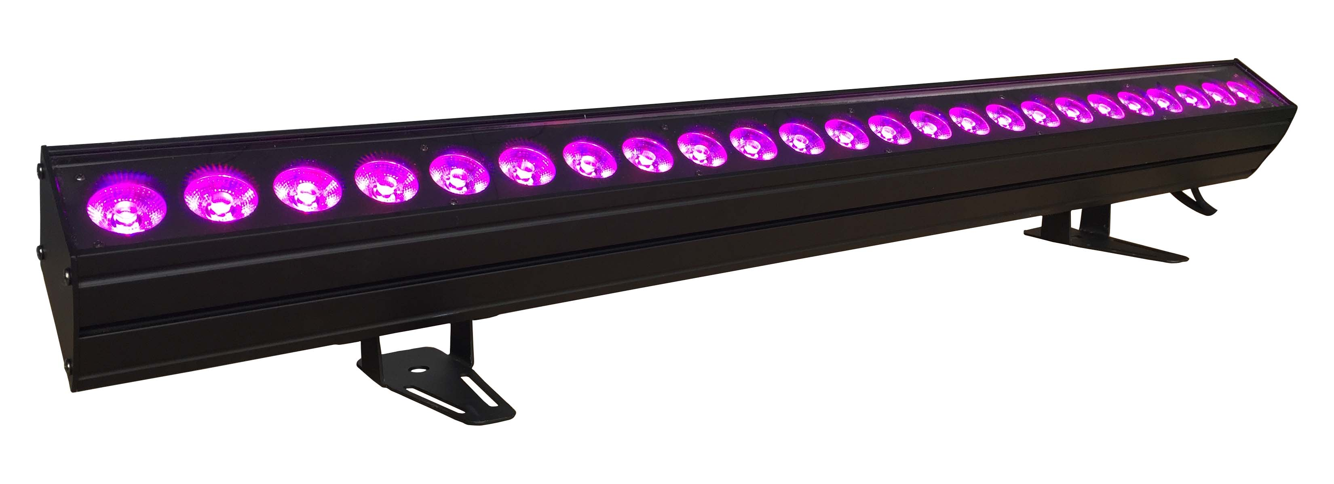

USER MANUAL

Thank you very much for choosing our product. For safety purpose, please read this manual carefully before your operation. This manual included installation and using information. Please install and operate it according to this manual.

Part 1 Product
  - Product introduction
This product is designed for indoor use. Suitable applications include wash or effect lighting for architectural, stage or nightclub applications. This product can also be installed for use in signage and advertising using the dynamic functions available with DMX512 control. Direct input of DMX512 signal allows the units to be controlled from any DMX512 controller. This product can be operated as a single unit or in multiple units for large applications.

1.2 Technical Specifications
Voltage: AC100-240V, 50/60Hz

Power: 360W
Light Source: 24X15W RGBWA+UV 6in1 ultra bright LED
Lifespan: around 50,000-100,000 hours
Control: DMX 512,6/10/12 channels
Control mode: DMX 512, Auto mode, Master/Slave, Sound active
Beam angle: 40 º
Net Weight：4.5Kg

1.3 Safety Warning

IMPORTANT:
ALWAYS READ THE USER MANUAL BEFORE OPERATION. PLEASE CONFIRM THAT THE POWER SUPPLY STATED ON THE PRODUCT IS THE SAME AS THE MAINS POWER SUPPLY IN YOUR AREA.
● This product must be installed by a qualified professional.
● Always operate the equipment as described in the user manual.
● A minimum distance of 0.5m must be maintained between the equipment and combustible surface.
● The product must always be placed in a well ventilated area.
● Always make sure that the equipment is installed securely.
● DO NOT stand close to the equipment and stare directly into the LED light source.
● Always disconnect the power supply before attempting and maintenance.
● Always make sure that the supporting structure is solid and can support the combined weight of the products.
● The earth wire must always be connected to the ground.
● Do not touch the power cables if your hands are wet.
ATTENTION:
● This product left the place of manufacture in perfect condition. In order to maintain this condition and for safe operation, the user must always follow the instructions and safety warnings described in this user manual.
● Avoid shaking or strong impacts to any part of the equipment.
● Make sure that all parts of the equipment are kept clean and free of dust.
● Always make sure that the power connections are connected correct and secure.
● If there is any malfunction of the equipment, contact your distributor immediately.
● When transferring the product, it is advisable to use the original packaging in which the product left the factory.
● Shields, lenses or ultraviolet screens shall be changed if they have become damaged to such an extent that their effectiveness is impaired.
● The lamp (LED) shall be changed if it has become damaged or thermally deformed.

PART 2 INSTALLATION

2.1 Mounting:
2.1-1 Hanging
The product can be mounted in a hanging position using the supporting bracket. The bracket should be secured to the mounting truss or structure using a standard mounting clamp. Please note that when hanging the unit a safety cable should also be used
.
2.1-2 Upright
The product can be mounted in an upright or sitting position using the supporting brackets.

NOTE:
The product can be mounted at any angle and in any position. It is possible to further adjust the angle of the product using the two adjustment knobs located on the side of the fixture.

2.2 Special construction for DMX connection.
☆ At last fixture, the DMX cable has to be terminated with a terminator to reduce signal errors. Solder a 120-ohm 1/4W resistor between pin 2(DMX-) and pin 3(DMX+) into a 3-pin XLR-plug and plug it in the DMX-output of the last fixture.
☆ If the controller is 5-pin output, it’s necessary to use an adaptor to transfer signal from 5-pin output to 3-pin XLR-plug or you can connect cables as following:
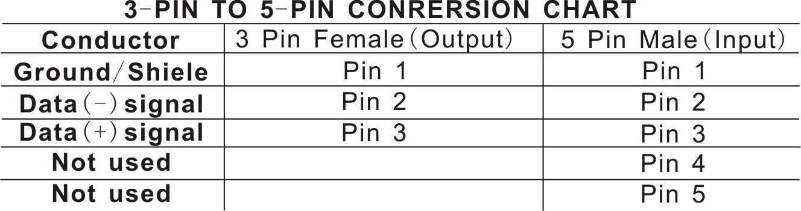

PART 3 Display Panel Operation

3.1 Display panel menu instruction
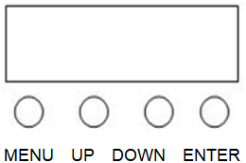
[MENU] menu selection or return to previous menu.
[UP] press [UP] through the menu list to increase/change the value of the current function.
[DOWN] press [DOWN] through the menu list to decrease/change the value of the current function.
[ENTER] confirm & quit out current function setting.

3.2 Display panel operation instruction
Main-Menu | Sub-Menu 1 | Sub-Menu 2 | Description
Addr | A.(001-512) |  | DMX address
CH-- | 10CH |  | 10CH
CH-- | 6CH |  | 6CH
CH-- | 12CH |  | 12CH
Au-- | Pr.01 | T.(00-99) | Auto 1
Au-- | Pr.02 | T.(00-99) | Auto 2
Au-- | ... |  | ...
Au-- | Pr.10 | T.(00-99) | Auto 10
Soun | Sou | So.（00-99） | Sound mode
Colo | r.(000-255) |  | Static Mode-Red(0-255)
Colo | g.(000-255) |  | Static Mode-Green (0-255)
Colo | b.(000-255) |  | Static Mode-Blue (0-255)
Colo | u.(000-255) |  | Static Mode-White(0-255)
Colo | A.(000-255) |  | Static Mode-Amber (0-255)
Colo | P.(000-255) |  | Static Mode-UV (0-255)
Colo | S.(0-20) |  | Static Mode-Strobe (0-20)
Di-- | nod.0 |  | Dimming delay, OFF
Di-- | nod.1 |  | Dimming delay, Fastest
Di-- | nod.2 |  | Dimming delay, Fast
Di-- | nod.3 |  | Dimming delay, Slow
Di-- | nod.4 |  | Dimming delay, Slowest
Temp | -25~100 |  | Display the real-time temperature of the lamp
rSET | no |  | No operation
rSET | yes |  | Parameter restore to factory value

3.3 DMX Channel instruction
10 Channels Mode
Channel | Value | Function | Description
1 | 0-255 | 0~100% | Dimmer
2 | 0-255 | 0~100% | Red
3 | 0-255 | 0~100% | Green
4 | 0-255 | 0~100% | Blue
5 | 0-255 | 0~100% | White
6 | 0-255 | 0~100% | Amber
7 | 0-255 | 0~100% | UV
8 | 0-13 | no function (0Hz) | Strobe
8 | 14-255 | 1~20Hz | Strobe
9 | 0-50 | no function | Function Selection
9 | 51-100 | Different Colors output (Channel 8 to choose color) | Function Selection
9 | 101-109 | Auto-1 | Function Selection
9 | 110-119 | Auto-2 | Function Selection
9 | ... | ... | Function Selection
9 | 190-199 | Auto-10 | Function Selection
9 | 200-255 | Sound mode | Function Selection
10 | 0-255 | Function/Speed | Slow to Fast (At the Colors output and sound choose the color)

6 Channels Mode
Channel | Value | Function | Description
1 | 0-255 | 0~100% | Red
2 | 0-255 | 0~100% | Green
3 | 0-255 | 0~100% | Blue
4 | 0-255 | 0~100% | White
5 | 0-255 | 0~100% | Amber
6 | 0-255 | 0~100% | UV

12 Channels Mode
Channel | Value | Function | Description
1 | 0-255 | 0~100% | Dimmer
2 | 0-255 | 0~100% | Red
3 | 0-255 | 0~100% | Green
4 | 0-255 | 0~100% | Blue
5 | 0-255 | 0~100% | White
6 | 0-255 | 0~100% | Amber
7 | 0-255 | 0~100% | UV
8 | 0-10 | no function | Pre-defined colors and color temperature
8 | 11-30 | Red 100%, Green0-100%, Blue 0% | Pre-defined colors and color temperature
8 | 31-50 | Red 100-0%, Green 100%, Blue 0% | Pre-defined colors and color temperature
8 | 51-70 | Red 0%, Green 100%, Blue 0-100% | Pre-defined colors and color temperature
8 | 71-90 | Red 0%, Green 100-0%, Blue 100% | Pre-defined colors and color temperature
8 | 91-110 | Red 0~100%, Green 0%, Blue 100% | Pre-defined colors and color temperature
8 | 111-130 | Red 100%, Green 0%, Blue 100-0% | Pre-defined colors and color temperature
8 | 131-150 | Red 100%, Green 0-100%, Blue 0-100% | Pre-defined colors and color temperature
8 | 151-170 | Red 100-0%, Green 100-0%, Blue 100% | Pre-defined colors and color temperature
8 | 171-200 | Red 100%, Green 100%, Blue 100% | Pre-defined colors and color temperature
8 | 201-205 | Colour temperature1 | Pre-defined colors and color temperature
8 | 206-210 | Colour temperature2 | Pre-defined colors and color temperature
8 | 211-215 | Colour temperature3 | Pre-defined colors and color temperature
8 | 216-220 | Colour temperature4 | Pre-defined colors and color temperature
8 | 221-225 | Colour temperature5 | Pre-defined colors and color temperature
8 | 226-230 | Colour temperature6 | Pre-defined colors and color temperature
8 | 231-235 | Colour temperature7 | Pre-defined colors and color temperature
8 | 236-240 | Colour temperature8 | Pre-defined colors and color temperature
8 | 241-245 | Colour temperature9 | Pre-defined colors and color temperature
8 | 246-250 | Colour temperature10 | Pre-defined colors and color temperature
8 | 251-255 | Colour temperature11 | Pre-defined colors and color temperature
9 | 0-13 | no function (0Hz) | Strobe
9 | 14-255 | 1~20Hz | Strobe
10 | 0-20 | no function | Auto Mode
10 | 21-30 | Auto1 | Auto Mode
10 | 31-40 | Auto2 | Auto Mode
10 | 41-50 | Auto3 | Auto Mode
10 | 51-60 | Auto4 | Auto Mode
10 | 61-70 | Auto5 | Auto Mode
10 | 71-80 | Auto6 | Auto Mode
10 | 81-90 | Auto7 | Auto Mode
10 | 91-100 | Auto8 | Auto Mode
10 | 101-110 | Auto9 | Auto Mode
10 | 111-120 | Auto10 | Auto Mode
10 | 121-255 | Sound mode | Auto Mode
11 | 0-255 | Auto Speed(Slow to Fast) | Auto Speed
12 | 0-5 | According to the menu setting | Dimming Speed Setting
12 | 6-55 | Dimming delay-OFF | Dimming Speed Setting
12 | 56-105 | Dimming delay, Fastest（DIM1） | Dimming Speed Setting
12 | 106-155 | Dimming delay, Fast（DIM2） | Dimming Speed Setting
12 | 156-205 | Dimming delay, Slow（DIM3） | Dimming Speed Setting
12 | 206-255 | Dimming delay, Slowest（DIM4） | Dimming Speed Setting

Part 4, Maintenance
The cleaning of internal must be carried out periodically to optimize light output. Cleaning frequency depends on the environment in which the fixture operates: damp, smoky or particularly dirty surrounding can cause greater accumulation of dirt on the fixture’s optics.
● Clean with soft cloth using normal glass cleaning fluid.
● Always dry the parts carefully.
● Clean the external optics at least every 20 days.
● Clean the internal optics at least every 30/60 days – Up to vary products.

Please ask professional technical to clean waterproof products and make sure the fixture will be reassembled well for waterproof.

