36 * 6in1 RGBWA UV LED moving head wash light

Instruction manual

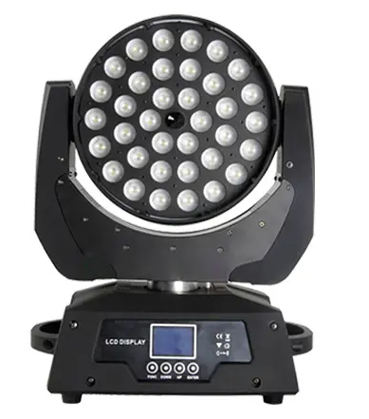

Thank you for using our products, is safe and effective use of this product to you, before you use this product, please read this instruction manual carefully complete. This manual contains: the performance of the product is and how to safely install, and use of important information, please properly keep, in order to use as a reference. When installing and using relevant instructions must be strictly observed.
Technical parameters:
Power supply: AC100V - 240 - v
Frequency: 50 hz - 60 hz
Total power: 520 w
Fuse: 7 a
Lamp source power: 432W
Color temperature: 8500 k
Average life: 2000H
Control signal: international standard DMX512
Appearance: high temperature resistant plastic + die alloy material
Light body color: black
Protection level: IP20
Features:
1. International standard control signal: DMX512
2. Number of channels: 16CH channel.
3. Number of motors:3 silent motors
4. The X axis rotate for 540 ℃, Y axis vertical rotation of 270 ℃, with automatic correction.
5. X, Y axis operation can be tempered and micro, the software band calibration localization function, high precision!
6. Dimming: 0-100% linear adjustment.
7. Strobe: stroboscopic speed (1-30 times/SEC), full linear dimming and variable stroking speed.
8. Intelligent dimming control (prolong the life of lamp source)
Connection of DMX512 signal:
The lamps and lanterns use DMX512 signal control model, the control signal of lamps and lanterns is a parallel relationship, the connection is more than one signal lamps and lanterns, it is best to use double core shielded cables. Connection, all through the lamps and lanterns of lamps and lanterns DMX signal on jack (context) INPUT (INPUT) and OUTPUT (OUTPUT) are connected, connect the line of lamps and lanterns 3 core XLRXL plug terminal must correspond to each other, when the connection signal lamps and lanterns, it is recommended to use DMX signal terminal. Can be avoided, due to electrical noise damage control signal, DMX signal terminal device is a XLR plugs connection between 2 and 3 feet a 120 ohm resistance of 1 w, and connect it on the last stage of lamps and lanterns of the OUTPUT (OUTPUT) jack.
The initial address code calculation method of lamps and lanterns:
The starting address code of the current light fixture is equal to (the initial address code of the last light fixture) + (the number of channels of the lamp) :
1. The initial address code of the first lamp is A001.
2: the basic channel number of the controller should be greater than or equal to the total number of use channels.
3. Note: when using any controller, each lamp should have its own initial address code. If the initial address code of the first light lamp is set A001, the number of the luminaire number is 16CH; The starting address of the second light fixture is set to A017. The starting address code of the third light fixture is set to A033; So on and so forth, (this setting also needs to be determined according to different control)

Description of installation of lamps and lanterns:
This luminaire can be placed horizontally, slanting and hanging upside down, and must pay attention to the installation method when hanging and hanging upside down.
Fixed installation: 1. The lamps and lanterns of lamps and lanterns before positioning, to ensure the stability of the installation site, when the reverse hanging installation, must ensure that the lamps and lanterns is not tumbled down on the supporting frame and handle with a safety rope through the racks and lamps and lanterns, assist hanging; In order to ensure safety. To prevent fall and slide of lamps and lanterns, lamps and lanterns in the installation and debugging, the ban pedestrians pass, regularly check whether the safety rope appear wear away, whether hook screws loosen, if because hanging installation is not stable, lead to fall all consequences arising from the lamps and lanterns manufacturer does not assume any responsibility.
unnecessary breakdowns and injuries.
1. Non-professional personnel, do not remove the fittings of lamps and lanterns without permission.
2. AC power supply: check whether the local power supply meets the rated voltage requirement.
3. The lamps and lanterns is according to the type of electric shock protection design, lamps and lanterns should be used with sufficient power supply system grounding, and lamps and lanterns of the ground wire must be connected to the ground of the power supply system. Do not use insulation damaged power cord, with no don't take the power cord overlap on the other wire.
4. When installation location and lamps and lanterns, any point on the surface of lamps and lanterns and any easy to burn the explosive keep minimum distance of 10 meters, 2.5 meters from irradiation distance, please don't directly installed in the lamp to burn the material surface.
5. Ambient temperature of lamps: (-10 degrees + 40 degrees), the highest temperature of the lamp surface is 80 degrees, the lamps and lanterns should be kept away from the liquid material and wet environment.
6. Make sure the lamps are well grounded before using the lamps, and do not install and remove any parts of the lamps.
7. When installing the lamps, the fixed screws must be fastened and equipped with safety cables and checked periodically.
8. In the process of use, if the lamp is abnormal, the lamps should be stopped in time.
9. The rotating part of the lamp and the pasting accessories must be checked regularly and loosened, and the shaking should be strengthened in time to prevent accidents.
10. The lamps and lanterns USES is strong wind cooling, accumulate dirt easily, must per month on a clean, especially the cooling tuyere, otherwise you'll be in a dust jam, lead to bad heat dissipation, the lamps and lanterns is abnormal.

Maintenance and insurance:
Shutdown operation: before each off, the light source in advance to shut down. Let the cooling fan inside heat when using the lamps and lanterns, fast discharge, it can prolong the parts inside the lamps and lanterns, especially the service life of the light source! In order to ensure the lamps and lanterns can steadily run, should keep it clean, open lamps and lanterns for repair or before maintenance work that make sure the power is disconnected, it is important to keep the lamps and lanterns is clean, clean, clean, please regularly not only keep the maximum brightness output, but also can prolong the service life of lamps and lanterns, it is recommended to use high quality glass cleaner and use a clean soft cloth to clean, use the vacuum cleaner at least half an year is clean inside the lamp.

After-sales service
Attention! When the lamps and lanterns are out of the factory, they are strictly inspected and the packing is in good condition. Please follow the instructions.
The fault of the machine is not covered by the machine.
1. The company will provide technical advice to customers throughout the lifetime.
If the product fails, please show the warranty card and fill in the relevant content
We provide timely feedback to the products, so that we can improve the product in the first place.
2. Besides the luminaires, the following accessories can also be selected:
Attachment: power line: 1, signal line: 1, instruction: 1 copy

The choose and buy
Lamp source (according to customer requirements)
Light hook safety cable (customer selection)

1. Interface description:
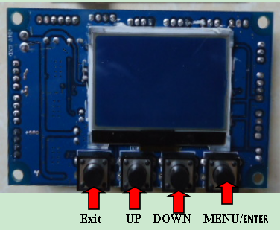
The main interface

3.2. setting interface
options | instructions
System Settings | DMX address | 001-512 from machine status: receive DMX signal from console or host  Press "ok" to enter edit status. At this time, select the hundreds place, press "up" and "down".  The key changes the address code. Click "ok" to select the ten editors again. Click again  "Determine" the key to select the individual edit. Press the exit edit status again.
System Settings | The encoder | Start using encoder (optical coupling) to judge the missing step and automatically correct the position  Close the correct position without encoder (decoupling)
System Settings | X inversion | Closed/open
System Settings | Y inversion | Closed/open
The operation mode | The operation mode | DMX/voice control/automatic
The operation mode | The operation mode | DMX/voice control/automatic
The operation mode | Channel selection | 16CH
Display Settings | Language selection | Chinese, English
 | Pour screen Settings | Shut down
 | Screen saver Settings | open
The factory set up | The X axis calibration | 128
The factory set up | The Y axis calibration | 128
The factory set up | Focusing calibration | 128
The factory set up | red | 220
The factory set up | green | 220
The factory set up | blue | 220
The factory set up | white | 220
The factory set up | yellow | 220
The factory set up | purple | 220
The factory set up | Logo to choose | 000
3.6. Inverted interface
Press "ok" button and the interface can be inverted 180 degrees.
3.7. English interface
Press "ok" and switch to English mode.
3.8. Chinese interface
Press "ok" to switch to Chinese mode.
Channel mode：
channel
1 | Pan
2 | Tilt
3 | P/T Speed
4 | Dimmer
5 | Red (R) group 1
6 | Green (G) group 1
7 | Blue (B) group 1
8 | White (W) group 1
9 | Yellow(y) group 1
10 | purple(p) group 1
11 | Shutter
12 | Focus
13 | Function mode
14 | Functional mode speed
15 | Pan Fine
16 | Tilt Fine
17 | Rest(255)

