Moving head RGB 6 head Beam Bar Light
User Manual

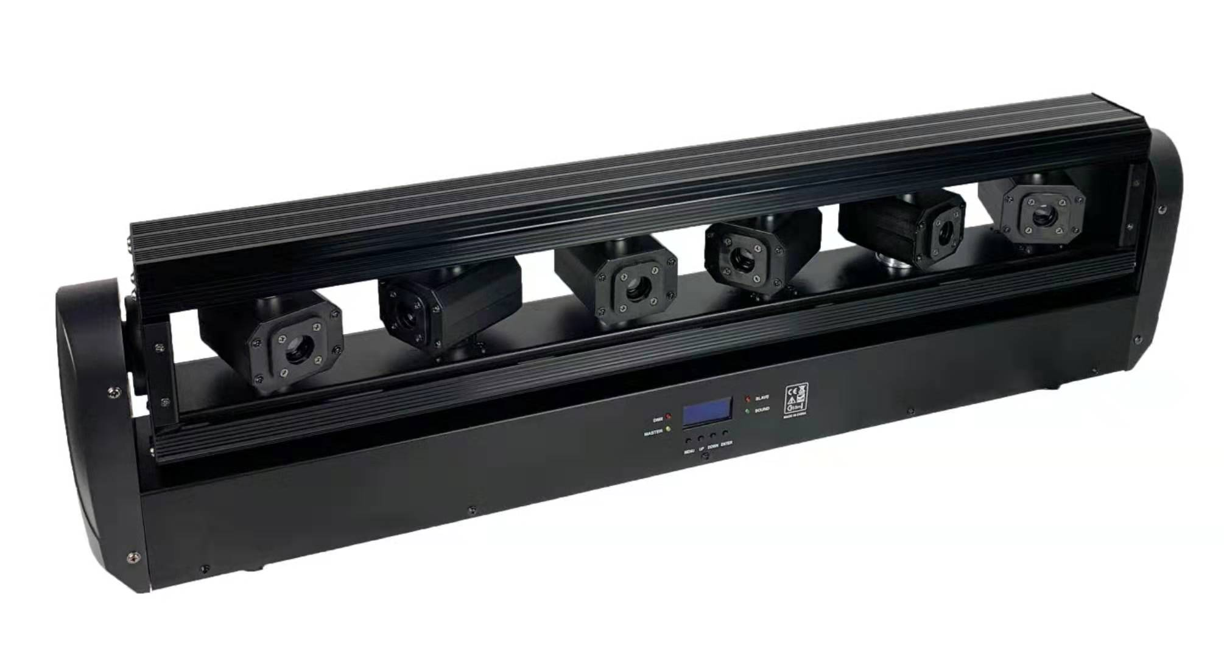

Note: This manual contains important information on how to install and use it safely. Please read it carefully and install and operate as required. At the same time, please keep this manual properly for emergencies

Upon receipt of the product, please be careful to take place; check if the product is damaged by transportation may cause; and inspect all cartons with the following accessories:
1. AK- full color animation laser light one. 2.PIN power line 3. One User Manual

Note :
1. strict accordance with the instructions of the operating procedures of this operation, do not disassemble lamps. Failure to professionals maintenance.
2. This product is only suitable for indoor use, and to ensure that water, moisture, shock, do not use in dusty environments.
3. Based on the characteristics of semiconductor lasers, requires a stable working environment at a temperature of 15 ~ 30 ℃, continuous work after two childhood,
Turn off the lamps 10 minutes re-use of lasers to cool completely, otherwise it will shorten the life of the laser.
4. fixed installation, avoid strong vibration or impact lighting. Do not use jitter. Between the lamp and the object to be irradiated
Should be more than 1 meter intervals.
5. prevent foreign matter into the body, so as not to cause a malfunction.
6. When the unit is operating, ensure unobstructed ventilation exhaust passage.
7. Before electricity, pay attention to the plug is inserted firmly, make sure the power is properly grounded to prevent electric shock.
8. Do not frequent switching, to avoid affecting the laser lamp life, and try to avoid prolonged open.
9. stickers shall repair torn, otherwise the company will not be responsible for repair.
10. Avoid using afar observe the laser source device, this may increase the danger.
11. When your hands are wet, do not touch the product, do not pull on the cord.
12. The interior lighting is no user-serviceable parts, do not open the lamp.
13. When the semiconductor laser brightness decreased or other damage, please contact your dealer.
14. transport again, please note that shock is best to use the original packaging.

Warning:
1. Before performing any installation and maintenance work, make sure that the power cut off.
2. This lamp laser danger rating for Class III B, to observe directly in the beam is dangerous, the minimum irradiation distance 13cm,
The maximum exposure time of ten seconds or less safe.
3. Please keep a distance between the lamp and combustible materials 0.5 meters.
4. The lamp on the power requirements of 220/110 ± 10% V, if outside this range, use the regulator device, otherwise it will seriously affect the laser life.
-1-
Installation instruction:
1. Before installing, make sure the voltage matches the power supply voltage and lamps you use the logo.
2. The need for a professional installation, safe and reliable fixture fixed and adjusted to the appropriate irradiation angle.
3. When installing the device, make sure at least 0.5 meters of no extreme explosive flammable items (ornaments, etc.), to ensure that lighting and wall spaced 15 cm or more.
4. Make sure the ventilation fan and exhaust passages no other equipment or decorative material clogging.
5. For security reasons, please use lamps can withstand 10 times the weight of the insurance rope assisted lifting.
6. For safety reasons, the earth grounding is very important.
Maintenance
Regular maintenance of the product. Long-term use of the lamp, the light at the mouth of the lens surface will absorb dust, reducing the output power of the laser, use a lens cleaning paper or with a cotton swab dipped in alcohol to clean the lenses to optimize light output, careful not to wipe the lens with a damp cloth or other chemical solvents, cleaning frequency depends on the frequency of operation of the lamp and around the use of the environment, it is recommended to clean once every 20 days. Wipe with a clean towel chassis surface periodically to check and clean the fan opening.
Statement
This product is fully rigorous testing at the factory, good performance, packaging integrity. All users should strictly comply with the above stated warnings and operating instructions for any misuse due to damage caused to the product are not within the scope of our warranty, failures and problems of neglect resulting operating manual nor the dealer responsible within the scope of any operation resulting laser damage to the human body, the company responsible.

Menu function:
DMX Address A001---A512 Address Code
Channel Mode 11CH, 26CH, 38CH channel selection
Show Mode SOUND AUTO, effect selection
Slave Mode MASTER, SLAVE, main and auxiliary machine selection
Black Out YES, NO Standby mode
Sound State ON, OFF voice switch
Sound Sense sound sensitivity (0 off, 100 most sensitive)
Pan Inverse YES, NO level reverse
Tilt1 Inverse YES, NO vertical reverse
Tilt2 Inverse YES, NO vertical reverse
Tilt3 Inverse YES, NO vertical reverse
Tilt4 Inverse YES, NO vertical reverse
Tilt5 Inverse YES, NO vertical reverse
Tilt6 Inverse YES, NO vertical reverse
Back Light ON, OFF backlight switch
Auto Test Auto Test
Firmware Version V104 software version number
Defaults YES, NO Restore factory settings
System Reset YES, NO Machine reset

DMX channel function
11CH:
1.X-axis motor stroke: 0---255 0°-------360° positioning
2.X-axis motor speed: 0---255 speed from fast to slow
3.Y1---Y6 axis motor stroke: 0 no function 1---255 0°-------360° positioning
4.Y-axis motor speed: 0---255 speed from fast to slow
5. Self-propelled: 0---55 No function
56---80 Self-propelled effect 1 (XY uncontrollable)
81---105 Self-propelled effect 2 (XY uncontrollable)
106---130 Self-propelled effect 3 (XY uncontrollable)
131---155 Self-propelled effect 4 (XY uncontrollable)
156---180 Self-propelled effect 5 (XY uncontrollable)
181---205 voice control (XY uncontrollable)
206---230 Self-propelled effect 6 (XY uncontrollable)
231---255 voice control (XY uncontrollable)
6. Self-propelled speed: self-propelled speed and voice-activated sensitivity
7. Laser total dimming: 0---255 0---100% total dimming
8. Strobe: 0---9 No strobe 10---255 Strobe speed from slow to fast
9. Laser effect: 0---15 No function
16---27 Effect 1 28---39 Effect 2
40---51 effect 3 52---63 effect 4
64---75 effect 5 76---87 effect 6
88---99 effect 7 100---111 effect 8
112---123 Effect 9 124---135 Effect 10
136---147 effect 11 148---159 effect 12
160---171 effect 13 172---183 effect 14
184---195 effect 15 196---207 effect 16
208---219 effect 17 220---231 effect 18
232---243 effect 19 244---255 effect 20
10. Laser effect speed: 0---255 self-propelled speed from fast to slow
11. Reset: 0----249 No function, 250---255 machine reset (value stays for 5 seconds)
26CH:
1.X-axis motor stroke: 0---255 0°-------360° positioning
2.X-axis motor speed: 0---255 speed from fast to slow
3.Y1 axis motor stroke: 0---255 0°-------360° positioning
4.Y2 axis motor stroke: 0---255 0°-------360° positioning
5.Y3 axis motor stroke: 0---255 0°-------360° positioning
6.Y4 axis motor stroke: 0---255 0°-------360° positioning
7.Y5 axis motor stroke: 0---255 0°-------360° positioning
8.Y6 axis motor stroke: 0---255 0°-------360° positioning
9.Y1---Y6 axis motor stroke: 0 no function 1---255 0°-------360° positioning
10.Y-axis motor speed: 0---255 speed from fast to slow
11. Self-propelled: 0---55 No function
56---80 Self-propelled effect 1 (XY uncontrollable)
81---105 Self-propelled effect 2 (XY uncontrollable)
106---130 Self-propelled effect 3 (XY uncontrollable)
131---155 Self-propelled effect 4 (XY uncontrollable)
156---180 Self-propelled effect 5 (XY uncontrollable)
181---205 voice control (XY uncontrollable)
206---230 Self-propelled effect 6 (XY uncontrollable)
231---255 voice control (XY uncontrollable)
12. Self-propelled speed: self-propelled speed and voice-activated sensitivity
13. Laser total dimming: 0---255 0---100% total dimming
14. Strobe: 0---9 No strobe 10---255 strobe speed from slow to fast
15. Red laser 1--6 dimming: 0 no function 1---255 1---100% dimming
16. Green laser 1--6 dimming: 0 no function 1---255 1---100% dimming
17. Blue laser 1--6 dimming: 0 no function 1---255 1---100% dimming
18. The first group of RGB lasers: 0---31 off 32---63 red
64---95 Green 96---127 Blue
128---159 yellow 160---191 purple
192---223 cyan 224---255 full bright
19. The second group of RGB lasers: 0---31 off 32---63 red
64---95 Green 96---127 Blue
128---159 yellow 160---191 purple
192---223 cyan 224---255 full bright
20. The third group of RGB lasers: 0---31 off 32---63 red
64---95 Green 96---127 Blue
128---159 yellow 160---191 purple
192---223 cyan 224---255 full bright
21. The fourth group of RGB lasers: 0---31 off 32---63 red
64---95 Green 96---127 Blue
128---159 yellow 160---191 purple
192---223 cyan 224---255 full bright
22. The fifth group of RGB lasers: 0---31 off 32---63 red
64---95 Green 96---127 Blue
128---159 yellow 160---191 purple
192---223 cyan 224---255 full bright
23. The sixth group of RGB lasers: 0---31 off 32---63 red
64---95 Green 96---127 Blue
128---159 yellow 160---191 purple
192---223 cyan 224---255 full bright
24. Laser effect: 0---15 No function
16---27 Effect 1 28---39 Effect 2
40---51 effect 3 52---63 effect 4
64---75 effect 5 76---87 effect 6
88---99 effect 7 100---111 effect 8
112---123 Effect 9 124---135 Effect 10
136---147 effect 11 148---159 effect 12
160---171 effect 13 172---183 effect 14
184---195 effect 15 196---207 effect 16
208---219 effect 17 220---231 effect 18
232---243 effect 19 244---255 effect 20
25. Laser effect speed: 0---255 self-propelled speed from fast to slow
26. Reset: 0----249 No function, 250---255 machine reset (value stays for 5 seconds)

38CH:
1.X-axis motor stroke: 0---255 0°-------360° positioning
2.X-axis motor speed: 0---255 speed from fast to slow
3.Y1 axis motor stroke: 0---255 0°-------360° positioning
4.Y2 axis motor stroke: 0---255 0°-------360° positioning
5.Y3 axis motor stroke: 0---255 0°-------360° positioning
6.Y4 axis motor stroke: 0---255 0°-------360° positioning
7.Y5 axis motor stroke: 0---255 0°-------360° positioning
8.Y6 axis motor stroke: 0---255 0°-------360° positioning
9.Y1---Y6 axis motor stroke: 0 no function 1---255 0°-------360° positioning
10.Y-axis motor speed: 0---255 speed from fast to slow
11. Self-propelled: 0---55 No function
56---80 Self-propelled effect 1 (XY uncontrollable)
81---105 Self-propelled effect 2 (XY uncontrollable)
106---130 Self-propelled effect 3 (XY uncontrollable)
131---155 Self-propelled effect 4 (XY uncontrollable)
156---180 Self-propelled effect 5 (XY uncontrollable)
181---205 voice control (XY uncontrollable)
206---230 Self-propelled effect 6 (XY uncontrollable)
231---255 voice control (XY uncontrollable)
12. Self-propelled speed: self-propelled speed and voice-activated sensitivity
13. Laser total dimming: 0---255 0---100% total dimming
14. Strobe: 0---9 No strobe 10---255 strobe speed from slow to fast
15. Red laser 1--6 dimming: 0 no function 1---255 1---100% dimming
16. Green laser 1--6 dimming: 0 no function 1---255 1---100% dimming
17. Blue laser 1--6 dimming: 0 no function 1---255 1---100% dimming
18. The first group of red lasers: 0---255 0---100% dimming
19. The first group of green lasers: 0---255 0---100% dimming
20. The first group of blue lasers: 0---255 0---100% dimming
21. The second group of red lasers: 0---255 0---100% dimming
22. The second group of green lasers: 0---255 0---100% dimming
23. The second group of blue laser: 0---255 0---100% dimming
24. The third group of red lasers: 0---255 0---100% dimming
25. The third group of green lasers: 0---255 0---100% dimming
26. The third group of blue laser: 0---255 0---100% dimming
27. The fourth group of red lasers: 0---255 0---100% dimming
28. The fourth group of green lasers: 0---255 0---100% dimming
29. The fourth group of blue laser: 0---255 0---100% dimming
30. The fifth group of red laser: 0---255 0---100% dimming
31. The fifth group of green lasers: 0---255 0---100% dimming
32. The fifth group of blue laser: 0---255 0---100% dimming
33. The sixth group of red laser: 0---255 0---100% dimming
34. The sixth group of green lasers: 0---255 0---100% dimming
35. The sixth group of blue laser: 0---255 0---100% dimming
36. Laser effect: 0---15 No function
16---27 Effect 1 28---39 Effect 2
40---51 effect 3 52---63 effect 4
64---75 effect 5 76---87 effect 6
88---99 effect 7 100---111 effect 8
112---123 Effect 9 124---135 Effect 10
136---147 effect 11 148---159 effect 12
160---171 effect 13 172---183 effect 14
184---195 effect 15 196---207 effect 16
208---219 effect 17 220---231 effect 18
232---243 effect 19 244---255 effect 20
37. Laser effect speed: 0---255 self-propelled speed from fast to slow
38. Reset: 0----249 No function, 250---255 machine reset (value stays for 5 seconds)

Motor fine-tuning function operation:
Press the menu button “MENU” to enter the menu, press the “ENTER” button for at least 3 seconds, the menu interface displays “Pan Offerset”, press the OK button at the value -127----127 Adjust the motor position internally, and then press the OK key to save the trimming value you set.
Maintenance:
1. Eliminate the artificial laying of dust, dirt and fume into the lamp body as far as possible, and keep the laser performer clean as possible in the environment.
2. Please use professional glass cleaner regularly every month and wash the mirror with flannel cloth to ensure maximum laser brightness output and prolong the service life of the light source.
Warranty Notes
Warranty Period: This product is guaranteed for one year from the date of purchase.
Warranty clauses:
1. Faults arising from the normal use of the product during the warranty period may be repaired free of charge by presenting the warranty card and purchase ticket (photocopy) according to the content of the warranty clause.
2. During the warranty period, the following conditions will be implemented to provide paid maintenance services.
(1) Failure to produce a valid warranty card.
(2) There are omissions, alterations and no sales names on the warranty card.
(3) Faults and damages caused by irresistibility.
(4) Faults and damages caused in transportation and handling.
(5) Failure or damage caused by failure to follow the instructions.
(6) Failure or damage caused by disassembling, repairing or refitting products without authorization of the manufacturer or non-professional personnel. Failure caused by using control series not approved by our factory or matched by our factory.
(7) Consumables - Our factory reserves the right of final interpretation of this warranty clause.

Product warranty card
Product Name | Product Model

End users
Unit name:
Address:
Contacts:
Telephone:

Date of manufacture | User Purchase Date

Retailer
Contacts:
Telephone: Seal：
Note: The blanks mentioned above must be filled out and stamped truthfully by the end-users and sellers, otherwise they are not guaranteed.

