Thank you for buying our LED products. In order to better use and operate this product, please read this instruction carefully before using it. LED lamps adopt high efficiency and energy saving LED light source, with low power consumption, low temperature, long service life,(can reach about 60,000 hours in general), overcome the shortcomings of traditional light source, such as high power consumption, short service life, is the ideal products for stage lighting and various effects decoration. For your safety and better use of this product, please carefully read the instructions before use, and strictly follow the rules to avoid misuse of the safety or damage to the light fixtures.
Menu:
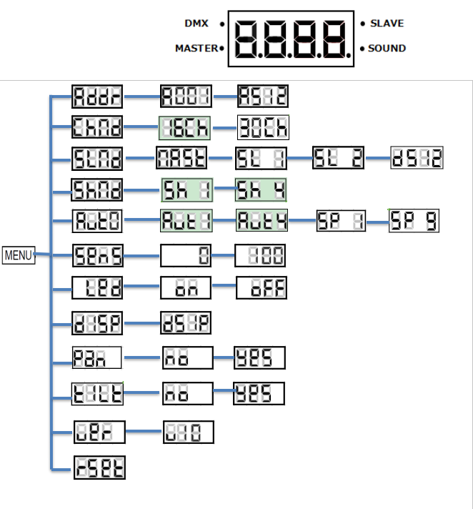

15 Channels model:
When using 13 channel:14 channel 0-255 is on,15 channel 0-255 for speed regulation.
When using 14 channel:15 channel 0-255 for speed regulation.
Channel description:
15-ch Mode | Function | Value
1 | Pan | 000-255 X
2 | Pan Fine | 000-255
3 | Tilt | 000-255 Y
4 | Tilt Fine | 000-255
5 | Pan&Tilt Speed | 000-255 X.Y axis running speed from fast to slow
6 | Total Dimmer | 000-255 Dimming 0 ~ 100%
7 | Light beam Strobe | 000-008 No Function
7 | Light beam Strobe | 009-250 Strobe slow to fast
7 | Light beam Strobe | 251-255 Turn on the light
8 | Red Dimming | 000-255 Dimming 0 ~ 100%
9 | Green Dimming | 000-255 Dimming 0 ~ 100%
10 | Blue Dimming | 000-255 Dimming 0 ~ 100%
11 | White Dimming | 000-255 Dimming 0 ~ 100%
12 | Built-in effect | 0-255
13 | Monochromatic selection | 000-010 No Function
13 | Monochromatic selection | 11-255 Monochromatic selection
14 | Special | 000-199 No Function
14 | Special | 200-209 Reset
14 | Special | 210-239 No Function
14 | Special | 240-255 Sound Action
15 | LED lights bring | 0-255

13-ch Mode | Function | Value
1 | Pan | 000-255 X 0° ~ 540°
2 | Tilt | 000-255 Y
3 | Pan&Tilt Speed | 000-255 X.Y axis running speed from fast to slow
4 | Total Dimmer | 000-255 Dimming 0 ~ 100%
5 | Light beam Strobe | 000-008 No Function 009-250 Strobe slow to fast 251-255 Turn on the light
6 | Red Dimming | 000-255 Dimming 0 ~ 100%
7 | Green Dimming | 000-255 Dimming 0 ~ 100%
8 | Blue Dimming | 000-255 Dimming 0 ~ 100%
9 | White Dimming | 000-255 Dimming 0 ~ 100%
10 | Built-in effect | 000-255
11 | Monochromatic selection | 000-255 Dimmer 0 ~ 100%
12 | Special | 000-255 Dimmer 0 ~ 100%
13 | LED lights bring | 000-008 No Function
13 | LED lights bring | 009-255 Strobe slow to fast

Technical ：
Voltage: AC90-240V, 50/60HZ
Light source: 1* 60W red, green, blue, white, four in one lamp bead
12*5050 four in one light belt;
Access: 10/13;
Control mode: DMX512, master, slave, voice control;
X axis: 540 ° Y axis: 270 °
Location: KTV, Box, Bar

LED Stage Lighting Equipment User Manual

60W Beam moving head light RGBW 4 IN 1 LED

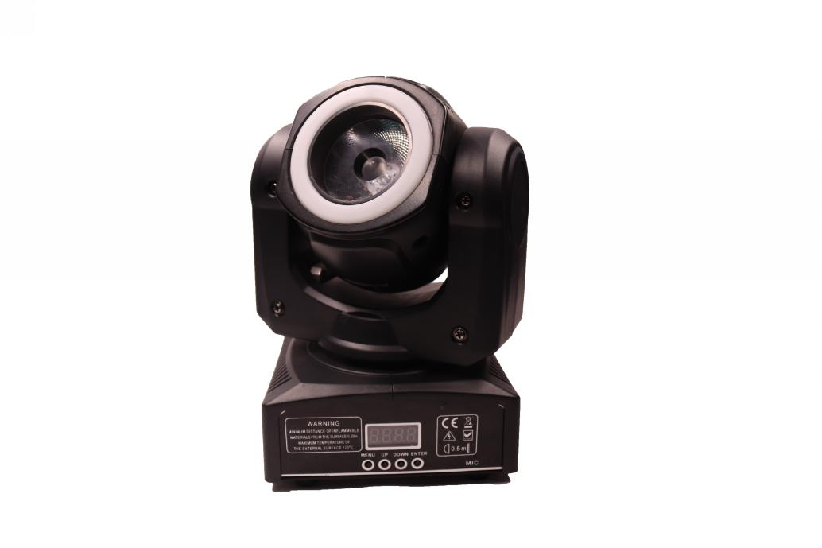

Please read the instructions carefully before using

