60W BEAM MOVING HEAD

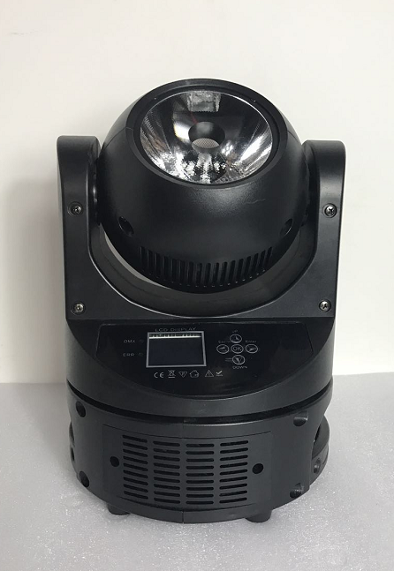
1. DMX512 Address Set (DMX Address setting)
This option is used to set the DMX address, press "Enter" button to Enter the Settings, press the "UP" key to address increasing number, against the "DOWN" key to address number, choose the right address after press "Enter" save the exit.
2. Run Mode (setting of lamp body working Mode)
This option is used to set the lamp body working mode, press "Enter" key to Enter the Settings, press the "UP" or "DOWN" button can work mode selection, work mode, in turn, have "DMX512", "missile", "Fast", "Sound" and "manual", choose the right press "Enter" to save out after working mode.
DMX512: console operation mode.
Slow: Slow down mode
Fast: Fast walking mode
Sound voice control mode
Manual: manual mode can be used for scene setting and can be online
3. Invert PAN/TILT
This option is to reverse set of X/Y direction, press "Enter" key to Enter the Settings, press the "UP" or "DOWN" key to X/Y axis is the reverse choice, choose "Yes" said X/Y reverse, select "NO" said X/Y axis does not reverse, choose the right direction after press "Enter" save the exit.
4. Display Set (screen setting)
This option is for liquid crystal display board backward, Chinese and English font display and backlight set, press "Enter" key to Enter the Settings, LCD backlight press "UP" or "DOWN" key to switch to choose, select "Yes" said LCD backlight has been bright long, isn't broken, select "NO" said there was NO button switch off after operation for 20 seconds, until there is reopened when the keystrokes. Select the Settings and press Enter to save the exit.
Invert Word fonts backwards
English/Chinese: Chinese and English translation
LCD Backlight on LCD Backlight setting
5. Manual Set (Manual mode setting)
This option is for the lamp body scene parameters setting, press "Enter" button to Enter to save, can be Run online, if the operation Mode of the lamp body (the Run Mode) to set up as the manul, manual Mode is effective, power outages, a boot before the next boot recoverable.
PAN X position
PAN_C X axis unpole control
The PANMICO X axis is fine-tuned
TILT Y axis position
TILT_C Y axis has no polar control
TILTMICO Y axis fine tuning
XY_SPEED XY speed
DIM light tuned
STROBE stroboscopic
DIM_ R red light
DIM_ G green light
DIM _B blue light
DIM_ W white dimming
STA_ CH static effects
MOV_CH dynamic effect
SHOW_SP effect speed
MACRO_CH macro function control
6. Sound Sence
This option is to switch lamp body acoustic sensitivity Settings, press "Enter" key to Enter the Settings, press the "UP" or "DOWN" key to the sensitivity of 0 ~ 100 degrees for choice, choose good sensitivity, press "Enter" to save after exit.
7. System Set (System parameter setting)
System Information (System Information) :
The version: V1 software version number
PAN Reset: X axis Reset status display Normal (Normal) Wrong
TILT Reset: Y axis Reset status display Normal (Normal) Wrong
Default Settings: restore factory Settings
Code Settings: password channel
When the password channel is used, the user needs to transfer the password to view and set the XY fine tuning and the lamp bead white balance parameter
The number of password is 8, press "UP" or "DOWN" key input, the factory password is "DOWN UP UP.
UP UP UP UP"

Mode/  Channel | Value | Function
1 | 0-255 | PAN Movement 0-540°
2 | 0-55 | PAN Movement stop
2 | 56-155 | Forwards Pan rotation from fast to slow
2 | 156-255 | Backwards Pan rotation from slow to fast
3 | 0-255 | Pan Fine 16bit
4 | 0-255 | TILT Movement 0-360°
5 | 0-55 | TILT Movement stop
5 | 56-155 | Forwards Pan rotation from fast to slow
5 | 156-255 | Backwards Pan rotation from slow to fast
6 | 0-255 | Tilt Fine 16bit
7 | 0-255 | Speed Pan/Tilt movement
8 | 0-255 | Dimmer intensity Intensity 0 to 100%
9 | 0-55 | No function
9 | 56-155 | Speed of the same pace is slow to fast（1HZ-25HZ)
9 | 156-205 | Random stroboscopic
9 | 206-255 | Lightning flashes
10 | 0-255 | Red(0-Black, 255-100% Red)
11 | 0-255 | Green (0-Black, 255-100% Green)
12 | 0-255 | Blue (0-Black, 255-100% Blue)
13 | 0-255 | White (0-Black, 255-100% White)
14 | 0-24 | static effect 1
14 | 25-49 | static effect 2
14 | 50-74 | static effect 3
14 | 75-99 | static effect 4
14 | 100-124 | static effect 5
14 | 125-149 | static effect 6
14 | 150-174 | static effect 7
14 | 175-199 | static effect 8
14 | 200-224 | static effect 9
14 | 225-249 | static effect 10
14 | 250-255 | Effect flow display, speed is controlled by 16 channels
15 | 0-49 | Dynamic effect 1, speed is controlled by 16 channels
15 | 50-99 | Dynamic effect 2, speed is controlled by 16 channels
15 | 100-149 | Dynamic effect 3, speed is controlled by 16 channels
15 | 150-255 | Dynamic effect 4, speed is controlled by 16 channels
16 | 0-255 | From fast to slow
17 | 0-49 | No function
17 | 50-99 | Static display
17 | 100-149 | Dynamic display
17 | 150-199 | Auto
17 | 200-255 | sound
18 | 0-250 | No function
18 | 251-255 | reset

