(Mini) Aluminum alloy LED Par 7x12W RGBW Lighting
Lighting

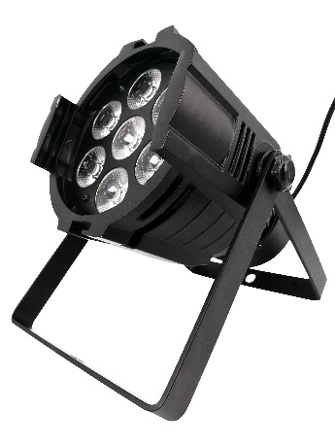

Maintenance
1.Please keep the light in dryness and avoiding use in wet place.
2.Using intermittenlly can be extended the life.
3.Attention to clean the fan and lens usually in order to get the ventilating effects and lighting effects better.
4.Please do not wipe the crust using organic menstruum for avoid to damaged the product.

Statement
The product has well capability and intact packing when leave factory,All of the user should comply with above warning item and manual ,any misuse cause of the damages are not included in our guarantee,and also can’t be responsible for any malfunction & problem owing to ignore the manual.
Please forgive that we will not be notice for technical change

Attention Item
1.For guarantee the life of product,please do not put it on the wet place and not use it the place over 40 degree.
2.Please don’t lay the product on the un-fixable or shakable place.
3.Ask for the professional to maintain the product in order to avoid the danger of get an electric shock.
4.Power supply should not be changed over +&-10% while the light is using,it will be decreased the life of lamp if the power is too high,but it will be influenced the luminosity if the power is too low.
5.After power off,if it is need used again,please cool down over 20 minuter.
6.Please look round the manual for ensure the product can be used normally.

DMX Channel Summary-7 Channels Mode
Channel | Value | Function
CH1 | 0-255 | Total Dimmer
CH2 | 0-255 | Red Dimmer
CH3 | 0-255 | Green Dimmer
CH4 | 0-255 | Blue Dimmer
CH5 | 0-255 | White Dimmer
CH6 | 0-49  50-99  100-149  150-199  200-255 | No Effect  Jump Mode  Gradual Mode  Auto program  Sound Mode
CH7 | 0-255 | Strobe RGBW  Function Speed Adjustment -CH9

Display Control Instruction
No | Display | Function
d001 | 0-512 | Channel DMX Address
P001 | 0-255 | Auto program
L001 | 0-255 | Gradual Mode
E001 | 0-255 | Jump Mode
SOUD | 0-255 | Sound Mode
R001 | 0-255 | Red Dimmer
G001 | 0-255 | Green Dimmer
b001 | 0-255 | Blue Dimmer
u001 | 0-255 | White Dimmer
F001 | 0-255 | Flash

Display Control Instruction
Welcome to use our light.The light uses energy-saving LED,long Product life,shockproof,dustproof, DMX receiver and self-running feature, which can produce a variety of vivid lighting effects,easy to operate, suitable for all types of entertainment decoration,architectural lighting industry.

E
A:Function
B:Up
C:Down
D:Enter
E:LED Display

A B C D
Instructions:Press the function key A cycled out the eight different function effects,digital tube first two digits on behalf of which the current function(see menu).The last two digits represent the functions in which the address code or speed parameters.Press the B or C key to modify the parameter values.Press the D key to confirm.

Product Introduction
* Power Supply:AC90--275V,50--60HZ
* Power consumption:84W
* Fixing lamp:LED 7×12W RGBW
* DMX-Control-channels:7 DMX Channels
* Shuttle:Flash rate:0--10HZ
* Dimmer:0-100% mechanic dimmer
* Long Lifespan LEDs(more than 60,000 hours)

