LED matrix (8+8) laser moving head light
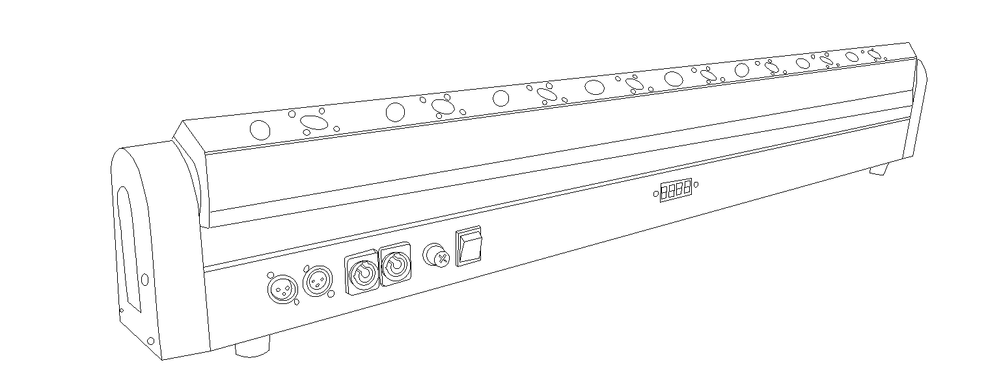

Menu function:
ADDR A001---A512 address code
SLND MAST, SLAV
SHND SOUD, AUTO Sound control, self-propelled selection
MANU LASER1---LASER8,STROBE，Manual test
SENS Sound control sensitivity (0 is off, 100 is the most sensitive)
LED ON, OFF Backlight switch
TEST automatic testing
VER V100 Software version number
Product parameter introduction：
Input power: AC90V-240V
Power frequency: 50/60Hz
Power: 70W
Cooling method: air cooling
Maximum operating environment temperature: 45℃
Number of LEDs: 8
Single LED power: 3W
The average life of LED: 50000 hours
LED color temperature: 3200K
Number of lasers: 8
Laser model: 500MW/638NM red
Strobe: 1-25 times/sec or random
Number of DMX control channels: 30CH
DMX connector: 3Pin XLR
Operation mode: DMX/automatic/sound control
Vertical scan: 270°
Display mode: LED digital tube
30CH DMX512 ：
CN | Features | DMX | description
1 | Y axis | 0-255 | 0---270°
2 | Y-axis fine adjustment | 0-255 | 0--1.0°
3 | LED total dimming | 0-255 | Dimming 0%-dimming 100%
4 | LED strobe | 0-255 | Strobe from slow to fast
5 | LED1 | 0-255 | LED1 dimming from dark to bright
6 | LED2 | 0-255 | LED2 dimming from dark to bright
7 | LED3 | 0-255 | LED3 dimming from dark to bright
8 | LED4 | 0-255 | LED4 dimming from dark to bright
9 | LED5 | 0-255 | LED5 dimming from dark to bright
10 | LED6 | 0-255 | LED6 dimming from dark to bright
11 | LED7 | 0-255 | LED7 dimming from dark to bright
12 | LED8 | 0-255 | LED8 dimming from dark to bright
13 | Laser total dimming | 0-255 | Dimming 0%-dimming 100%
14 | Laser strobe | 0-255 | Strobe from slow to fast
15 | Laser 1 | 0-127 | No function
15 | Laser 1 | 128-255 | Laser bright
16 | Laser 2 | 0-127 | No function
16 | Laser 2 | 128-255 | Laser bright
17 | Laser 3 | 0-127 | No function
17 | Laser 3 | 128-255 | Laser bright
18 | Laser 4 | 0-127 | No function
18 | Laser 4 | 128-255 | Laser bright
19 | Laser 5 | 0-127 | No function
19 | Laser 5 | 128-255 | Laser bright
20 | Laser 6 | 0-127 | No function
20 | Laser 6 | 128-255 | Laser bright
21 | Laser 7 | 0-127 | No function
21 | Laser 7 | 128-255 | Laser bright
22 | Laser 8 | 0-127 | No function
22 | Laser 8 | 128-255 | Laser bright
23 | LED macro function | 0-255 | Built-in LED macro function effect
24 | LED macro function effect speed regulation | 0-255 | Built-in LED macro function effect speed regulation
25 | Laser macro function effect | 0-255 | Built-in laser macro function effect
26 | Laser macro function effect speed adjustment | 0-255 | Built-in laser macro function effect speed adjustment
27 | LED+laser macro function effect | 0-255 | Built-in LED+laser macro function effect
28 | LED+laser macro function effect speed adjustment | 0-255 | Built-in LED+laser macro function effect speed regulation
29 | Y axis speed control | 0-255 | From fast to slow
30 | Reset | 0-250 | No function
30 | Reset | 251-255 | The lamp body is reset, valid for 3s.

