700W CMYT PROFILE MOVEHEAD
Please read over this manual before operation the light
USER MANUAL
（RDM TFT DISPLAY & TOUCH）
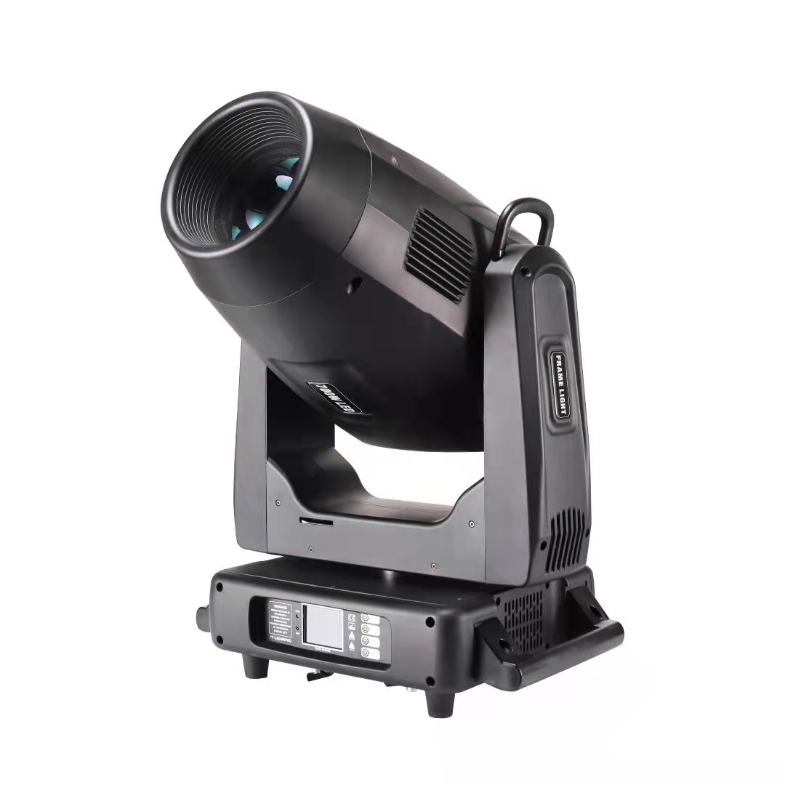
CONTENTS
Chapter 1 Installation and attention 1
1. Maintenance 1
2. Statement 1
3. Safety Precaution 1
4. Cable connection（DMX） 1
5. Rigging (Optional) 2
6. RDM NOTE 3
Chapter 2 Panel operation 4
1. Brief 4
2. Operation 4
1. Operate fixture with touch or encoder/button 4
2. Parameter value setting 4
3. Boolean parameter setting 5
4. Sub Menu（Parameter） 5
3. Operation and parameter instruction 6
1. DMX Address setting 6
2. Fixture operating mode setting 6
3. Set display 7
4. Scene 7
5. Set light run parameter 8
6. Status and information 9
Chapter 3 Channel description 11
1. Channel table 11

Chapter 1 Installation and attention

Maintenance
- To reduce the risk of electrical shock or fire, do not expose this unit to rain or moisture.
- Intermittently using will extend this item’s service life.
- Please clear the fan, fan net, and optical lens in order to keep good work state.
- Do not use the alcohol or any other organic solvent to wipe the shell.

Statement
The product has perfect performance and integrity packing. All users should be strictly complying with the warning and operating instructions as stated. Or we aren’t in charge of any result by misusing. Any damage resulting by misuse is not within the Company’s warranty. Any fault or problem caused by neglecting the manual is also not in the charge of dealers.
Note: All information is subject to change without prior notice.

Safety Precaution
- In order to guarantee the product’s life, please don’t put it in the damp places or even the environment over 60degress.
- Always mount this unit in safe and stable matter.
- Install or dismantle should operate by professional engineer.
- Using lamp，the change rate of power voltage should be within±10%，If the voltage is too high，it will shorten the light’s life; If it’s not enough, will influence the effect.
- Please restart it 20 minutes later after turning off light , until full-cooling. Frequent switching will reduce the life span of lamps and bulbs; intermittent using will improve the life of bulbs and lamps.
- In order to make sure the product is used well, please read the Manual carefully.

Cable connection（DMX）
Use a cable conforming to specifications EIA RS-485: 2-pole twisted, shielded, 120Ohm characteristic impedance, 22-24 AWG, low capacity. Do not use microphone cable or other cable with characteristics differing from those specified. The end connections must be made using XLR type 3 or 5-pin male/female connectors. A terminating plug must be inserted into the last projector with a resistance of 120Ohm (minimum 1/4 W) between terminals 2 and 3.
IMPORTANT: The wires must not make contact with each other or with the metal casing of the connectors. The casing itself must be connected to the shield braid and to pin 1 of the connectors.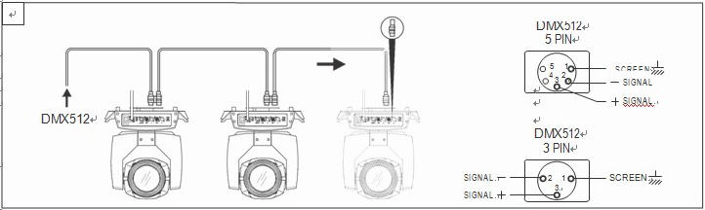
Figure 1 DMX Cable connection

Rigging (Optional)
This equipment can be positioned and fixed by clamp in every direction of the stage. Locking system makes it easy to fasten to the bracket.
Attention! Two clamps is needed to fix the equipment. Every clamp is locked by fastener of 1/4 kind. Fastener can only be locked clockwise.
Attention! Fasten a safety string to the additional hole of side aluminum piece. The secondary accessory can not hang on the delivery handle. Nip the equipment on bracket.
- Check if rigging clamp (not including the one inside) damaged or not? If stand ten times weight as the equipment. Make sure the architecture can stand ten times weight as all the equipments, clamps, wirings and other additional fixtures.
- Screws for clamping must be fixed firmly. Take one M12 screw (Grade 8.8 or higher) to clamp bracket, and then screw the nuts.
- Level the two hanging points at the bottom of clamp. Insert fastener to the bottom, lock the two levers by 1/4 rotating clockwise; then install another clamp.
- Install on safety string which stands at least ten times weight as equipment. Terminal of the accessory is designed for clamps.
- Make sure pan/tilt lock unlocked or not. Keep the distance more than 1M from equipment to flammable material or lighting source.
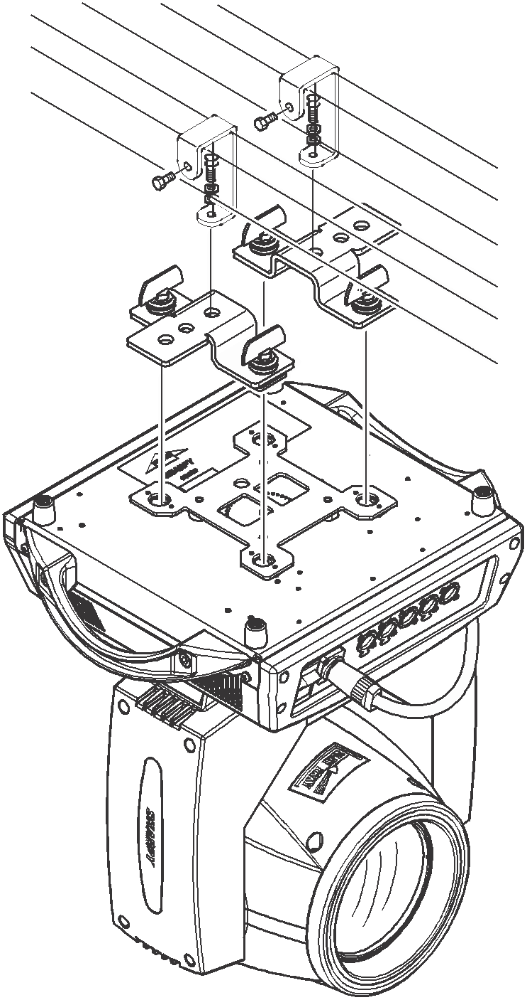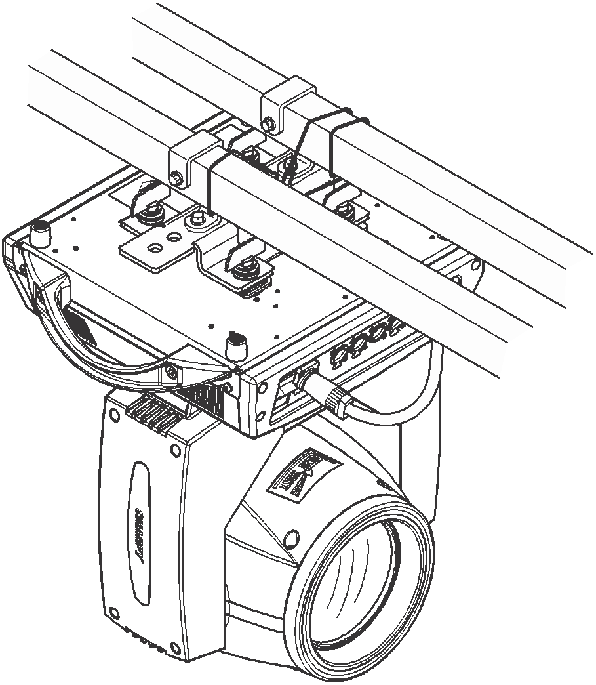
Figure 2 Installation

RDM Note
RDM is an extended version of DMX512-A protocol. It is a remote device management protocol. Traditional DMX512 protocol communication is one-way communication. The protocol is based on RS-485 bus. RS-485 is a time-sharing multi-point, half-duplex protocol. Only one port is allowed to output at the same time. So, when using RDM, we should pay attention to it. The following points:
- To use console or host device that supports RDM host protocol.
- Use bidirectional signal amplifier, traditional one-way signal amplifier is not suitable for RDM protocol, because the RMD protocol needs feedback data, the use of one-way amplifier will block the return of data, resulting in no search fixture;
- All fixture must be set to DMX mode to ensure only one host on the cable.
- A 120 ohm impedance matching resistor must be inserted between terminals 2 and 3 of the terminal plug. When the signal line is longer, reducing the signal reflection will make the differential signal more stable and beneficial to the quality of communication.
- When the fixture appears to accept DMX control, but can not been search by RDM host, first check the signal amplifier, and then check whether the signal line 2, 3 lines have bad contact.

Chapter 2 Panel operation

Brief
The light panel diagram show as Figure 3, above area is Title for fixture description, below area show fixture real-time status, such as DMX cable status, lamp status, error or information(ps. when there are message hav’t been checked, echo ’ERR’ in status bar, otherwise echo ‘NOR’).
Fixture TFT Displayer support touch, and right area is encoder or button, both of touch and coder button can operate fixture and setting.
Display & operation just like ‘Android operation system’, touch the item will set or modify setting.
RDM protocol is embed in fixture, user set DMX address via cable using the controller surpport RDM function. when fixture was search by controller, displayer will echo ‘RDM’ indicate this RDM is work.
Note: Prevent damage the touch or TFT displayer, Can not use sharp objects chick displayer.
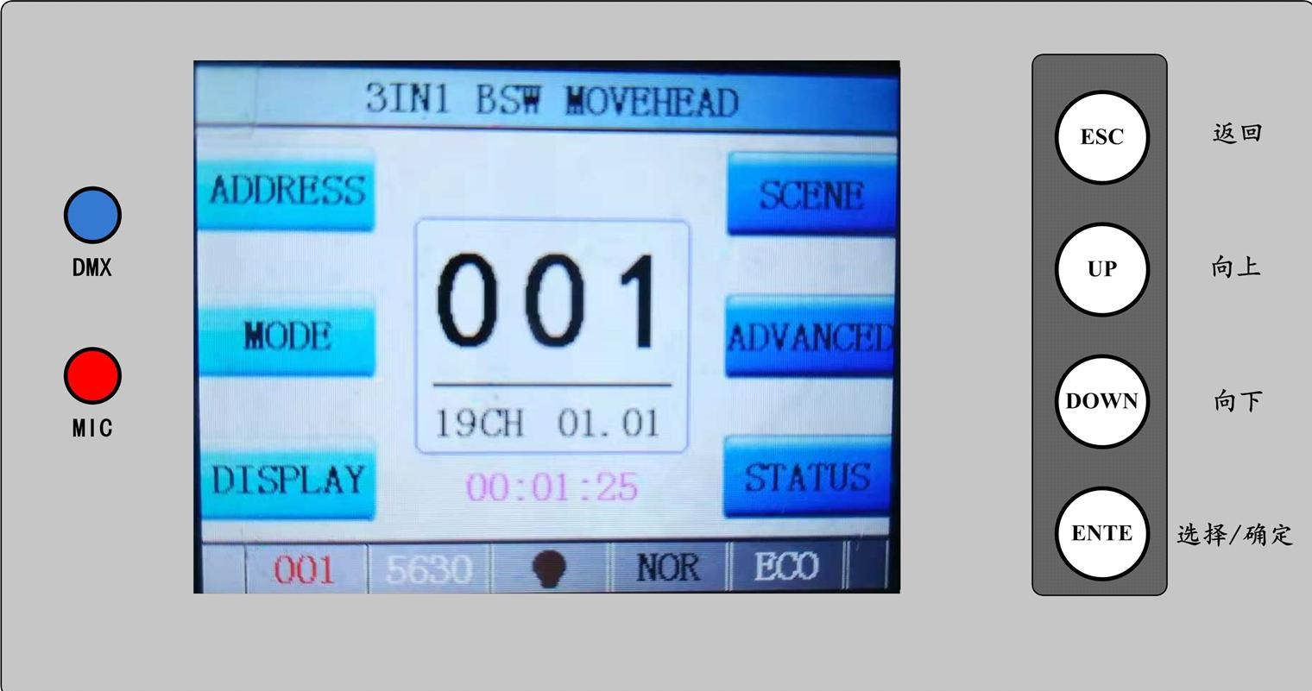
Figure 3 Panel diagram

Operation

Operate fixture with touch or encoder/button
- The left area is TFT Displayer and touch(product which support touch), chick item or value with finger will to complete operation of set light setting(parameters) or view light state.
- The area on the right hand side is rotary encoder with button or key, As auxiliary input interface, if fixture disable touch function, the encoder/key can been choose to set or view the item, and then press the encoder button/key to confirm the selection, rotary encoder or push key again set the parameter value, finally, Press encoder button/key one again to save value or setting.

Parameter value setting
When the selected item is value need to been modified, the dialog shown in Figure 4 will popup.
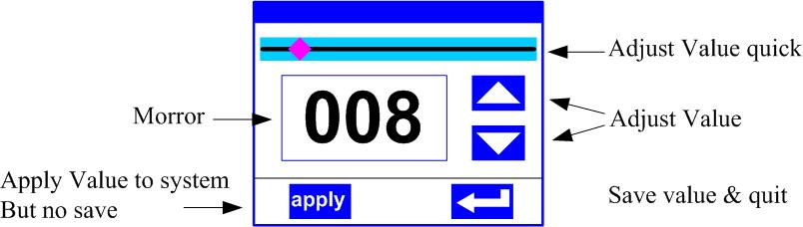
Figure 4 Dialog of value setting
- Modify value：Can quickly modify value via pull the slider to the desired position, or click the button of ‘up’ or ‘down’ whit finger on the right side to set the exact desired value, another way is roll encoder on the right hand side of panel.
- Apply value：When Value had been modified, Then press the bottom of ‘apply’ in the left corner to apply to the light, but hav’t saved；
- Save Value：Any time, click on the lower right corner of the "OK" button, the setting will been saved into internal memory.

Boolean parameter setting
- when the selected parameters is a Boolean value (such as ON or OFF), can directly modify setting by chick corresponding item, the setting will been saved right now.
- When the parameter is a key item, chick corresponding item, a dialog shown in Figure 5 will been popup ask for the confirm. Chick ‘sure’ to confirm.
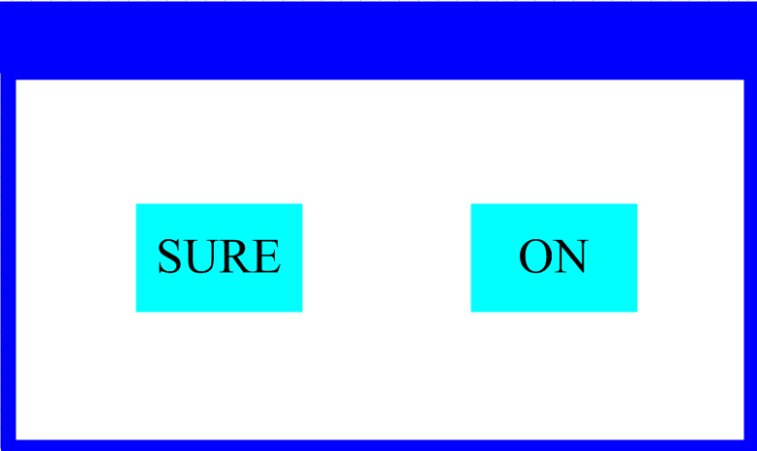
Figure 5 Dialog of confirm

Sub Menu（Parameter）
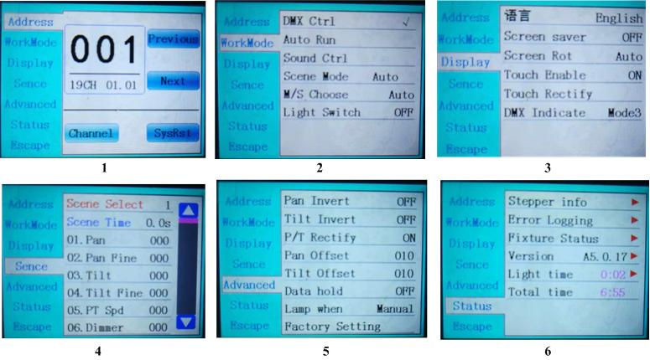
Figure 6 Parameter menu

Operation and parameter instruction
Chick item of main menu, enter corresponding sub menu shown in Figure 6, In main menu, chick 1/6 function button into corresponding parameter menu.
In sub menu(page), chick main item on the left side of displayer, can shift to corresponding sub menu(page) quickly.

DMX Address setting
Enter page show in Figure6-1, can set fixture DMX address, channel mode and so on.
The menu settings of fixture have optimized the setting of addresses. Several settings of the address are as follows:
- Select " previous " or "next", the fixture will be based on the current address and channel mode, automatically calculate the next or last address, make address setting can quickly;
- Click on the address alue, you can enter the numeric editing window, where you can set any valid address, fixture system automatically get the current number of channels, automatically filter the unusable address (512 - the current number of channels).
- Fixture support RDM protocol, remote address can be set through RDM.
Provide two buttons:
- Channel mode: you can choose different channel modes by cycle.
- Fixture reset: reset all motors. Set Light work mode

Fixture operating mode setting
Through the page shown in Figure 6-2, the operating mode of the fixture can be set and the lamp can be controlled. The fixture supports four operating modes (DMX mode, auto mode, voice control mode and scene mode). Detailed parameter settings can be refer in the previous section. Specific parameter descriptions are as follows:
operating mode
DMX Ctrl | DMX mode, receive DMX signal, RDM signal
Auto Run | Fixture run automatically according to built-in programs
Sound Ctrl | When the fixture detects a strong sound, the fixture automatically runs a scene according to the built-in program, otherwise it will stay the last scene
Scene Mode 01 | runs in a set scebe, which supports most of the custom editing of 10 scenes.
Scene Mode 01 | 1~10 | outputs the specified scene
Scene Mode 01 | Auto | Automatically loops the output scene in the set scene time (non-zero) order, and the scene with time 0 automatically ignore
M/S Choose | Master and slave selection, non-DMX mode takes effect, select the mode of data output, fixture detect DMX cable state automatic switch output, prevent data conflicts
M/S Choose | Master | fixture runs built-in program. If DMX has no signal, it outputs data (synchronization), otherwise it does not output data.
M/S Choose | Slave | ixture runs built-in program and do not output data
M/S Choose | Auto | If DMX has no signal, the fxiture will runs built-in program. Otherwise, the fixture will run in DMX Mode(follow DMX).
Lamp switch | (Lamp light source) pop-up confirmation dialog box, select "SURE" to confirm the current operation, turn on or off the lamp, switch time interval limited to 30 seconds
Lamp switch | Off | the current lamp output is off
Lamp switch | On | The current lamp output is turned on
Scene mode applies to a single or a small number of fixture, just output a fixed scene, or need to run a simple program, you no need connect to the console, in the scene page can be edited.
If the light source is lamp, wait for 10 minutes before turning off the lamp.

Set display
The fixture support Chinese and English, invert display and so on. Enter the corresponding parameter settings as shown in Figure 6-3. The specific menu contents are as follows:
DISPLAY SETTING
Language | display language settings
Language | English | English display
Language | Chinese | Chinese display
Screen saver | Set screen 30 seconds without operation, the screen's display content or method.
Screen saver | OFF | Keep the last operation page
Screen saver | Mode1 | Black
Screen saver | Mode2 | Black screen, showing the address code of the current fixture in the lower left corner.
Screen saver | Mode3 | Display trademark information, address code and operation mode.
Screen Rot | Set the display direction of the screen.
Screen Rot | OFF | No reverse display
Screen Rot | ON | Reverse display
Screen Rot | AUTO | Automatically detect the direction of lamps and automatically switch direction.
DMX Indicate | Set the indication mode of DMX signal indicator.
DMX Indicate | Mode1 | When signal is bright, no signal is off.
DMX Indicate | Mode2 | When signal is off, no signal is bright.
DMX Indicate | Mode3 | When signal is flash, no signal is off.
Signal Bright | Set the brightness of the signal indicator
Signal Bright | 1~10 | 10
Screen Lihgt | Set the screen backlight for 10 seconds without operation
Screen Lihgt | 1~10 | 10
Touch switch | Choose whether to disable the touch function. When the screen touch is accidentally damaged, you can disable the touch function and use auxiliary input to set the fixture.
Touch | When the screen touch function work anomaly, you can enter the corrected page correction screen touch
Which fixture support touch function, if there is a bad touch, you can enter the correction page to re-calibrate the touch accuracy of the touch screen, under normal circumstances, do not enter this page. If the touch is damaged, please choose to disable the touch switch.

Scene
Enter the page shown in Figure 6-4, and the fixture enters the scene editing mode. Under this page, the fixture does not receive DMX console data, and the edited data will effect on the fixture immediately.
The content of the page depends on the currently selected channel mode, and the channel content and order displayed are consistent with the fixture channel table. Through this page, you can edit 10 scenes, as shown in the following table:
SCENE MODE
Scene Select | Select the current operation scenario.
Scene Select | 1~10 | The 10 scenes sets the format
Scene Time | Sets the retention time of the current scene when it is automatic, unit in 0.1 seconds.
Scene Time | 0 | The current scene is not output in automatic scene output.
Scene Time | 1-255 | 0..1s-25.5s
1. PAN | 0-255 | Set up the data of each channel, and the contents and order of the display are one-to-one correspondence with the channel list of fixture.
…… | 0-255
…… | 0-255
N. Function | 0-255
If the reset channel in the scene edits the effective reset data, the fixture will reset, but after reset, the corresponding reset channel value will automatically set 0, preventing multiple consecutive resets.
Looking at this page, you can get the current channel table slot of the fixture. For specific channel data, please refer to the detailed channel description.

Set light run parameter
Enter the page shown in Figure 6-5, adjust the field parameters of fixture, facilitate the installation of fixture, etc.
ADVANCED SETTING
Pan Invert | Set the rotation direction of PAN
Pan Invert | OFF
Pan Invert | ON
Tilt Invert | Set the rotation direction of TILT
Tilt Invert | OFF
Tilt Invert | ON
P/T Rectify | Setting up fixture to detect XY lost step and correct
P/T Rectify | OFF | Uncorrected position after out of step
P/T Rectify | ON | After losing step, the position is automatically corrected and the out of step fault is recorded.
Pan Offset | Setting the zero point of the PAN of the fixture
Pan Offset | 4-150
Tilt Offset | Setting the zero point of the TILT of the fixture
Tilt Offset | 4-48
Data hold | When the fixture is not equipped with DMX signal, the output state of the fixture
Data hold | OFF | No signal, so the motor and light source return to the position and state when reset is completed.
Data hold | ON | No signal, keep the last frame DMX data output.
Lamp mode | Set the way to first open the lamp after power up
Lamp mode | Power on | Turn on the lamp at power up and reset the lamp after 30 seconds.
Lamp mode | After reset | Reset the fixture after 3 seconds when power-on, and turn on the lamp after reset.
Lamp mode | Manual | After reset, manually turn on the lamp through the menu or console.
Factory Setting | Pop up the confirmation box, select "SURE", and return the lamp parameters to the factory settings.
When choosing power-on mode, the lamp will wait for 30 seconds after power-on, let the lamp fully start, internal voltage is stable enough, then start the reset program, if the field capacity is stable, recommend power-on mode.
When the fixture can not calibrate the position, please check whether the "P/T Rectify" is turned off.
When the signal is unplugged, check the Data Hold setting first if the position of the fixture is not output as expected.
When setting the XY offset, after setting up, please control XY with the maximum stroke first to check that XY will not bump into the positioning rod or shell.

Status and information
Entering the page shown in Figure 6-6, you can view the information and real-time status of the fixture to get their usage status. If the fixture need customer service, please provide the status information displayed on the page as a basis for judgment, as shown in the following table:
STATUS INFORMATION
Stepper info | Display information status of all motors and signals in fixture.
Stepper info | Hall | No display, indicating that the motor has no Hall, 0 indicating that the motor leaves the correction position point, 1 indicating that the motor is in the correction position point
Stepper info | Status | Display motor reset status
Stepper info | PAN | Display real-time position value of PAN optocoupler feedback
Stepper info | TILT | Display real-time position value of TILT optocoupler feedback
Stepper info | PAN OP | Displays the PAN TILT optocoupler two signal level state, binary
Error Logging | Show the latest 8 error records when the fixture is reset and running. The error records are not saved after power failure. The current power cycle is valid.
Error Logging | Error Logging | Total number of failures detected after power on
Error Logging | 12：:03 | The time of power failure when the fault occurs is in minutes.
Error Logging | Hall error | The effective hall signal is not detected when the motor is reset
Error Logging | Hall short | When the motor is reset, the hall signal of the motor is always effective
Error Logging | Opti error | No effective optocoupler signal is detected when the motor is reset.
Error Logging | Lose stop | The corresponding motor is out of step during its operation.
Error Logging | Hit | Striking the positioning rod when the motor is reset
Error Logging | Lamp error | Lamp explosion accident
Error Logging | NTC error | The temperature sensor signal is abnormal
Error Logging | Fan error | The main fan is not working properly.
Fixture status | Displays the critical state data of the current fixture for reference.
Fixture status | Communication prec | 0~100%, Communication quality of internal data link of lamps and lanterns
Fixture status | Error cnt | The number of erroneous frames was detected after power on, and the total number of erroneous frames was detected.
Fixture status | Light Temperature | Show the temperature of the current light source, "---" means no detection.
Fixture status | Panel Temperatrue | Displays the temperature of the current display panel or the ambient temperature.
Fixture status | Sensor1 Temperatrue | Display the ambient temperature of the motherboard temperature or the motherboard installation position.
Version | Display the information and version of the current fixtrue, important reference for after sales maintenance.
Version | Device | The name of the fixture is the same as the equipment information of RDM.
Version | Model | The type of fixture is the same as the model information of RDM.
Version | Panel | Firmware version and serial number of display panel
Version | Main Board | Firmware version and serial number of mother board 1
Light time | Record the total cumulative time of light source opening, unit minute, user manual cleaning, as a reference for regular maintenance of light source time
Total time | The total accumulated time for recording the opening of fixture is not allowed to be removed.

Chapter 3 Channel description

Channel table
This luminaire channel can be viewed in scene mode in order, channel mode is set in the "Address Settings" page, specific details of the data as follows:
CHANNEL TABLE
Channel | Name | Value | Brief
CH1 | PAN | 0-255 | 0-540deg
CH2 | PAN 16bit | 0-255 | 0-2deg
CH3 | TILT | 0-255 | 0-270deg
CH4 | TILT 16bit | 0-255 | 0-1deg
CH5 | PT Speed | 0-255 | Fast to slow
CH6 | Strobe | 0-3 | Dark
CH6 | Strobe | 4-127 | slow to fast strobe mode1
CH6 | Strobe | 128-191 | slow to fast strobe mode2
CH6 | Strobe | 192-251 | slow to fast strobe mode3
CH6 | Strobe | 252-255 | Open
CH7 | Dimmer | 0-255 | 0-100%
CH8 | Dimmer fine | 0-255
CH9 | Focus | 0-255 | Far to near
CH10 | Focus fine
CH11 | Zoom | 0-255 | large to small
CH12 | Zoom fine | 0-255
CH13 | Auto focus | 0-63 | disable
CH13 | Auto focus | 64-127 | 7.5meter
CH13 | Auto focus | 128-191 | 10meter
CH13 | Auto focus | 192-255 | 15meter
CH14 | Auto focus fine | 0-255
CH15 | Color | 0-127 | Linear
CH15 | Color | 128-137 | Color1
CH15 | Color | 138-146 | Color2
CH15 | Color | 147-155 | Color3
CH15 | Color | 156-164 | Color4
CH15 | Color | 165-173 | Color5
CH15 | Color | 174-182 | Color6
CH15 | Color | 183-191 | Color7
CH15 | Color | 192-222 | Fast to slow forwad rainbow
CH15 | Color | 223-224 | Stop
CH15 | Color | 225-255 | Slow to fast reverse rainbow
CH16 | Show value | 0 | None
CH16 | Show value | 1-255 | 0-100%
CH17 | C | 0-255 | 0-100%
CH18 | M | 0-255 | 0-100%
CH19 | Y | 0-255 | 0-100%
CH20 | CTO | 0-255 | 0-100%
CH21 | Static gobo | 0-9 | White
CH21 | Static gobo | 10-19 | Gobo1
CH21 | Static gobo | 20-29 | Gobo2
CH21 | Static gobo | 30-39 | Gobo3
CH21 | Static gobo | 40-49 | Gobo4
CH21 | Static gobo | 50-59 | Gobo5
CH21 | Static gobo | 60-69 | Gobo6
CH21 | Static gobo | 70-79 | Slow to fast shake gobo1
CH21 | Static gobo | 80-89 | Slow to fast shake gobo2
CH21 | Static gobo | 90-99 | Slow to fast shake gobo3
CH21 | Static gobo | 100-109 | Slow to fast shake gobo4
CH21 | Static gobo | 110-119 | Slow to fast shake gobo5
CH21 | Static gobo | 120-129 | Slow to fast shake gobo6
CH21 | Static gobo | 130-190 | Fast to slow forward rainbow
CH21 | Static gobo | 191-192 | Stop
CH21 | Static gobo | 193-255 | Slow to fast reverse rainbow
CH22 | Rot Gobo | 0-9 | White
CH22 | Rot Gobo | 10-19 | Gobo1
CH22 | Rot Gobo | 20-29 | Gobo2
CH22 | Rot Gobo | 30-39 | Gobo3
CH22 | Rot Gobo | 40-49 | Gobo4
CH22 | Rot Gobo | 50-59 | Gobo5
CH22 | Rot Gobo | 60-69 | Gobo6
CH22 | Rot Gobo | 70-79 | Slow to fast shake gobo1
CH22 | Rot Gobo | 80-89 | Slow to fast shake gobo2
CH22 | Rot Gobo | 90-99 | Slow to fast shake gobo3
CH22 | Rot Gobo | 100-109 | Slow to fast shake gobo4
CH22 | Rot Gobo | 110-119 | Slow to fast shake gobo5
CH22 | Rot Gobo | 120-129 | Slow to fast shake gobo6
CH22 | Rot Gobo | 130-190 | Fast to slow forward rainbow
CH22 | Rot Gobo | 191-192 | Stop
CH22 | Rot Gobo | 193-255 | Slow to fast reverse rainbow
CH23 | Gobo.rot | 0-127 | 0-360deg
CH23 | Gobo.rot | 128-190 | Fast to slow forward rainbow
CH23 | Gobo.rot | 191-192 | Stop
CH23 | Gobo.rot | 193-255 | Slow to fast reverse rainbow
CH24 | Gobo3 Insert | 0-10 | None
CH24 | Gobo3 Insert | 11-255 | 0-100%
CH25 | Gobo3 | 0-2 | Stop
CH25 | Gobo3 | 3-128 | Fast to slow forward rainbow
CH25 | Gobo3 | 129-255 | Slow to fast reverse rainbow
CH26 | Iris | 0-255 | 100%-0
CH27 | Prism1 | 0-127 | None
CH27 | Prism1 | 128-255 | Prism1
CH28 | Prism1 rot | 0-127 | 0-360deg
CH28 | Prism1 rot | 128-187 | Fast to slow forward rainbow
CH28 | Prism1 rot | 188-195 | Stop
CH28 | Prism1 rot | 196-255 | Slow to fast reverse rainbow
CH29 | Prism2 | 0-127 | None
CH29 | Prism2 | 128-255 | Prism2
CH30 | Prism2 rot | 0-127 | 0-360deg
CH30 | Prism2 rot | 128-187 | Fast to slow forward rainbow
CH30 | Prism2 rot | 188-195 | Stop
CH30 | Prism2 rot | 196-255 | Slow to fast reverse rainbow
CH31 | Frost | 0-127 | None
CH31 | Frost | 128-255 | Frost
32 | reserve | 0-255
CH33 | Cut1 | 0-255 | 0-100%
CH34 | Cut2 | 0-255 | 0-100%
CH35 | Cut3 | 0-255 | 0-100%
CH36 | Cut4 | 0-255 | 0-100%
CH37 | Cut5 | 0-255 | 0-100%
CH38 | Cut6 | 0-255 | 0-100%
CH39 | Cut7 | 0-255 | 0-100%
CH40 | Cut8 | 0-255 | 0-100%
CH41 | Profile rot | 0-255 | 0-90deg
CH42 | Function | 210-215 | Reset XY stay 6sec
CH42 | Function | 220-235 | Reset Head mt stay 6sec
CH42 | Function | 240-255 | Reset ALL stay 6sec

