Lifting Stepless Beam Strobe Light
User Manual

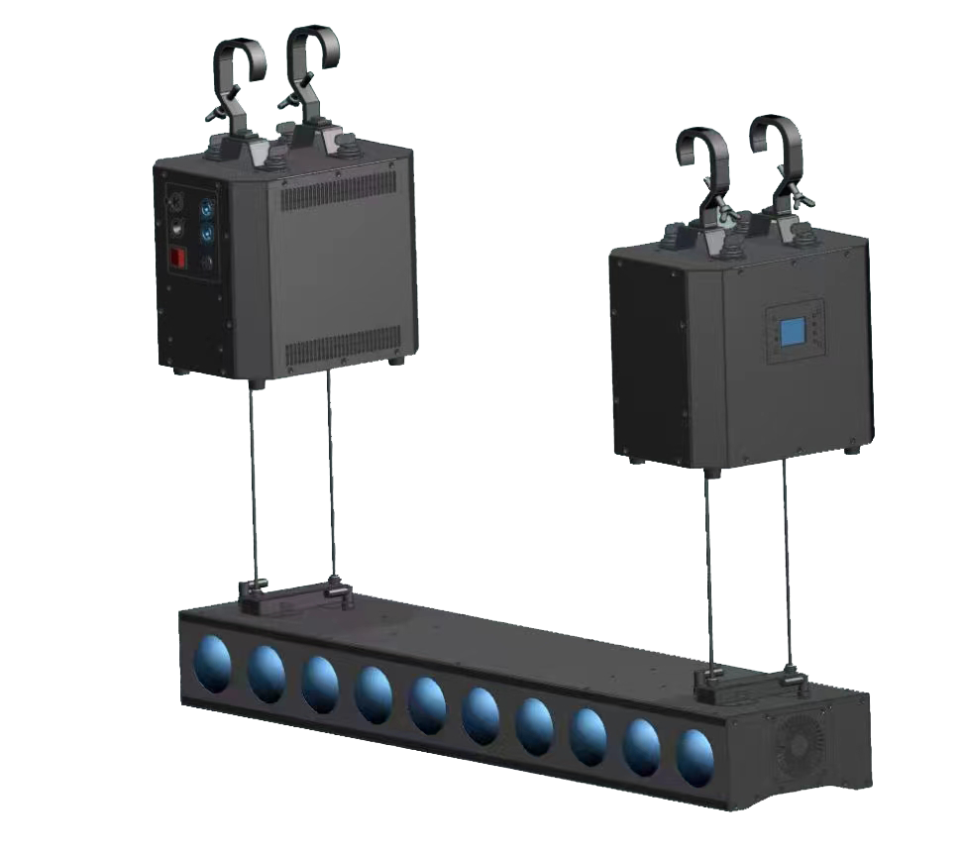
Please read the instructions carefully before use.
Table of contents
Chapter 1 Precaution and installation 1
1. Maintanence 2
2. Declarations 2
3. Precautions for products 2
4. Installation 2
Chapter 2 Panel operation 3
1. Overview 3
2. Operation 4
1. Use intuitive touch or auxiliary input to operate the lamp (products that support touch) 4
2. Parameter value input 4
3. Set Boolean parameter 4
4. Subpage (Parameters) 5
3. Function operation and parameter setting 5
1. Set the DMX address code 5
2. Set the lamp operating mode 5
3. The panel displays the settings 6
4. Scene mode 7
5. Set light operating parameters 8
6. View the current status of the light 9-10
Chapter 3 Channel 11
1. Channel table 12
Chapter 4 Common Faults and Precautions 14
1. Common fault handling 15
2. Precautions for use 15
3. RDM Usage Considerations 15

Chapter 1 Precaution and installation

Maintenance
- The lamp should be kept dry and avoid working in humid environment.
- Intermittent use will effectively extend the life of the lamp.
- In order to get a good ventilation effect and lighting effect, we should pay attention to cleaning the fan and fan net and lens frequently.
- Do not use organic solvents such as alcohol to wipe the lamp housing to avoid damage.

Declaration
This product is in good condition and complete packaging when it leaves the factory. All users shall strictly abide by the warnings and operating instructions stated above. Any damage caused by misuse is not within the scope of the company's guarantee, and the failure and problems caused by ignoring the operating manual are not within the scope of the distributor's responsibility.
This manual is subject to technical changes without notice.

Product notices
- In order to ensure the service life of the product, this product should not be placed in a humid or leaky place, nor should it work in an environment with a temperature above 60 degrees.
- Do not place the product in a place where it is easy to loosen or vibrate.
- In order to avoid the risk of electric shock, the maintenance of this product requires professional maintenance.
- When the bulb is used, the change of power supply voltage should not exceed ± 10%. If the voltage is too high, the life of the bulb will be shortened. If the voltage is too low, the light color of the bulb will be affected.
- After the power is cut off, it takes 20 minutes for the lamp to be fully cooled before it can be used again.
- To ensure the normal use of this product, please read these instructions carefully. Signal line connection (DMX)

Use RS-485 cable that meets specifications: shielded, 120ohm characteristic impedance, 22-24 AWG, low capacitive reactance. Do not use microphone cables or cables with different specified characteristics. Terminals must be connected using 3 or 5 pin XLR type male/female connectors. (Minimum 1/4 W).

Important: The wires must not touch each other or the metal housing.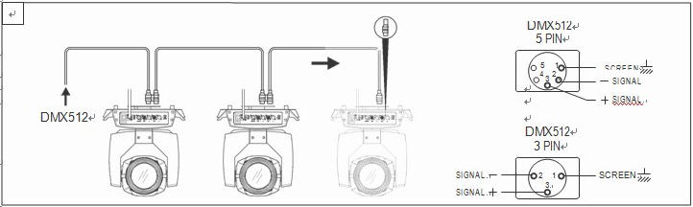
Fig 1 DMX Schematic diagram of signal line connection

Installation
Lamps can be placed horizontally, diagonally and upside down. Be sure to pay attention to the installation method when hanging obliquely and upside down.
As shown in Fig. 2, before positioning the lamp, it is necessary to ensure the stability of the installation site. During reverse hanging installation, it is necessary to ensure that the lamp does not fall down from the support frame. It is necessary to use a safety rope to pass through the support frame and the lamp handle for auxiliary hanging to ensure safety. Prevent the lamp from falling and sliding.
During the installation and commissioning of lamps, pedestrians are not allowed to pass below. Regularly check whether the safety rope is worn and whether the hook screw is loose.
Our company will not assume any responsibility for any consequences caused by the falling of lamps due to unstable hanging installation.
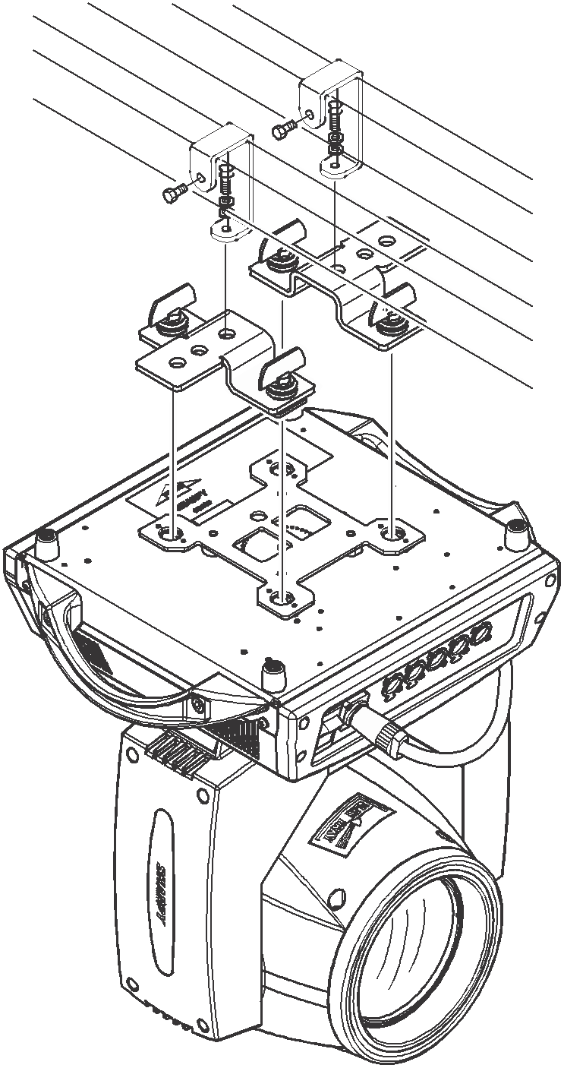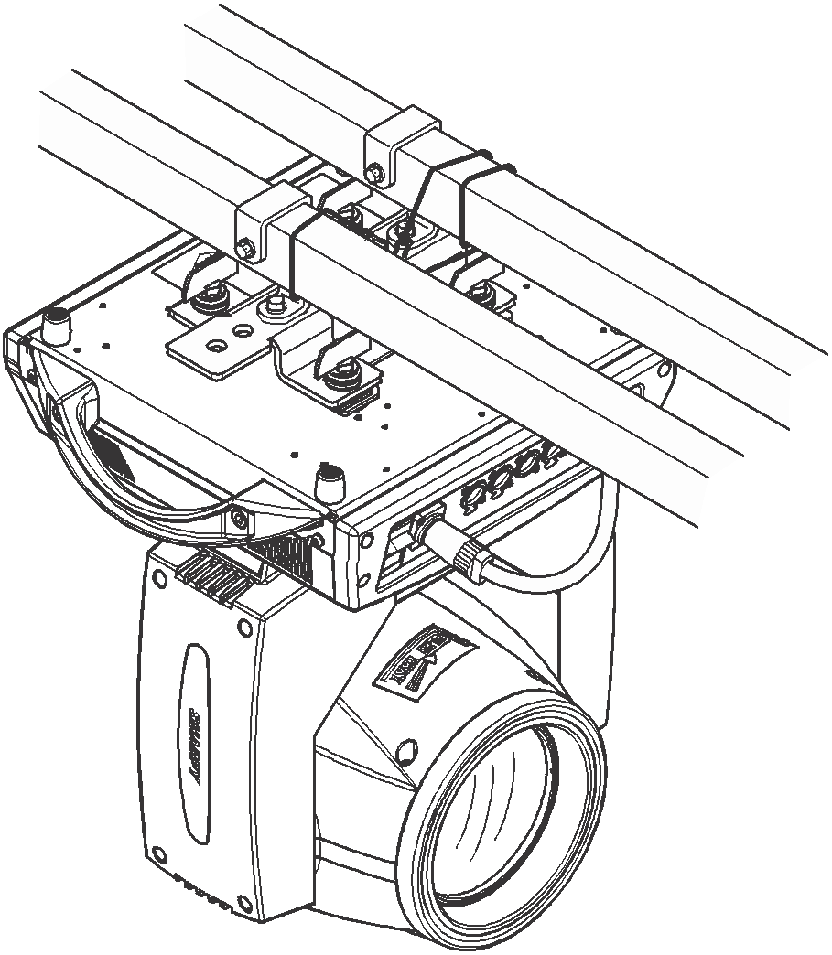
Fig 2 Schematic diagram of upside-down lamps

Chapter 2 Panel operation

Overview
The schematic diagram of the lamp panel is shown in Figure 3. The title above displays the lamp name, and the status bar below displays the current lamp signal, bulb status, fault (when the fault information is not viewed, it displays "ERR", otherwise it displays "NOR"), etc.
The lamp supports DMX/RDM protocol. When the lamp is searched by the RDM host, three letters "RDM" will appear on the panel, indicating that the lamp is enumerated normally.
Display and operation are similar to "Android operating system", which can be operated by clicking on the corresponding items with fingertips or blunt objects.
Caution: Do not use a sharp or pointed object to tap the display screen to prevent damage.
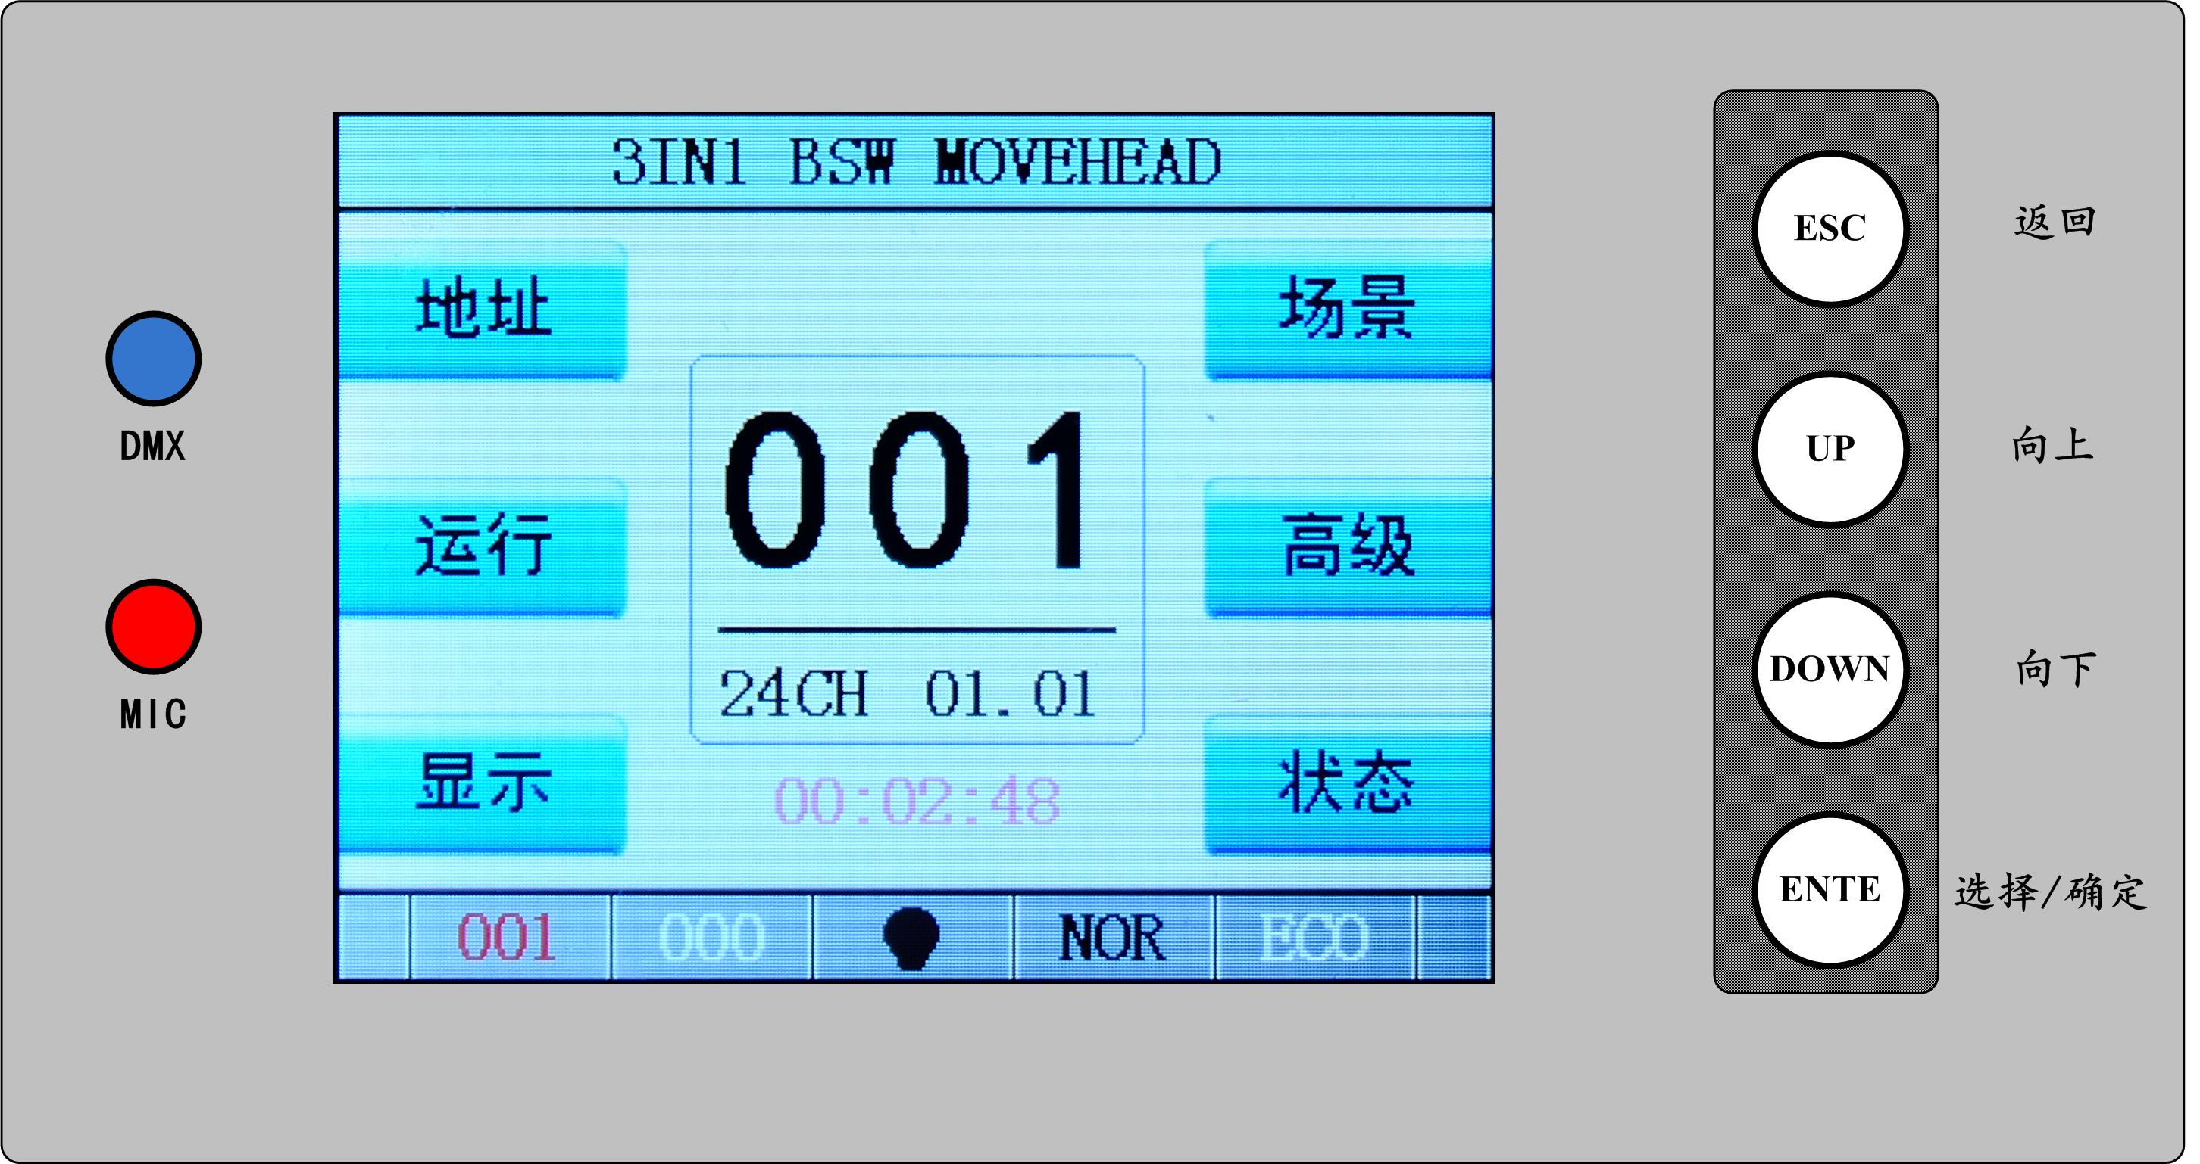
图3 显示面板示意图

Operation

1. Use intuitive touch or auxiliary input to operate the lamp (products that support touch)
- The left area is the TFT display area and touch area. Click the panel content with your finger or blunt hardware to complete the parameter setting or view the status and other operations.
- The right area is the auxiliary input. If you do not use the touch function of TFT, you can use the auxiliary input to select the item to be set or viewed to complete the operation.

2. Parameter value input
When the selected parameter item needs to input the value, the window as shown in Figure 4 will open:
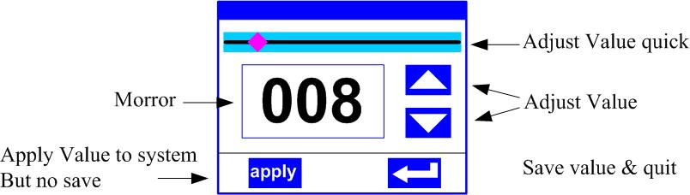
Fig 4 value setting page

- Set the value: You can directly pull the slider bar to quickly set the required value, or click the "Up" or "Down" button on the right to accurately set the required value or use the auxiliary input to set it.
- Apply the value: when the data is set through the "up" or "down" button, and then press the "apply" application button in the lower left corner, the value is immediately sent to the lamp, but the value is not saved.
- Save the value: at any time, click the "OK" key in the lower right corner to save the current value to the internal memory. The saved value will be applied to the lamp at the next power-on.

3. Set Boolean parameter
- When the set parameter is a Boolean value (such as ON or OFF), you can directly click the corresponding item to switch the parameter value. The modified parameter will be saved to the internal storage. Press the parameter option on the right, and the corresponding option will turn gray. When the hand is released, the corresponding parameters are changed and saved. If the pressed parameter option is not the parameter you want to change, you can move your finger to another part of the screen, and the corresponding parameter will not change.
- Important Boolean parameters will be set through the "Confirm" window, as shown in Figure 5 below:
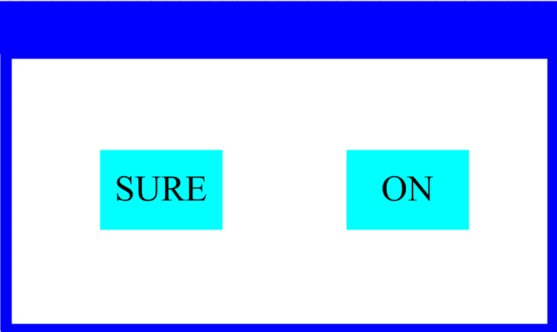
Fig 5 确定输入窗口
4. Subpage (Parameters)

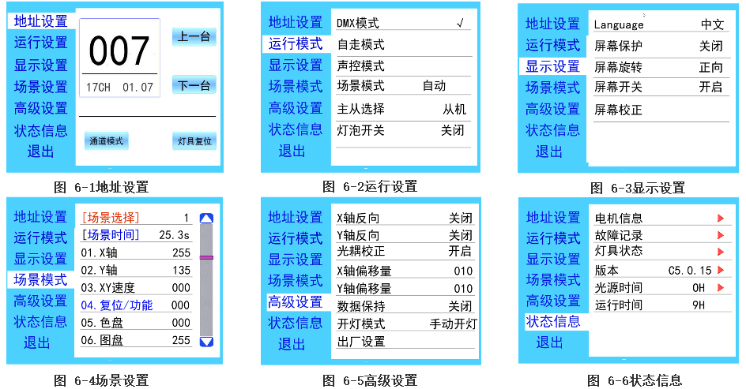

3. Function operation and parameter setting
- Enter the setting interface, as shown in Figure 6-1:
- In the main interface, you can enter the corresponding parameter setting interface by selecting six buttons.
- In the parameter setting interface, you can press the blue option on the left to quickly switch to other setting interfaces.

Setting DMX address code

- The DMX address and channel mode of the lamp can be set through the page as shown in Figure 6-1.
- The menu setting of the lamp optimizes the setting of the address, and the operation of several setting address codes is as follows:
- Select "Previous" or "Next", the lamp will automatically calculate the address code of the next or previous one according to the current address code and channel data, which can be set quickly;
- Click the address code value to enter the value editing window, where any valid address code can be set, the lamp automatically obtains the current channel number of the lamp, and automatically filters the unavailable address code (512-current channel number).
- The lamp supports RDM protocol, and the lamp address code can be set remotely through RDM.
- Two buttons are available:
- Channel mode: different channel modes can be selected circularly;
- Lamp reset: reset all motors.

Setting light working mode

The operation mode of the lamp can be set and the light bulb can be controlled through the page as shown in Figure 6-2. The lamp supports four operation modes (DMX mode, self-propelled mode, voice control mode and scene mode). Please refer to the previous section for detailed parameter value settings. The specific parameter descriptions are shown in the following table:

Operation mode
DMX mode | Console mode, receive DMX signal, RDM signal
Auto-running mode | The lamp operates automatically according to the built-in program.
Voice activated mode | When the lamp detects a strong sound, the lamp automatically runs a scene according to the built-in program, otherwise it keeps the last scene.
Scene mode 01 | Run in the set scene mode, and support custom editing of up to 10 scenes
Scene mode 01 | 1~10 | Output the specified scene
Scene mode 01 | auto | Automatically output the scenes in the sequence of the set scene time (not 0), and the scene with time 0 will be automatically skipped and ignored.
Master/Slave | In case of non-DMX mode, select the mode of data output, and the lamp automatically detects the DMX state and automatically switches the output to prevent data conflict.
Master/Slave | Master | The luminaire operates as built in. If DMX has no signal, it outputs data (sync), otherwise it does not output data
Master/Slave | Slave | The lamp operates as built-in and does not output data (other lamps are not synchronized)
Master/Slave | Automatic | If DMX has no signal, the luminaire operates as built-in, otherwise, the luminaire operates as DMX signal
Light bulb switch | (Bulb light source) The confirmation dialog box pops up. Select "SURE" to confirm the current operation. Turn on or off the bulb. The switching interval is limited to 30 seconds.
Light bulb switch | Close | The current bulb output is already off
Light bulb switch | Open | The current light output is already on
Scene mode is applicable to a single or a small number of lamps. You only need to output a fixed scene, or you need to run a simple program. You can edit it in the scene page without connecting to the console.
If the light source of the lamp is a bulb, after turning off the bulb, please wait for 10 minutes before turning on the bulb.

Panel display setting
The lamp supports both Chinese and English, upside-down display, etc. Enter the corresponding parameter settings as shown in Figure 6-3, and the specific menu contents are shown in the following table:
Display setting
Language | Set the language of the display
Language | English | Display in English
Language | Chinese | Display in Chinese
Screen saver | Set what or how the screen is displayed after 30 seconds of inactivity on the screen
Screen saver | Close | Keep the last operation page and light up the screen.
Screen saver | mode1 | Screen off
Screen saver | mode2 | Black screen, display the address code of the current lamp in the lower left corner
Screen saver | mode3 | Display brand information, address code and operation mode
The screen rotates | Sets the display orientation of the screen
The screen rotates | Close | Do not invert the display
The screen rotates | Open | Invert the display
The screen rotates | Automatic | Automatically detect the direction of lamp hanging and automatically switch the display direction
DMX indication | Set the indication of the DMX signal indicator
DMX indication | mode1 | On when there is a signal, off when there is no signal
DMX indication | mode2 | Off when there is a signal, on when there is no signal
DMX indication | mode3 | Flashes when there is a signal and goes out when there is no signal
The signal indicates brightness | Set the brightness of the signal indicator
The signal indicates brightness | 1~10 | 10 levels
Screen backlight | Set the brightness of the screen backlight after 10 seconds of no operation, and it is fully bright during operation.
Screen backlight | 1~10 | 10 levels
Touch screen switch | Select whether to disable the touch screen. You can disable the touch function if the screen touch is accidentally damaged. Use the auxiliary input to set the lamp.
Touch correction | When the screen touch is not accurate, you can enter the correction page to correct the screen
For lamps that support touch operation, in case of poor touch, enter the correction page to re-correct the touch accuracy of the touch screen. Under normal circumstances, please do not enter this page. If the touch is damaged, select Disable Touch Switch.

Scenes mode
Enter the page as shown in Figure 6-4, and the lamp enters the scene editing mode. On this page, the lamp does not receive DMX console data, and the edited data is immediately reflected on the lamp.
The content of the page depends on the currently selected channel, and the displayed channel content and sequence are consistent with the lamp channel table. Through this page, 10 scenes can be edited, as shown in the following table:

Scenes mode
Scene selection | Select the current operation scenario
Scene selection | 1~10 | 10 scene settings format
Scenes time | Sets the retention time of the current scene in Auto, in 0.1 second
Scenes time | 0 | The current scene does not participate in automatic scene output
Scenes time | 1-255 | 0.1 second to 25.5 seconds
1. X Shaft | 0-255 | Set the data of each channel, and the display content and sequence correspond to the channel table of the lamp.
…… | 0-255
…… | 0-255
N. Function | 0-255
If valid reset data is edited in the reset channel in the scene, the lamp will be reset, but after reset, the value of the corresponding reset channel will be automatically cleared to prevent multiple consecutive resets.
View this page to obtain the current channel table sequence of the lamp. For specific channel data, please refer to the detailed channel description.

Setting working parameters
Enter the page as shown in Fig. 6-5 to adjust the field parameters of the lamps to facilitate the field installation of the lamps:
Advanced setting
The X axis is reversed | Set the X-axis rotation direction
The X axis is reversed | Close | No reverse
The X axis is reversed | Open | Reverse
The Y axis is reversed | Set the Y-axis rotation direction
The Y axis is reversed | Close | No reverse
The Y axis is reversed | Open | Reverse
Optocoupler calibration | Sets whether the luminaire detects and corrects XY desynchronization
Optocoupler calibration | Close | Do not correct position after out-of-step
Optocoupler calibration | 开启 | Automatically correct the position after out-of-step and record the out-of-step fault
X-axis offset | Sets the position of the lamp's X-axis zero point
X-axis offset | 4-150
Y-axis offset | Set the position of the zero point of the Y axis of the luminaire
Y-axis offset | 4-48
Data retention | Set the output status of the lamp when the lamp has no DMX signal
Data retention | Close | There is no signal, so the motor and light source return to the position and state when the reset is completed.
Data retention | Open | No signal, hold the last frame of DMX data output
Turn on the light mode | Set the way to turn on the bulb for the first time after it is powered on
Turn on the light mode | Power on and open the bulb | Turn on the bulb when powering on, and reset the lamp after 30 seconds.
Turn on the light mode | Open the bulb after reset | Reset the lamp after 3 seconds of power-on, and turn on the bulb after the reset.
Turn on the light mode | Open the bulb manually | After the reset is completed, turn on the bulb manually through the menu or the console
Factory settings | A confirmation box pops up. After "SURE" is selected, the lamp parameters return to the factory settings.

When selecting the power-on bulb mode, the lamp will wait for the bulb for 30 seconds after it is powered on, so that the bulb can be fully started. After the internal voltage is stable enough, the reset procedure can be started. If the on-site power consumption is stable, the power-on bulb mode is recommended.
When the lamp cannot be calibrated, please check whether the "optocoupler calibration" is turned off.
When the signal is unplugged, if the position of the lamp is not output as expected, check the "Data Hold" setting first.
When setting the XY offset, after completing the setting, first control the XY with the maximum stroke to check that the X Y will not hit the positioning rod or the housing after setting.

Check current status
Enter the page as shown in Fig. 6-6 to view the information and real-time status of the lamps, so as to know the use status of the lamps. If the lamps need to be sold, please provide the status information displayed on this page as the basis for judgment, as shown in the following table:

Status information
Motor information | Displays the message status of all motors and signals within the luminaire
Motor information | Hall | Not displayed, indicating that the motor has no Hall correction, 0 indicates that the motor is away from the correction position point, and 1 indicates that the motor is at the correction position point
Motor information | Status | Display motor reset completion status
Motor information | X-axis | Display the real-time position value of X-axis optocoupler feedback
Motor information | Y-axis | Display the real-time position value fed back by Y-axis optocoupler
Motor information | Optocoupler | Display the level status of two signals of X-axis and Y-axis opt couplers, binary
Fault/status record | Display the last 8 fault records when the lamp is reset and running. The fault records are not saved after the power is off, and the current power-on cycle is valid.
Fault/status record | Fault data | Total number of faults detected since power-up
Fault/status record | 12：:03 | Power-up time when the fault occurs, in minutes
Fault/status record | Hall failure | The motor does not detect a valid Hall signal when the corresponding motor is reset
Fault/status record | Hall short circuit | When the corresponding motor is reset, the Hall signal of the motor is detected to be always valid.
Fault/status record | Optocoupler fault | No valid optocoupler signal is detected when the corresponding motor is reset.
Fault/status record | Out of step | The corresponding motor is out of step during operation.
Fault/status record | Hit the bar | Collide the positioning rod when the corresponding motor is reset
Fault/status record | The bulb is faulty | Bulb accidentally extinguished
Fault/status record | Faulty sensor | Abnormal temperature sensor signal,
Fault/status record | Fan failure | The main fan is not working properly
Lamp status | Key status data of the current luminaire is displayed for reference
Lamp status | Communication | 0~100%, Communication quality of data link inside the lamp
Lamp status | Error count | Total number of error frames detected after power-up, cumulative
Lamp status | Light source temperature | Displays the temperature of the current light source, with "--" indicating no detection
Lamp status | Displays the panel temperature | Display the temperature of the current display board or the ambient temperature nearby
Lamp status | Sensor 1 temperature | Displays the current motherboard temperature or the ambient temperature where the motherboard is installed
Version information | Display the information and version of the current lamp, which is an important reference for after-sales maintenance
Version information | Equipment | The name of the luminaire, which is the same as the device information of the RDM
Version information | Model | The model of the lamp is the same as the model information of the RDM
Version information | Display Board | Displays the firmware version and serial number of the board
Version information | Motherboard 1 | Board 1 Firmware Version and Serial Number
Light source time | Record the total accumulative time for turning on the light source, in minutes, which can be manually cleared by the user as the time reference for regular maintenance of the light source.
Lamp time | Record the total cumulative time of turning on the lamp in minutes, which cannot be cleared.

Chapter 3 Channel description

Channel table
The channel sequence of this lamp can be viewed under the scene mode. The channel mode is set in the "Address Setting" page. The detailed data is shown in the following table:
Channel table
Channel 1 | Channel 2 | Name | Numerical value | Description
CH1 | CH1 | X-Axis | 0-255 | From high to low
CH2 | CH2 | X fine adjust | 0-255
CH3 | CH3 | Angle of inclination | 0-255
CH4 | CH4
CH5 | CH5 | XY speed | 0-255 | From fast to slow
CH6 | CH6 | reset | 251-255 | Resetting over 6 seconds
CH7 | CH7 | blank | 0-255
CH8 | CH8 | Dimming | 0-255 | 0-100% Dimming
CH9 | CH9 | effect | 0-14 | Turn off
CH9 | CH9 | effect | 15-255 | One effect for every 5 values
CH10 | CH10 | speed | 0-127 | Forward flow from fast to slow
CH10 | CH10 | speed | 192-255 | Slow to fast reverse rotation
CH11 |  | LED1 | 0-255 | Red, green, blue, white
CH12 |  | LED2 | 0-255 | Red, green, blue, white
CH13 |  | LED3 | 0-255 | Red, green, blue, white
CH14 |  | LED4 | 0-255 | Red, green, blue, white
CH15 |  | LED5 | 0-255 | Red, green, blue, white
CH16 |  | LED6 | 0-255 | Red, green, blue, white
CH17 |  | LED7 | 0-255 | Red, green, blue, white
… |  | … | 0-255 | Red, green, blue, white
… |  | … | 0-255 | Red, green, blue, white
… |  | … | 0-255 | Red, green, blue, white
CH28 |  | LED18 | 0-255 | Red, green, blue, white
CH29 |  | LED19 | 0-255 | Red, green, blue, white
CH30 |  | LED20 | 0-255 | Red, green, blue, white
 | CH11 | LED1 | 0-255 | Red
 | CH12 | LED1 | 0-255 | Green
 | CH13 | LED1 | 0-255 | Blue
 | CH14 | LED1 | 0-255 | White
 | CH15 | LED2 | 0-255 | Red
 | CH16 | LED2 | 0-255 | Green
 | CH17 | LED2 | 0-255 | Blue
 | CH17 | LED2 | 0-255 | White
 | CH18 | LED3 | 0-255 | Red
 | CH19 | LED3 | 0-255 | Green
 | CH20 | LED3 | 0-255 | Blue
 | CH21 | LED3 | 0-255 | White
 | CH22 | LED4 | 0-255 | Red
 | CH23 | LED4 | 0-255 | Green
 | CH24 | LED4 | 0-255 | Blue
 | CH25 | LED4 | 0-255 | White
 | CH26 | LED5 | 0-255 | Red
 | CH27 | LED5 | 0-255 | Green
 | CH28 | LED5 | 0-255 | Blue
 | CH29 | LED5 | 0-255 | White
 | CH30 | LED6 | 0-255 | Red
 | CH31 | LED6 | 0-255 | Green
 | CH32 | LED6 | 0-255 | Blue
 | CH33 | LED6 | 0-255 | White
 | CH34 | LED7 | 0-255 | Red
 | CH35 | LED7 | 0-255 | Green
 | CH36 | LED7 | 0-255 | Blue
 | CH37 | LED7 | 0-255 | White
 | CH38 | LED8 | 0-255 | Red
 | CH39 | LED8 | 0-255 | Green
 | CH40 | LED8 | 0-255 | Blue
 | CH41 | LED8 | 0-255 | White
 | CH42 | LED9 | 0-255 | Red
 | CH43 | LED9 | 0-255 | Green
 | CH44 | LED9 | 0-255 | Blue
 | CH45 | LED9 | 0-255 | White
 | CH46 | LED10 | 0-255 | Red
 | CH47 | LED10 | 0-255 | Green
 | CH48 | LED10 | 0-255 | Blue
 | CH49 | LED10 | 0-255 | White
 | CH50 | LED11 | 0-255 | Red
 | CH51 | LED11 | 0-255 | Green
 | … | … | 0-255 | Blue
 | … | … | 0-255 | White
 | … | … | 0-255 | Red
 | CH55 | LED20 | 0-255 | Green
 | CH56 | LED20 | 0-255 | Blue
 | CH57 | LED20 | 0-255 | White

Chapter 4 Common faults and precaution
1. Common fault handling
The lamp contains professional components such as microcomputer circuit board and high-voltage power supply. For your safety and product life, non-professionals should not disassemble the lamp and related accessories without authorization.
1. Bulb does not light (except LED light source)
- Possible causes: the bulb is not completely cooled, or the bulb reaches the end of its life, and the treatment is as follows:
- If the bulb is not completely cooled due to abnormal operation, the lamp body shall be cooled for more than 10 minutes to completely restore its internal normal state, and then the power supply shall be started again;
- Check whether the bulb has reached its service life and replace it with a new one;
- Check whether there is leakage, falling off or poor contact between the bulb and the igniter circuit;
- Replace the lamp with a new one.

2. The beam of light appeared dim
Possible causes:
- the bulb is used for a long time or the light path is not clean, and the treatment is as follows:
- Check whether the bulb has reached its service life and replace it with a new one;
- Check whether the optical components or bulbs are clean, whether there is dust accumulated on the bulbs and other optical devices, and regularly clean and maintain the bulbs and components in the lamp.

3.The pattern cast is blurred
- Check whether the electronic focus channel value is suitable for the current projection distance.
4. The lamp operates intermittently
Possible cause:
the internal circuit enters the protection state, and the processing is as follows:
- Check whether the fan operates normally or becomes dirty, causing the internal temperature of the lamp to rise;
- Check whether the internal temperature control switch is closed;
- Check whether the bulb has reached its service life and replace it with a new one.

5. After normal reset, the lamp will not be controlled by the console.
Possible causes:
signal line fault or abnormal lamp parameter setting, the treatment is as follows:
- Check the starting address code and the connection of DMX signal line (whether the signal line cable is in good condition and whether the connector connection is loose);
- A signal amplifier and a 120 ohm terminal resistor are added;

6. Lamps do not start
Possible cause:
the power line is poor, and the treatment is as follows:
- Check whether the fuse on the power input socket is fused, and replace the fuse;
- Poor line contact caused by vibration of lamps during long-distance transportation
- Check the input power supply, computer board and other connectors.

Precautions for use
- Check whether the local power supply meets the rated voltage requirements of the product, and whether the leakage protector and overcurrent protector meet the load requirements;
- Do not use the power cord with damaged insulation layer, and do not connect the power cord to other wires;
- Lamps are cooled by strong wind, which is easy to accumulate dust, so they must be cleaned once a month, especially the cooling air outlet, otherwise they will be blocked by dust, resulting in poor heat dissipation and abnormal lamps.
- When installing the lamps, the fixing screws must be fastened and equipped with safety cables, and they shall be checked regularly;
- When the lamp is installed and positioned, the minimum distance between any point on the surface of the lamp and any flammable and explosive object shall be 10 meters, and the distance from the illuminant shall be 2.5 meters. Please do not install the lamp directly on the surface of flammable material;
- It is recommended that the continuous working time of the lamp should not exceed 10 hours, and the interval between continuous starting of the lamp should not be less than 10 minutes, otherwise it will not be triggered normally due to the overheat protection of the bulb;
- The closing time of the switch valve shall not exceed 5 minutes. If the light needs to be closed for a long time, the light bulb shall be closed by using the console (light bulb control channel);
- In order to ensure that multiple lamps can better comply with the scene effect, the lamps should not always be in the state of not completing the current scene, that is, starting the next scene action. It is better that this state should not exceed 3 minutes to ensure that multiple lamps can run synchronously;
- In the course of use, if the lamp is abnormal, stop using the lamp in time to prevent other faults.

RDM usage considerations
RDM Is the extended version of DMX512-a protocol, which is the Remote Remote Device Management protocol. The traditional DMX512 protocol communication is one-way communication, which is based on RS-485 bus. RS-485 is time-sharing multipoint and half-duplex protocol. Only one port is allowed to output for the host at a time, so the following points should be noted when using RDM:
A console or host device that support that RDM protocol host is to be used;
To use a bidirectional signal amplifier, the traditional unidirectional signal amplifier is not applicable to the RDM protocol, because the RMD protocol requires feedback data, and the use of a unidirectional amplifier will block the returned data, resulting in no search for lamps;
All lamps must be set to DMX mode to ensure that there is only one host on the signal line;
A 120ohm impedance matching resistor must be inserted between terminals 2 and 3 of the terminal plug. When the signal line is relatively long, reducing signal reflection will make the differential signal more stable, which is conducive to the quality of communication;
When the lamp is controlled by DMX, but the lamp cannot be searched by RDM, check the signal amplifier first, and then check whether the second and third lines of the signal line are in poor contact.

