LED Outdoor Par Light

30X10W RGBW 4in1 LED

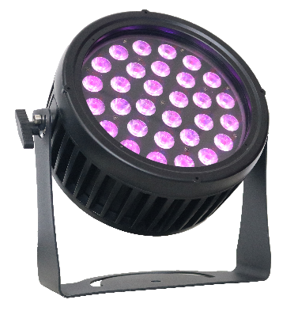

USER MANUAL

Thank you very much for choosing our product. For safety purpose, please read this manual carefully before your operation. This manual included installation and using information. Please install and operate it according to this manual.

Part 1 Product
  - Product introduction
This product is designed for indoor use. Suitable applications include wash or effect lighting for architectural, stage or nightclub applications. This product can also be installed for use in signage and advertising using the dynamic functions available with DMX512 control. Direct input of DMX512 signal allows the units to be controlled from any DMX512 controller. This product can be operated as a single unit or in multiple units for large applications.

1.2 Technical Specifications
Input voltage: AC100-240V, 50/60Hz
Rated power: 300W
Light source: 30*10W high power LED (4 in 1 RGBW)
Channel:5/8 channels
Color mixing: RGBW color mixing, colorful infinite change
Strobe: 0-20Hz
Control: international standard DMX512
Lens angle: 25°
Display: OLED function menu with 4 buttons
Heat dissipation: intelligent temperature control, active
Maximum ambient temperature 40°C
Minimum ambient temperature -20°C
Maximum case temperature 65°C
Power connection IP65 Seetronic power connectors input/output
Data connection IP65 Seetronic DMX connectors input/output
LED life: 50,000-100,000 hours
Waterproof rating: IP65
Net weight: 7.6kg

Features:
4 dimming curves, high standard linear dimming
Exquisite die-cast aluminum housing, IP65 protection level, suitable for outdoor performances
Silent operation, no flicker output
Unique structure design, excellent natural heat dissipation effect
Double hanger design, convenient for air suspension and ground placement
DMX control, RDM intelligent control.
Features and advantages: Adopt waterproof sealing design, high color purity, special optical design, more uniform light effect, waterproof grade IP65. Suitable for various indoor and outdoor performances, environmental art lighting, outdoor lighting and other dyeing and lighting effects.

1.3 Safety Warning

IMPORTANT:
ALWAYS READ THE USER MANUAL BEFORE OPERATION. PLEASE CONFIRM THAT THE POWER SUPPLY STATED ON THE PRODUCT IS THE SAME AS THE MAINS POWER SUPPLY IN YOUR AREA.
● This product must be installed by a qualified professional.
● Always operate the equipment as described in the user manual.
● A minimum distance of 0.5m must be maintained between the equipment and combustible surface.
● The product must always be placed in a well ventilated area.
● Always make sure that the equipment is installed securely.
● DO NOT stand close to the equipment and stare directly into the LED light source.
● Always disconnect the power supply before attempting and maintenance.
● Always make sure that the supporting structure is solid and can support the combined weight of the products.
● The earth wire must always be connected to the ground.
● Do not touch the power cables if your hands are wet.
ATTENTION:
● This product left the place of manufacture in perfect condition. In order to maintain this condition and for safe operation, the user must always follow the instructions and safety warnings described in this user manual.
● Avoid shaking or strong impacts to any part of the equipment.
● Make sure that all parts of the equipment are kept clean and free of dust.
● Always make sure that the power connections are connected correct and secure.
● If there is any malfunction of the equipment, contact your distributor immediately.
● When transferring the product, it is advisable to use the original packaging in which the product left the factory.
● Shields, lenses or ultraviolet screens shall be changed if they have become damaged to such an extent that their effectiveness is impaired.
● The lamp (LED) shall be changed if it has become damaged or thermally deformed.

PART 2 INSTALLATION

2.1 Mounting:
2.1-1 Hanging
The product can be mounted in a hanging position using the supporting bracket. The bracket should be secured to the mounting truss or structure using a standard mounting clamp. Please note that when hanging the unit a safety cable should also be used
.
2.1-2 Upright
The product can be mounted in an upright or sitting position using the supporting brackets.

NOTE:
The product can be mounted at any angle and in any position. It is possible to further adjust the angle of the product using the two adjustment knobs located on the side of the fixture.

2.2 Special construction for DMX connection.
☆ At last fixture, the DMX cable has to be terminated with a terminator to reduce signal errors. Solder a 120-ohm 1/4W resistor between pin 2(DMX-) and pin 3(DMX+) into a 3-pin XLR-plug and plug it in the DMX-output of the last fixture.
☆ If the controller is 5-pin output, it’s necessary to use an adaptor to transfer signal from 5-pin output to 3-pin XLR-plug or you can connect cables as following:
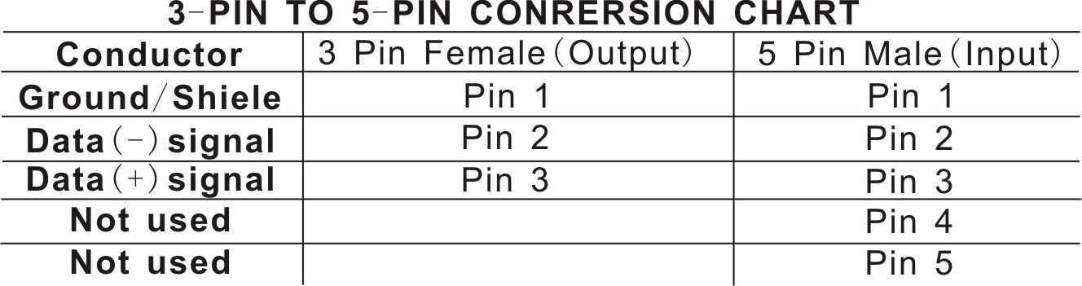

PART 3 Display Panel Operation

3.1 OLED Display panel menu instruction

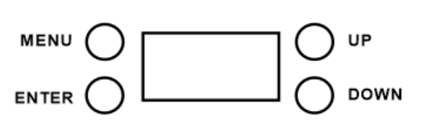
[MENU] menu selection or return to previous menu.
[UP] press [UP] through the menu list to increase/change the value of the current function.
[DOWN] press [DOWN] through the menu list to decrease/change the value of the current function.
[ENTER] confirm & quit out current function setting.

3.2 Display panel operation instruction
Menu | Sub-Menu |  | Description
DMX Address | A.(001-512) |  | DMX address 001-512
Mode | Manual |  | Manual Mode
Mode | DMX1 |  | 5CH Mode (default)
Mode | DMX2 |  | 8CH Mode
Mode | Auto |  | Auto Mode
Mode | Define |  | Define Mode
Color | Red |  | Red
Color | Green |  | Green
Color | Blue |  | Blue
Color | Cold |  | Cold White
Color | Pink |  | Pink
Color | Yellow |  | Yellow
Color | Cian |  | Cian
Color | Amber |  | Amber
Color | Warm |  | Warm White
Color | White |  | Day White
Color fine | Red | 0-255 | Red color fine, 0-255
Color fine | Green | 0-255 | Green color fine, 0-255
Color fine | Blue | 0-255 | Blue color fine, 0-255
Color fine | White | 0-255 | White color fine, 0-255
Dimmer | 0-255 |  | Dimmer,0-255
Strob | 0-20 |  | Strobe, 0-20, slow to fast
Auto prog | 3 Auto color | T.(00-99) | 3 colors change (0-99), Slow to fast
Auto prog | 7 Auto color | T.(00-99) | 7 colors change(0-99), Slow to fast
Auto prog | 7 color fade | T.(00-99) | 7 colors fade, 0-99, slow to fast
Auto prog | Strobe 1 | T.(00-99) | Strobe 1 , 0-99, slow to fast
Auto prog | Strobe 2 | T.(00-99) | Strobe 2 , 0-99, slow to fast
Display INV | 0 |  | Display Positive
Display INV | 180 |  | Display Reverse
Display OFF | ON |  | Display keep ON
Display OFF | 30s |  | Display OFF after 30s no operation
Display OFF | 60s |  | Display OFF after 60s no operation
Reset | NO |  | No function
Reset | YES |  | Parameter restore to factory value
Info | RGBW/V1.8 |  | Software version

3.3 DMX Channel instruction

5 Channels Mode
Channel | Function | DMX Value | Description
1 | Dimmer | 0-255 | Dimmer,0-100%
2 | Red | 0-255 | Red dimming,0-100%
3 | Green | 0-255 | Green dimming,0-100%
4 | Blue | 0-255 | Blue dimming,0-100%
5 | White | 0-255 | White dimming,0-100%

8 Channels Mode
Channel | Function | DMX Value | Description
1 | Dimmer | 0-255 | Dimmer,0-100%
2 | Red | 0-255 | Red dimming,0-100%
3 | Green | 0-255 | Green dimming,0-100%
4 | Blue | 0-255 | Blue dimming,0-100%
5 | White | 0-255 | White dimming,0-100%
6 | Strobe | 0-13 | No function
6 | Strobe | 14-255 | Strobe from slow to fast
7 | Auto Mode | 0-9 | No function
7 | Auto Mode | 10-99 | Color Macro(Hue), level 90
7 | Auto Mode | 100-139 | 3 colors change
7 | Auto Mode | 140-179 | 7 colors change
7 | Auto Mode | 180-209 | 7 Colors Fade
7 | Auto Mode | 210-229 | 7 Colors Strobe 1
7 | Auto Mode | 230-255 | 7 Colors Strobe 2
8 | Auto Speed | 0-255 | Auto speed, slow to fast

