LED 90W BEAM LIGHT USER MANUAL

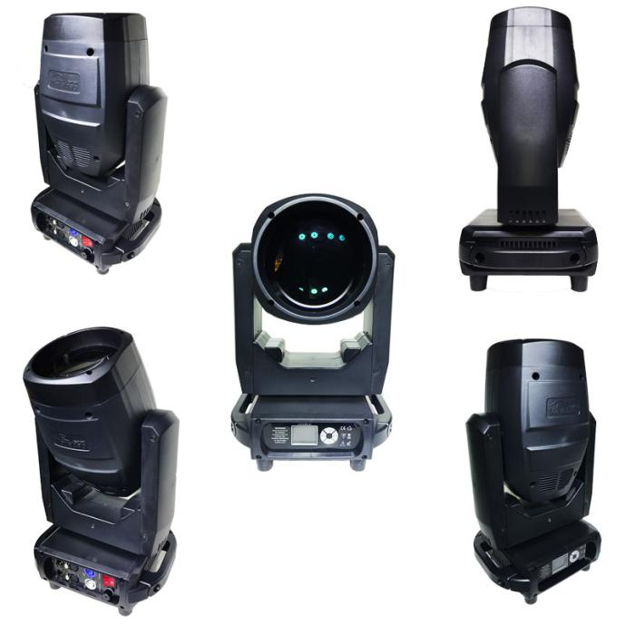

Specification：
Lighting source：90 LED white module
Max power consumption：250W
Voltage：wide voltage input switch power supply 100V-240V 50-60Hz
Color temperature：7000K-8000K
Lighting source lifespan：50000 hours
Spot angle：0-2°
Control mode：DMX512、master-slave
Channel mode:16CH/20CH
Support RDM function,DMX software upgrade function
Matched network：Artnet,sACN,network agreement
X/Y scan：horizontal 540°，vertical：270°
Color wheel：13 kinds of color+pure white，rainbow effect，Arbitrary positioning
Fixed gobo：12 kinds of fixed gobo，shake water flow effect
6colorful plate：one independent color 6 segments color plate,make gobo+rainbow effect.
Frost plate：frost flexible mirror
Dimming：0-100﹪ liner dimming
Strobe：sync pulse strobe,randomly pulse strobe
Prism :8 facets prism，two-way rotating effect
Focus：spot can arbitrary adjust to clear
Display：colorful liquid crystal display,Chinese and English bilingual,reversible display
High efficiency heat dissipation system,whole process temperature monitoring,overheat self-protection,non risk of lighting source damage.
Product dimension：31*23*49cm
Net weight:10.8kg
Gross weight：12kg

LED 90W MENU TABLE
MAIN | SECOND | THIRD
Dmx Address | 1 - 512
Fixture | Dmx Mode | STD/EXT
Fixture | Run Mode | DMX/Host/Sound
Fixture | Pan Invert | Close/Open
Fixture | Tilt Invert | Close/Open
Manual | Pan | 0 - 255
Manual | Pan Fine | 0 - 255
Manual | Tilt | 0 - 255
Manual | Tilt Fine | 0 - 255
Manual | ⁞ | ⁞
Manual | Reset | 0 - 255
Information | Time | Current Time：xxx H
Information | Time | Show Time：xxx H
Information | Time | Power Count：xxx
Information | Sensor | Type Information
Information | Temperature | Head Temp：xxx C
Information | Temperature | Fan Speed：xxxx RPM
Information | Software Version | Panel：Vx.xxx
Information | Software Version | XY Motor：Vx.xxx
Information | Software Version | Motor：Vx.xxx
Factory | Password | 0 - 255
Factory | Pan | 0 - 255
Factory | Tilt | 0 - 255
Factory | Dimmer | 0 - 255
Factory | Color | 0 - 255
Factory | FixGobo | 0 - 255
Factory | Colorful | 0 - 255
Factory | Frost | 0 - 255
Factory | Prism1 | 0 - 255
Factory | Prism2 | 0 - 255
Factory | Zoom | 0 - 255
Reset | All Reset | Cancel/Run
Reset | Factory | Cancel/Run
Display | Language | CH/EN
Display | Display Flip | Close/Open
Display | Display Mode | Show/60s

90W LED CHANNEL TABLE
20CH | 16CH | DMX values | Channel function
1 | 1 | 0－255 | X
2 | 2 | 0－255 | The X axis fine-tuning
3 | 3 | 0－255 | Y
4 | 4 | 0－255 | Y fine-tuning
5 | * | 0－255 | X, y axis speed
6 | 5 |  | STROBE
6 | 5 | 0-3 | Shut down
6 | 5 | 4-103 | Stroboscopic from slow to fast
6 | 5 | 104-107 | medallion
6 | 5 | 108-207 | Pulse stroboscopic from slow to fast
6 | 5 | 208-212 | medallion
6 | 5 | 213-225 | Random slow stroboscopic
6 | 5 | 226-238 | Random medium speed stroboscopic
6 | 5 | 239-251 | Random fast stroboscopic
6 | 5 | 252-255 | medallion
7 | 6 | 0-255 | Dimmer
8 | * | 0-255 | The dimming fine-tuning
9 | 7 |  | Color piece
9 | 7 | 0-4 | The white light
9 | 7 | 5-9 | White light plus color 1
9 | 7 | 10-14 | Color 1
9 | 7 | 15-19 | Color 1 plus color 2
9 | 7 | 20-24 | 2 colors
9 | 7 | 25-29 | Color 2 plus color 3
9 | 7 | 30-34 | The color of 3
9 | 7 | 35-39 | Color 3 plus color 4
9 | 7 | 40-44 | 4 color
9 | 7 | 45-49 | Color 4 plus color 5
9 | 7 | 50-54 | Color 5
9 | 7 | 55-59 | Color 5 plus color 6
9 | 7 | 60-64 | Color 6
9 | 7 | 65-69 | Color 6 plus color 7
9 | 7 | 70-74 | Seven colors
9 | 7 | 75-79 | Color 7 plus color 8
9 | 7 | 80-84 | Color 8
9 | 7 | 85-89 | Color 8 plus color 9
9 | 7 | 90-94 | Color 9
9 | 7 | 95-99 | Color 9 plus color 10
9 | 7 | 100-104 | Color 10
9 | 7 | 105-109 | Color 10 plus color 11
9 | 7 | 110-114 | Color 11
9 | 7 | 115-119 | Color 11 plus color 12
9 | 7 | 120-124 | Color 12
9 | 7 | 125-129 | Color 12 plus color 13
9 | 7 | 130-134 | The color of 13
9 | 7 | 140-149 | The white light
9 | 7 | 115－199 | From fast to slow water
9 | 7 | 200-205 | Water stop
9 | 7 | 206-255 | From slow to fast water
10 | * | 0-255 | Color piece of fine-tuning
11 | 8 |  | Fixed pattern
11 | 8 | 0-9 | The white light
11 | 8 | 10-19 | Pattern 1
11 | 8 | 20-29 | Pattern 2
11 | 8 | 30-39 | Pattern 3
11 | 8 | 40-49 | Pattern 4
11 | 8 | 50-59 | Pattern 5
11 | 8 | 60-69 | Pattern 6
11 | 8 | 70-79 | Pattern 7
11 | 8 | 80-89 | Pattern 8
11 | 8 | 90-99 | Pattern 9
11 | 8 | 100-109 | Pattern 10
11 | 8 | 110-119 | Pattern 11
11 | 8 | 120-127 | Pattern 1 jitter (from slow to fast)
11 | 8 | 128-135 | Pattern 2 jitter (from slow to fast)
11 | 8 | 136-143 | Pattern 3 jitter (from slow to fast)
11 | 8 | 144-151 | Pattern 4 jitter (from slow to fast)
11 | 8 | 152-159 | Pattern 5 jitter (from slow to fast)
11 | 8 | 160-167 | Pattern 6 jitter (from slow to fast)
11 | 8 | 168-175 | Pattern 7 jitter (from slow to fast)
11 | 8 | 176-183 | Pattern 8 jitter (from slow to fast)
11 | 8 | 184-191 | Pattern 9 jitter (from slow to fast)
11 | 8 | 192-199 | Pattern 10jitter (from slow to fast)
11 | 8 | 200-207 | Pattern 11jitter (from slow to fast)
11 | 8 | 208-230 | Pattern flowing (fast to slow)
11 | 8 | 231-232 | Water stop
11 | 8 | 233-255 | Pattern backflow (from slow to fast)
12 | 9 | 0－255 | focusing
13 | * | 0－255 | Focusing fine-tuning
14 | 10 |  | 7 colour
14 | 10 | 0-127 | empty
14 | 10 | 128-255 | 7 colour
15 | 11 |  | atomization
15 | 11 | 0-255 | Linear atomization
16 | 12 |  | Prism
16 | 12 | 0－127 | empty
16 | 12 | 128-255 | Prism opens
17 | 13 |  | Rotation of prism
17 | 13 | 0－63 | Linear orientation of prism
17 | 13 | 64－126 | Clockwise flow from fast to slow
17 | 13 | 127－128 | Water stop
17 | 13 | 129－191 | Counterclockwise flow from slow to fast
17 | 13 | 192－255 | Positive and negative rotation (from slow to fast)
18 | 14 |  | empty
18 | 14 | 0－127 | empty
18 | 14 | 128-255 | empty
19 | 15
19 | 15 | 0－63 | empty
19 | 15 | 64－126 | empty
19 | 15 | 127－128 | empty
19 | 15 | 129－191 | empty
19 | 15 | 192－255 | empty
20 | 16 |  | reset
20 | 16 | 200－205 | Lamps and lanterns is reset
20 | 16 |  | empty

