12x40W RGBW 4in1 zoom wash pixel moving head light
User Manual

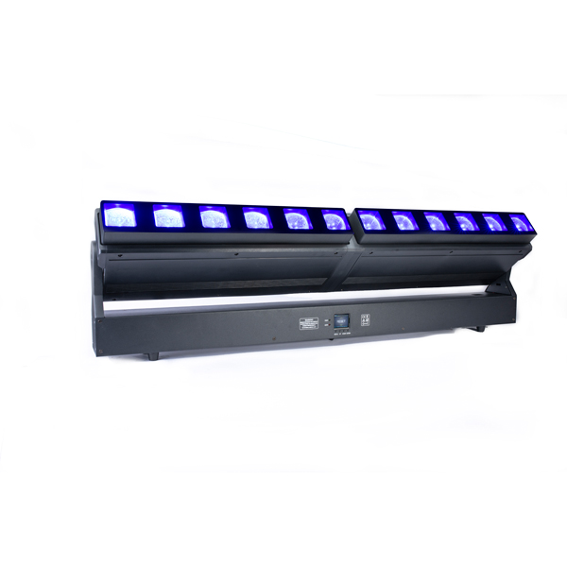

This manual contains important information. Please read before operating fixture.

1 SECURITY TIPS
WARNING!!! To reduce the risk of fire, electric shock, or injury to persons, follow these important safety instructions:
- non-professionals, not to disassemble the light arbitrarily and lighting accessories inside.
- rated voltage range: AC110V-120V/60Hz or AC200V-240V / 50HZ (to be selected).
- not beam irradiate the flammable materials, flammable materials and the lamp should be maintained at least 1M over the distance.
- lamps used in ambient temperature: -15 ℃ -40 ℃, the highest temperature of the surface of the lamp: 60 ℃.
- to keep away from the liquid substance and humid environment.
- before using the lights must ensure the good grounding, can not install charging and remove any parts.
- the installation of lamps, must be fixed screw fasteners with additional security cable and regular inspection.
- lamps consecutive working hours is not recommended more than 10 hours.
- should stop using the lights in time when happens unusual conditions during the process
- lamp parts of the rotation, external accessories and paste parts should be regular inspected, such as the emergence of loose and rock, should be reinforced in a timely manner to prevent the accident.
- lamps adopt strong winds to refrigerate, it is easy to accumulate the dust, so you have to clean it weekly especially the cooling air opening, otherwise the dust will plug leading to poor light

2 TECHNOLOGY REFERENCE
Input voltage: 110–240 V, 50/60 Hz
Power: 500W
Light source: 12pcs 40W, RGBW 4in1 mixing color
Working lifetime: About 50000 hours
IP rating: IP20
Working temperature:-20℃-40℃
Control mode: DMX 512, Auto, Master-slave, Sound
4Channel mode: STD/HSI/GUI/EXT (17/11/18/58CH)
Function: Dyeing, strobe, zoom, light beam effect
Pan: 540° (16bit) Electric correction
Tilt: 270° (16bit) Electric correction
Zoom range: 7°~ 70°
Dimmer: 0-100% dimmer
Display panel: Blue LCD screen
Housing material: Engineering plastics
Net weight: 15kg

MIN ZOOM-7° Beam Diameter
Distance(m) | 3m | 5m | 7m
Beam Openning | 0.60m | 0.90m | xxm
Itensity(lux) | lux | lux | lux
Red | 10920 | 4900 | 2140
Green | 22100 | 9038 | 4296
Blue | 25800 | 9953 | 4300
White | 29820 | 12560 | 6000
R+G+B+W | 92100 | 23560 | 11510

MIN ZOOM-70°Beam Diameter
Distance(m) | 1m | 3m | 5m
Beam Openning | XX | XX | XX
Itensity(lux) | lux | lux | lux
Red | 3536 | 518 | 198
Green | 6343 | 855 | 335
Blue | 6350 | 812 | 297
White | 9248 | 1160 | 468
R+G+B+W | 17580 | 2250 | 856
3 Board Instruction
ADDRESS | 001-512
RUN | DMX512
RUN | Auto
DMX MODE | 19CH
DMX MODE | 67CH
TEST | ALL
SET | Display | Yes
SET | Display | No
SET | Signal Keep | Yes
SET | Signal Keep | No
SET | Slave | Yes
SET | Slave | No
SET | English | Yes
SET | English | 否
INFO | Version | V1.11
MANUAL | Pan | 000-255
MANUAL | Tilt | 000-255
MANUAL | …… | ……
MANUAL | …… | ……
MANUAL | Strobe | 000-255
RESET | Yes
RESET | No
4 DMX CHANNEL SHEET
Mode:19CH
Channel | Function | DMX Value | Description
1 | Pan | 0-255 | Pan rotation
2 | Pan Fine | 0-255 | Pan fine
3 | Tilt | 0-255 | Tilt rotation
4 | Tilt Fine | 0-255 | Tilt fine
5 | P/T Speed | 0-255 | P/T speed
6 | Dim | 0-255 | Total dimmer 0-100%
7 | Zoom | 0-255 | Wide beam- narrow beam
8 | Strobe | 0 - 10 | No function
8 | Strobe | 11-255 | Strobe,from slow to fast
9 | Red | 0-255 | LED off - LED on
10 | Green | 0-255 | LED off - LED on
11 | Blue | 0-255 | LED off - LED on
12 | White | 0-255 | LED off - LED on
13 | CCT | 0-255 | colour temperature adjusting
14 | Macro | 0-255 | Macro color
15 | Effect | 0 | Closed
15 | Effect | 1-100 | Dream,gradual change from slow to fast
15 | Effect | 101-200 | Wave,from slow to fast
15 | Effect | 201-255 | No function
16 | Macro | 0-255 | Macro color
17 | Background DIM | 0-255 | Background Dimmer
18 | Background | 0-255 | Background color
19 | Reset | 0-244 | No function
19 | Reset | 245-255 | Fixture reset

Mode:67CH
Channel | Function | DMX Value | Description
1 | Pan | 0-255 | Pan rotation
2 | Pan Fine | 0-255 | Pan fine
3 | Tilt | 0-255 | Tilt rotation
4 | Tilt Fine | 0-255 | Tilt fine
5 | P/T Speed | 0-255 | P/T speed
6 | Dim | 0-255 | Total dimmer 0-100%
7 | Zoom | 0-255 | Wide beam- narrow beam
8 | Strobe | 0 - 10 | No function
8 | Strobe | 11-255 | Strobe,from slow to fast
9 | Red | 0-255 | LED off - LED on
10 | Green | 0-255 | LED off - LED on
11 | Blue | 0-255 | LED off - LED on
12 | White | 0-255 | LED off - LED on
13 | CCT | 0-255 | colour temperature adjusting
14 | Macro | 0-255 | Macro color
15 | Effect | 0 | Closed
15 | Effect | 1-100 | Dream,gradual change from slow to fast
15 | Effect | 101-200 | Wave,from slow to fast
15 | Effect | 201-255 | No function
16 | Macro | 0-255 | Macro color
17 | Background DIM | 0-255 | Background Dimmer
18 | Background | 0-255 | Background color
19 | Reset | 0-244 | No function
19 | Reset | 245-255 | Fixture reset
20 | Red 1 | 0-255 | LED Red1
21 | Green 1 | 0-255 | LED Green 1
22 | Blue 1 | 0-255 | LED Blue 1
23 | White 1 | 0-255 | LED White 1
24 | Red 2 | 0-255 | LED Red 2
25 | Green 2 | 0-255 | LED Green 2
26 | Blue 2 | 0-255 | LED Blue 2
27 | White 2 | 0-255 | LED White 2
28 | Red 3 | 0-255 | LED Red 3
29 | Green 3 | 0-255 | LED Green3
30 | Blue 3 | 0-255 | LED Blue 3
31 | White 3 | 0-255 | LED White 3
32 | Red 4 | 0-255 | LED Red 4
33 | Green 4 | 0-255 | LED Green 4
34 | Blue 4 | 0-255 | LED Blue 4
35 | White 4 | 0-255 | LED White 4
36 | Red 5 | 0-255 | LED Red 5
37 | Green 5 | 0-255 | LED Green 5
38 | Blue 5 | 0-255 | LED Blue 5
39 | White 5 | 0-255 | LED White 5
: | Red 6 | 0-255 | LED Red 6
64 | Red 12 | 0-255 | LED Red 12
65 | Green 12 | 0-255 | LED Green 12
66 | Blue 12 | 0-255 | LED Blue 12
67 | White 12 | 0-255 | LED White 12

5 DIFFICULTY RESOLUTION
The following is a list of problems and resolution, and other malfunction preparing work should be professionally qualified staff to deal with.
1. Bulb not working
  - Check whether approaching the service life of light bulbs, then change it
  - Check whether bulbs circuitry leak, loss or connect poorly
2. Beam appears bleak
- The bulbs maybe approach the service life, then change it, or the optical components are unclean.
- Bulbs have accumulation of dust, so the bulbs and other parts inside the lamp should be cleaned and maintained in regular period.
3. Computer lamp work intermittently
- Check whether the fan process naturally and become dirty
- Check inner temperature-response control plug is off
- Check whether the circuitry is good
4. The computer lamp not controlled by controller during lighting
- Check numeral starting address and the connection of communication control circuit
- The corresponding channel button of controller is open or not
- Check whether the fuse on power supply input jack is broken off
6 AFTER SERVICE
- Our company offer technical consultation to customers for ever.
- If the machine is wrong and need repairmen, please truthfully fill in the related content and feedback us the problems timely, as well as we have to improve the product.
- In addition to the lamp, also matching accessories are as follows：
accessories：Power line 1 piece Optional parts：(customers）

