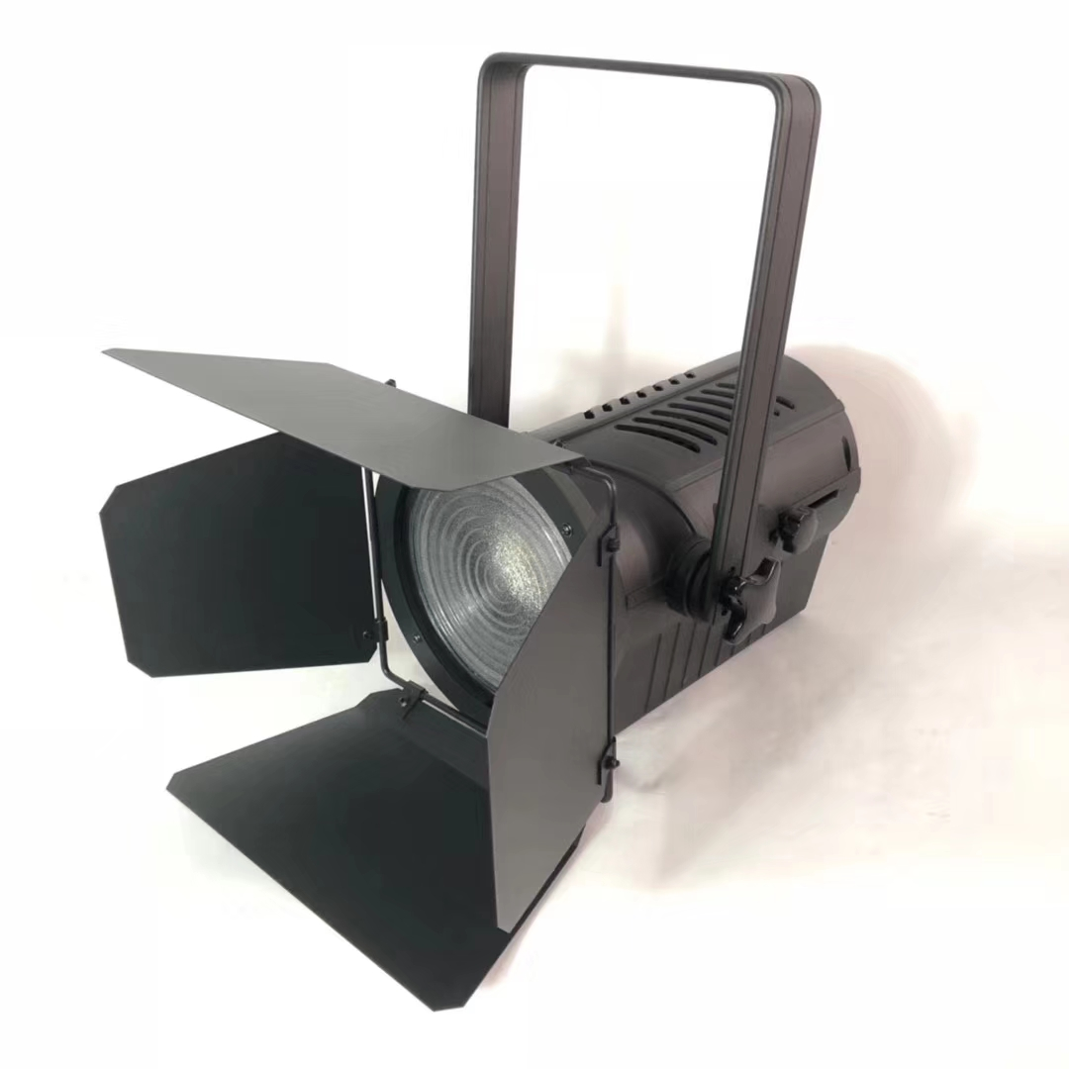
LED LCD display to use the instructions

- Graphic section:

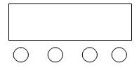
A. function key
B. additional key
C. The key reduction
D. Confirmation key
E.LED display window

A B C D

Operation instructions: pressing function key A will cycle 12 different functional effects, and the first two digits of the digital tube represent the current function (refer to the function table). The last two numbers represent the function of this kind.address code. Or the speed, the parameters of the. Press either B or C to modify the parameter values. Press the key D to confirm.

- LCD display window function control table (all functions are selected and then press D key to confirm)

order number | show | function declaration
1 | DMX-9CH  D: 001 | 9-channel address code, (001- -512)  Key B and C keys add or subtract the address code value
2 | DMX-5CH  D: 001 | 5-channel address code, (001- -512)  Key B and C keys add or subtract the address code value
3 | Jump  D: 099 | Colorful jump change, (00- -99)  B, C keys to modify the colorful jump speed
4 | Gchange  D: 099 | Colorful gradient, (00- -99)  B, C keys to modify the seven-color gradient speed
5 | Explosiv  flash | Flash, (00- -99)  - C key fies the flash speed  Color is controlled by (color selection)
6 | Voice  Running | Colorful voice control changes
7 | Color R  D: 255 | R color selection, (000- -255)  B and C key to modify the color selection
8 | Color G  D: 255 | G Color Selection, (000- -255)  - C key modifies color selection
9 | Color B  D: 255 | B color selection, (000- -255)  B and C key to modify the color selection
10 | Color W  D: 255 | W color selection, (000- -255)  - C key modifies color selection
11 | Color Y  D: 255 | Y color selection, (000- -255)  B and C key to modify the color selection
- LCD background display window function control table, (in A001 state, press A key often for 3-4 seconds to enter and press D key to exit)
order number | show | function declaration
1 | Current  R :255 | R color current, (020- -255) default value (235)
2 | Current  G : 255 | G color current, (020-255) default value (235)
3 | Current  B :255 | B color current, (020-255) default value (235)
4 | Current  W : 255 | W color current, (020- -255) default value (235)
5 | Current  Y :255 | Y color current, (020- -255) default value (235)
6 | Power  D: 255 | Total power limit, (050-255) default (255 no limit)
7 | Push  Yes?/NO | (Host background setting parameters) does not push the default value to the slave (NO)
7 | Push  Yes?/NO | Yes host pushes to slave to update slave background parameters  Note: The signal line between the host and the slave is connected and powered up, and the slave is set to DMX512 mode. After the host enters this option, the host does not rush to exit and wait for the slave lamp flash to indicate the success of the slave update, then the host can exit.
8 | Recovery  Yes?/NO | Not not factory factory default (NO)
8 | Recovery  Yes?/NO | Yes to restore factory Settings Note: after entering Yes, the menu is not circulating and press the D key to save the exit will take effect. If there is no need to restore the factory setting, press the B key or the C key in the Yes interface to go back to NO in NO mode. Returning to the factory settings (current values) and (total power limits) will not be restored.
9 | Tempe..e  D: 055 | Light body temperature value setting, (40-70) default value (55) Note: the lamp body should be connected to the temperature control resistance before this function works
10 | Signal  Maintain /Clear | dmx512 Section signal is not maintained (the light enters the closed light state after the segment signal)
10 | Signal  Maintain /Clear | The on-dmx512 segment signal hold (segment signal) default value (Maintain)
11 | Fcontrol  A/B /C | A fan is not subject to temperature control and light control (turn)  (With a two-line fan)
11 | Fcontrol  A/B /C | B fan is temperature control and light control default value (B) Note: the temperature shows the fan above 45 degrees starts, and the fan below 40 degrees and the temperature shows 40 degrees stops. If the fan is not controlled by the temperature, it is only controlled by the lights, that is, the open fan starts, and the fan stops after 60 seconds after the light is closed (use the two-line fan)
11 | Fcontrol  A/B /C | C fan temperature control and light control default value (B) note: temperature display below 30 degrees fan low speed operation, over 30 degrees began to accelerate slowly, 55 degrees for the highest speed, if there is no control temperature control fan only light control, the light fan start, 60 seconds after light fan stop (only with three line PWM speed regulating fan)
12 | CH patter  A/B | (CH-A) Channel Mode Switching Default Value (CH-A)  1 total adjustment 2 stroboscopic 3 function 4 speed 5R 6G
12 | CH patter  A/B | (CH-b) Channel mode switching  1 total adjustment 2R 3G 4 stroboscopic 5 function 6 speed
13 | Frequenc  D: 014 | Dimmer refresh frequency (02k- -14k) hz default value (14 khz)  Note: Too low frequency may lead to flicker but better dimming. Too high frequency may lead to poor dimming but no flicker image, so the setting frequency depends on the scene
14 | Curve  D:001 | Dmer (1-4), default (01)  01 Linear dimming.02 square of dimming.03 Inverse-square dimming.04 S-shaped dimming.
15 | D..level  16bt /8bt | 16bt 16 bit dimming mode (soft dimming and slower dimming) Default (16bt)
15 | D..level  16bt /8bt | -8bt 8 bit dimming mode (the dimming flashes slightly, while the dimming speed is synchronized with the console value change speed)
16 | D..speed  D: 001 | 001 (000-255) dimming speed is valid for 16bt dimming mode, default value (001)

4.DMX512 channel description (9 channels)

order number | function | explain
Channel 1 | Total dimming | Total dimming, linear dimming, from dark to bright
Channel 2 | Total frequency flash | Total frequency strobe, from slow to fast
Channel 3 | FS | Where 0-5 is empty;  6-100 jump  The 101-150 gradients  151-200 flash  201-255 Voice control
Channel 4 | Functional speed | Functional speed, from slow to fast
Channel 5 | R aiming | Linear dimming, from dark to bright
Channel 6 | G aiming | Linear dimming, from dark to bright
Channel 7 | B aiming | Linear dimming, from dark to bright
Channel 8 | W aiming | Linear dimming, from dark to bright
Channel 9 | Y aiming | Linear dimming, from dark to bright

5.DMX512 channel description (5 channels)

order number | function | explain
Channel 1 | R aiming | Linear dimming, from dark to bright
Channel 2 | G aiming | Linear dimming, from dark to bright
Channel 3 | B aiming | Linear dimming, from dark to bright
Channel 4 | W aiming | Linear dimming, from dark to bright
Channel 5 | Y aiming | Linear dimming, from dark to bright
6. RDM description:
order number | function | explain
1 | Feedback (address code) | Free to change
2 | Feedback (channel mode) | Free to change
3 | Feedback (device temperature) | Can't change

7. Functional features:
The operation is very simple, humanized design, dimming without flicker, jitter phenomenon, etc. Can adapt to photography, photography, television stations and other strict requirements on the lighting occasions.

