LED Digital Display Light Instructions
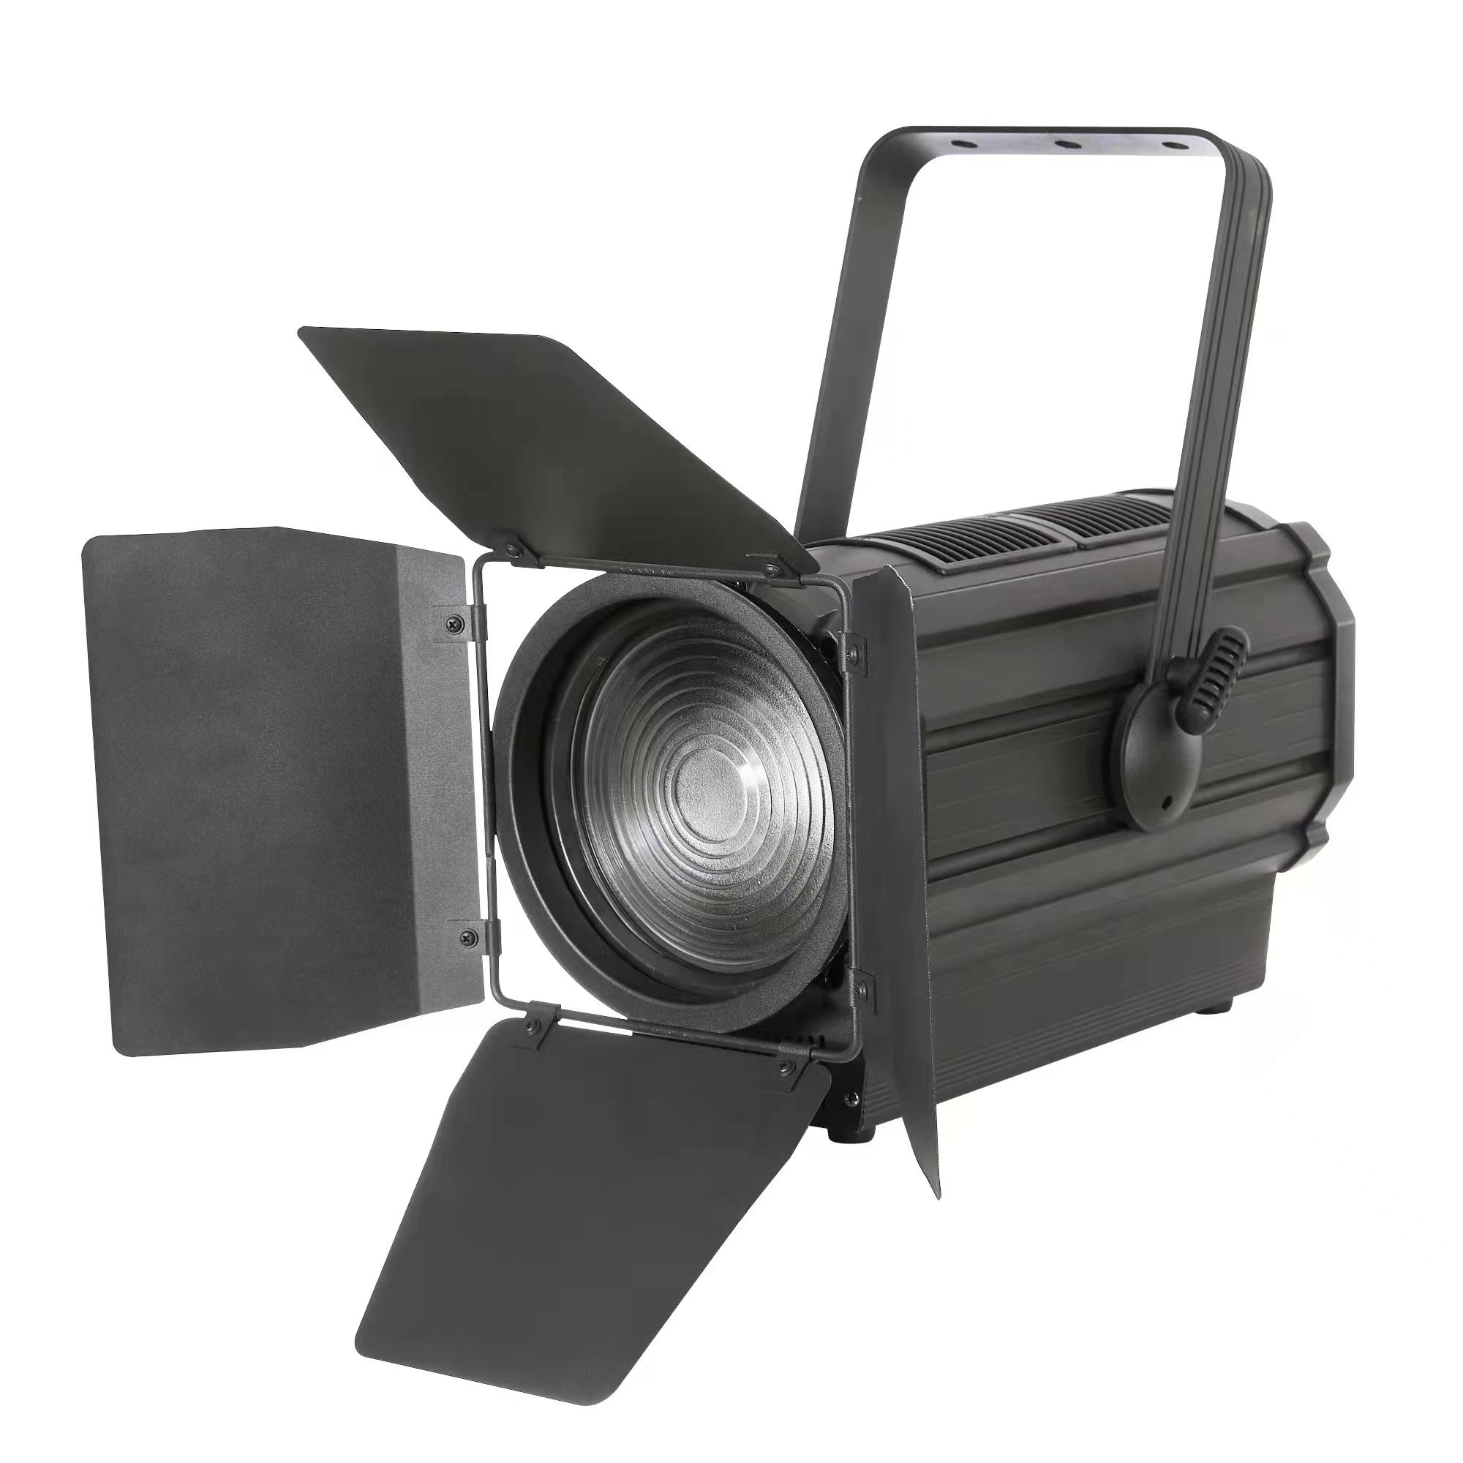
- Diagram part：

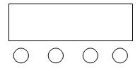
A．Function
B．UP
C．DOWN
D．Enter

A B C D
Operation description: Press function keys A will circulate 9 different functional effects, and the first two digits of the digital tube represent the function (reference meter). The latter two digits represent the. The address code, speed, and parameters of this function. Press B or C to modify the parameter value. Press the D key to confirm.

2. LeD display window function control table, (all functions can be confirmed according to the D key)
No. | display | function
1 | DMX-7CH  D:001 | 7Channel address code, (001-512)  B, C key to subtract address code value
2 | DMX-3CH  D:001 | 3Channel address code, (001-512)  B, C key to subtract address code value
3 | Function  [099] | Jump（01—99）  B、C Key to modify the jumping speed
4 | Gchange  [099] | gradual change，（01—99）  B、C Key to modify the gradient rate
5 | Pulse  D:[099] | strobe，（00—99）  B、C Key to modify the speed of flashes  Color (color selection) control
6 | Voice  Running | Colorful sound control changes
7 | Color Y  D:255 | Yellow color selection，（000—255）  B、C key modification color selection  If you adjust it to 000 (pulse), it will not flash yellow
8 | Color W  D:255 | White color selection，（000—255）  B、C key modification color selection  If you adjust it to 000 (pulse), it will not flash white
9 | Focus  [000] | Motor location，（000—255）  B、C Key modify Motor location
- LED background display window function control table, (in A001, often press the A key for 3-4 seconds, you can enter the D key to exit)
No. | display | function
1 | current  Y:235 | Yellow current, (020-255) default value (235)
2 | current  W:235 | White current, (020-255) default value (235)
3 | Power  D:255 | Total power limit, (050-255) default value (255 unlimited)
4 | Settings  Push:off | Settings (Parameters settings) do not push the default value from the machine (PUSH: OFF)
4 | Settings  Push:off | Pushh: ON hosts are pushed from the machine to update from the background parameters of the machine
5 | Reset  No | Reset does not restore the factory setting default value (NO)
5 | Reset  No | (YES) Restore the factory setting. Note: After selecting YES, the screen will flash. It will be prompted whether to restore the factory settings. The menu will not take the exit and exit without the loop. If you do not need to restore the factory settings, you can press B or C to return (N0) to continue the cycle. The restoration of factory settings (current value) and (total power limit) will not be restored.
6 | oC  D:055 | The temperature value of the lamp body, (40-70) default value (55) Note that the lamp body must be connected to the temperature control resistance before this function can only work
7 | Signal  maintain | Clear DMX512 segment signal does not keep it (the light enters the state of light after the signal)
7 | Signal  maintain | Maintain DMX512 segment signal holding (Maintain)
8 | Screen  aegis:on | OFF display backlight is often bright
8 | Screen  aegis:on | After 30 seconds of backlight of the on display, enter the screen Bao Mo Mo recognition (on)
9 | Fan-mode  mode-1 | MODE-1 fan is subject to the default value of temperature control and light control (1) Note: The temperature is displayed above 45 degrees and the lamp beads are started when the light is opened. If the fan is not controlled by the control of the temperature, the fan is only controlled by the light, that is, the light fan is started, and the fan stops 60 seconds after the light is closed.
9 | Fan-mode  mode-1 | 0 fan is not controlled by temperature control and light control (often transfer)
10 | Aisle  mode-a | Mode-A channel mode Switch the default value (A)  1 Total 2 Flight Flash 3 Function 4 Speed 5Y WG 7 Motor Cocion  (b) Channel mode switching  1 Total 2R 3G 4 Instant Flash 5 Function 6 Speed 7 Motor Cocket
11 | M trip  D：128 | Electric itinerary, (000-255) default (128)  Used for the adjustment of the motor itinerary,
12 | M Tune  D：128 | Electrical correction, (000-255) default (128)  The adjustment of the starting position of the motor may have a certain error because the lamp reset Hall and the magnet may have a certain error, and the starting position of each lamp may not be complete after the reset.
13 | Y Tune  D：005 | The speed of the motor turns is adjusted according to the combination of the lamps and the actual application. modify to fast can be directed to the motor to lose.
14 | Footbit | Singe-a lamp beads to switch monochrome  Singe-B lamp beads to switch bilateral
15 | Password lock screen | Unlock (lock_f) has a password lock  Unlock (lock_n) non -password lock
16 | Bit  16 | (16) 16 -bit dimming mode (soft and soft, at the same time, the dimming speed will slow) default value (16)
16 | Bit  16 | (8) 8 -bit dimming mode (the lighting is a bit flickering, and at the same time, the lighting speed is synchronized with the change speed of the console value)
17 | LEDspeed  D:001 | (000-255) The lighting speed is only for the choice of 16BT dimming mode. When selecting-8BT dimming mode, there will be no default value of this menu (001)

4．DMX512 channel description (7 channels)
No. | display | function
1 | Always lit | Allowing, linear light adjustment, from dark to bright
2 | Total flash | Total flash, from slow to fast
3 | Functional choice | 0--5: empty  6--40: Jumping (controlled by 512);  41--80: Gradient (controlled by 512);  81--120: pulse change (controlled by 512);  121--160: Jumping (motor startup program);  161--200: Gradient (Endivation of the motor);  201--240: pulse change (motor built-in program);  241--255: Sound control (motor starting program);
4 | Functional speed | Function speed, from slow to fast
5 | Y Light | Y lighting, linear lighting, from dark to bright
6 | W -lighting | W lighting, linear lighting, from dark to bright
7 | focusing | Focus from small to large

5．DMX512 channel description (3 channels)
No. | display | function
1 | Y Light | Y lighting, linear lighting, from dark to bright
2 | W -lighting | W lighting, linear lighting, from dark to bright
3 | focusing | Focus from small to large
6．RDM:
No. | display | function
1 | Feedback (address code) | Can be changed freely
2 | Feedback (channel mode) | Can be changed freely
3 | Feedback (device temperature) | Cant be changed

