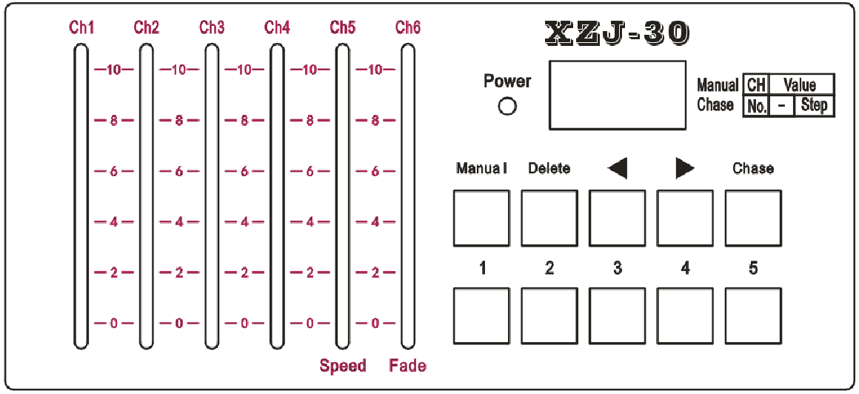
DMX-30 Controller
- Front panel
- Manual button to select lights manually
- Delete to delete programs.
- ◄button, back-forward to previous step when editing.
- ►button, forward to next step.Add one more step automatically, after press this button. (with a dot on the fourth digital value)
- Chase button to edit or operating programs. Short press and indicator on to operate programs, press 3 seconds until indicator blink to edit program.
- CH1/CH6 channels fader
- 1-5 buttons, to select operating programs or select lights.
- Speed fader, it will be effected, when running programs.
- Fade fader, effected when running program only.
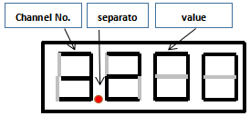
- Selecting lights manually
1、When power on indicator on, or press Manual button to enter manual mode.
2、Press number 1-6 to select lights(address).
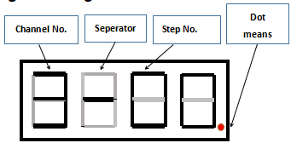
- Program editing
1、Press Chase over 3 seconds, indicators blinks until shows up“----”to enter edit program.
2、Select programs, from number 1—6,totally 6 programs.（Max. steps: 99 step）
For example 1：when choose number 1, if number 1 is empty，it shows up“1---”.
For example 2：when choose number 2, if number 2 is empty，it shows up“2-01”.
3、Choose editing steps, use ◄and ►button to choose single editing steps, or to check the edited steps; press ►button to save previous step and enter next step.
4、Delete steps: Press Delete button 3 seconds until it blinks to delete the previous step.
- Exit editing: press Chase button until indicator status from blink to on.
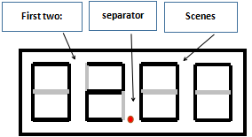
- Program running
1、Press Chase button to enter running mode until it blinks and shows up“----”.
2、Use number 1—5 to choose programs.
3、Use Speed fader to adjust each steps stay time, stay time shortest on the top.
4、Fading: use Fade fader to adjust fading time between two steps, on the top fading time shortest
5、Program switch and exit, use number 1—5 to choose different programs, indicators on means with programs. Short press the button to exit playing mode and indicators off.
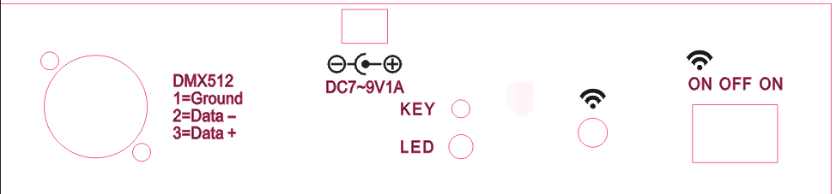
V. Wireless introduction（wireless version only）
1、Star this device and on the switch 
2、Press KEY button to adjust，
7 different colors for 7 code. The receiver and the controller match the same color, these two devices with be connected.
3、LED indicator instruction.
Protocol | Color statue | Description
Colors protocol | Red, green, blue, yellow, cyan, purple and white | 7 groups of wireless
Colors protocol | Red flash | Sending DMX signal
Colors protocol | Green flash | Receiving DMX signal
4、instruction
1) press display button to sub-menu to set ID，
2) press ID setting again, add one more value of each press
3)ID code and corresponding LED colors：
1：RED---red； 2：GREEN--green； 3：RED+GREED--yellow； 4：BLUE--blue；
5：RED+BLUE----purple；• 6：GREED+BLUE----cyan； 7：RED+GREED+BLUE---white

